

WESTLEA PRIMARY SCHOOL

Langstone Way
Westlea
Swindon
Wilts
SN5 7BT

TELEPHONE NO: 01793 870469

HEADTEACHER: Mrs Sarah Sumner

DEPUTY HEADTEACHER: Mrs Louise Edmonds

CHAIR OF GOVERNORS: Mr Bob Barrett

Westlea Primary School

Headteacher’s Welcome

Dear Parents and Carers,
As the Headteacher of Westlea Primary school, I am both proud and pleased to welcome you to our very inclusive school. Westlea is a child centered school, with a clear vision for each pupil.

The school vision is: Dream, Believe, Achieve through L.O.V.E: Learning, Opportunities, Vision and Educational Excellence. British Values are at the heart of the school vision.

Every child that attends Westlea is given a broad and balanced curriculum, tailored to their individual needs. There is a range of extra-curricular activities and experiences to enhance the curriculum, including different visitors and trips. We work closely with the three other West Swindon Schools, as part of the Link Academies Collaborative Trust, to provide the very best education for each child.

Social development and life-long learning are two of the key school drivers. Children need to cultivate their skills, so they can embrace challenges in the future. Our caring and inclusive ethos ensures that all of our pupils have high self-esteem and develop their confidence by the time they leave us.

Through a strong homeschool partnership, our professional and positive staff work collaboratively to ensure that every child strives to achieve their potential.


In October 2016, OFSTED confirmed their judgement, rating the school as Good. I look forward to meeting you and being able to showcase Westlea Primary School,

Sarah Sumner MA Ed
Headteacher

Admissions
Children are admitted to school at 4 years old in the September preceding their fifth birthday. Choosing a school for your child is one of the most important decisions you will make. Therefore, we recommend that you visit so you can see our wonderful school for yourself.

Each Autumn, prospective parents are encouraged to book a place at one of the open mornings and the dates are advertised on the school website. Applications for a place at Westlea should be made online, through Swindon Borough Council/Admissions.

School Organisation and Staffing
Westlea School is a primary school catering for children aged 4 – 11 years.
Westlea School opened in September 1983 to serve what was then the newly developed Westlea area, part of Swindon's major Western Development Plan. Westlea is one of several urban villages each of which is separated from its neighbours by main roads and open spaces. Several thousand homes have been built in the area bringing the population to somewhere between 8,000 and 10,000. A further development is in the final stage of completion now and for the first time, some social housing is part of the Westlea catchment area.

In November 2013, Westlea opened as an academy within the LACT – The Link Academy Collaborative Trust comprises of Millbrook, Shaw Ridge, Peatmoor and Westlea Primary School.

Currently, Westlea Primary School has 11 classes in the main school and an admission number of 45 children per year group, but moving forwards, this is going to be dropped to 30.

The class organisation and teaching teams for September 2020 will be:
2 x Year Reception classes (FS2)
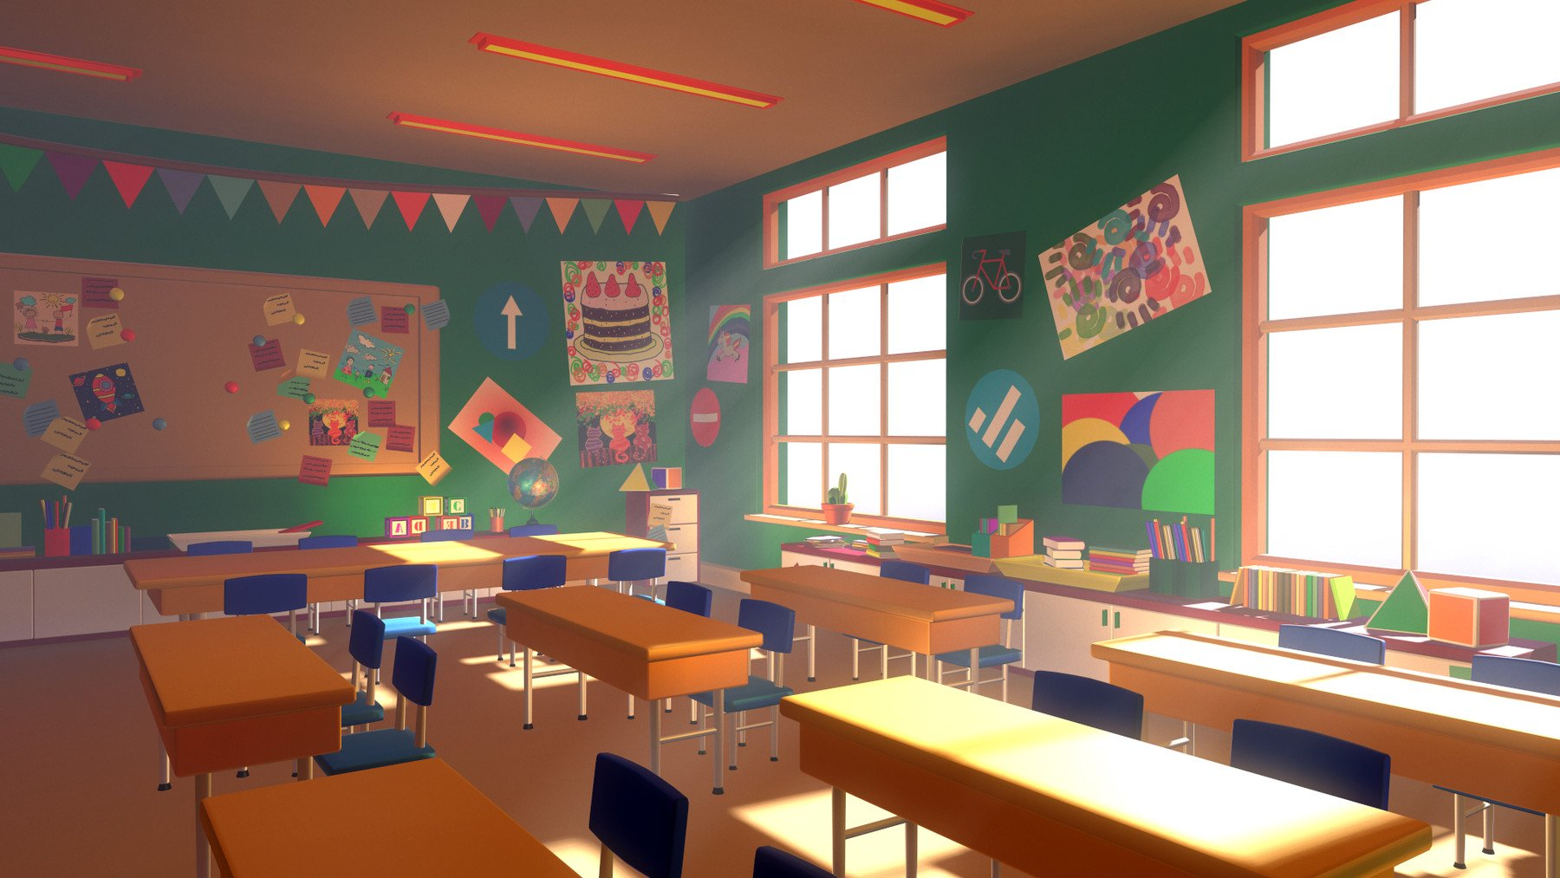
1 x Year 1 class
2 x Year 2 classes
1 x Year 3 class
1 x Year 3/4 class
1x Year 4 class
1x Year 5 class
1 x Year 5/6 class
1x Year 6 class

When looking at class organisation we always take into consideration the following factors:
• Infant Class size (must not exceed 30 pupils from within the mainstream)
• Age, gender, SEN, ability
• Social groupings and siblings
• Friendships

We are very proud to have a Special Resourced Provision (SRP) for children with physical disabilities taken from all areas within the town. It is the policy of the school to fully integrate them into main-stream classes.

At present up to 8 children with an EHCP can be part of this provision and they are supported by the Special Resourced Provision Lead and an excellent team of Learning Support Assistants who make an outstanding contribution towards the quality of education offered at Westlea. There are other children in school who also have special needs and these include learning, emotional or behavioural difficulties as well as physical ones and who are supported by a separate SEN team.

It is the policy of the school to encourage co-operative teaching wherever possible and great care is taken each year in the placement of staff and organisation of classes.

The Class Teacher constantly assesses the needs of each child in their class and provides for these needs. The children will receive whole class, individual and group teaching depending on what is most appropriate for a particular learning objective. Teaching groups are fluid, consisting of as many children as is best for a given situation. EYFS and KS1 classes are supported by a Learning Support Assistant and many classes have a higher ratio if they have PI children amongst their group. Being able to teach with such a degree of support ensures that each child really understands the work in hand and permits the teacher to vary methods to suit individuals. This also ensures that each child receives a high degree of adult time and attention.

Our aim is to take a child centered approach to achieving a broad, balanced and inclusive curriculum. Children’s worries, problems and/or special needs may interfere with the quality of their learning, therefore we remain aware of this and sensitive to the implications. Above all, we see the primary classroom as a living workshop where children develop the necessary skills for life long learning and social development.

Special Needs
Every child has a unique combination of strengths and abilities and areas of need. Within the life of the school these strengths and abilities should be developed and the areas of need addressed. Our school philosophy is that our educational provision and practice should enable all children to develop to their potential, offering each child appropriate work and experiences. Each child is of equal value and importance.

Many children will require individual support for learning and development at some stage of their educational life. Careful monitoring of progress through on-going teacher assessment, observation and record keeping, and discussion with parents will help provide early identification of specific areas of need.


We believe that the integration of special needs is highly beneficial to all our children, creating a caring and sensitive atmosphere amongst all members of the school. Contact with professional bodies outside the school is obviously important and physiotherapists, speech therapists, occupational therapists and educational psychologists are regular visitors. Our aim is to accept and value every child for who he or she is, and to take each child forward from where they are.

Attendance
Morning Session 9.00am – 12.30pm KS1
9.00am - 12.30pm KS2
Afternoon Session 1.30pm - 3.20pm KS1
Afternoon Session 1.30pm - 3.30pm KS2

We expect children to be punctual, but it is better to be late than not to arrive. Children should not arrive before 8.45 am but can then enter the school building immediately and proceed to their classrooms where their teachers will have a start activity waiting for them

Taking time off/Holidays in Term Time
Since September 2013 Headteachers are not permitted to authorize any leave or absence from school unless the circumstances are ‘exceptional’ and relating to a ‘one off’ isolated situation. ‘Exceptional circumstances’ do not cover
- Visiting relatives abroad
- Holidays (unless necessitated by work contracts)
- Family birthday celebrations

All holiday requests must be made in writing to the Headteacher on the approved form. Term time holidays are not permitted and if taken for 5 days or more will carry a fine.

Absences

Regular attendance at school will help your child to make the best of the educational opportunities afforded.

If your child is unavoidably absent, you need to phone school early in the morning. If the absence is going to be for any length of time, a telephone call is also needed daily. Certain illnesses such as measles, chickenpox, etc., have to be notified by the school to the Health Authority so it helps us if you let us know that your child has an infectious or contagious disease as soon as possible.

From time to time it may be necessary for you to take your children to the doctor or dentist during school hours. Please notify the class teacher in advance, especially if it is an early morning appointment and meal arrangements may be affected.

If your Child has not been reported Absent by Telephone, along with a valid reason for absence, they will have an "unauthorised absence" in the register and this will be included in the government annual return and in the annual report to parents.

Since September 2015, any child’s absence that falls below 90% is recorded as persistently absent. We work closely with our EWO to support our families and children where attendance is lower than 90%. We do have to take action with low attendance because of the detrimental impact it has on a child’s education.

If your Child is absent from school due to Sickness and or Diarrhea, then please note that School Policy is that they cannot return to School until 48hrs clear.

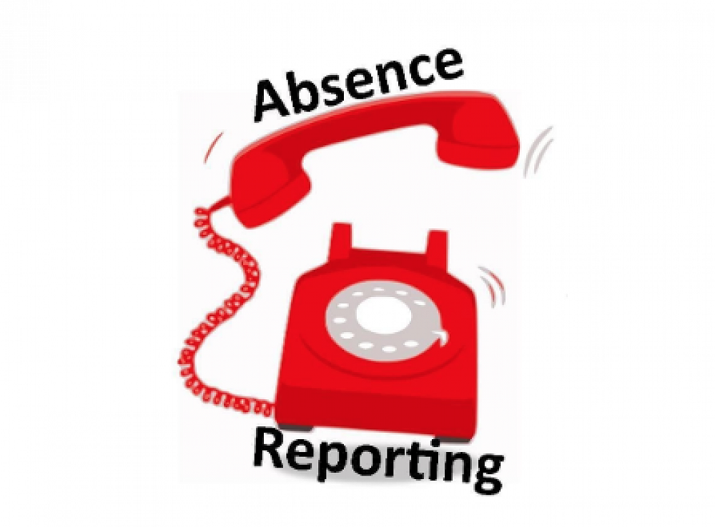

PUPIL ABSENCE RATES
The below table shows averages of unauthorized absences for Westlea Primary School, based on three terms of data;
Categories %
All Pupils 1.2

Gender
Male 2.2
Female 1.3

Free School Meals
FSM 1.0
Non FSM 1.8

English as first Language
English believed to be first language 1.1
Other than English believed to be first language 1.5

Special Education Needs
No SEN 0.9
SEN Support 1.7
SEN with EHC plan 1.0

Ethnic Group
White
British 1.1
Any other white background 0.9
Mixed
White & Black Carribean 3.3
White & Asian 0.4
Asian or Asian British
Indian 4.6
Pakistani 1.2
Bangledeshi 1.1
Any other Asian background 1.4
Other
Any other ethnic background 0.8

The Governing Body
The main responsibilities of the Governing Body are to ensure that:
- the school complies with the requirements of the National Curriculum
- the delegated budget is deployed appropriately to the needs of the school
- staffing levels are maintained and appointments are of the highest possible quality.

Other responsibilities include working with the Headteacher and the staff to agree policy on topics such as Religious Education and collective workshop, discipline, admission policy, and equal opportunities.

The day to day administration of the school is delegated to the Headteacher who is the ‘Accounting Officer’. FS4S support the school to carry out their statutory responsibilities.

While the Governors do not make educational policy, they monitor its implementation and are consulted on major changes. They are also responsible for securing a well balanced curriculum that is relevant to the academic, social, emotional and cultural needs of the pupils.

Finally, the Governors are responsible for the appointment of staff who are committed to the school’s philosophy, capable of fulfilling pupil needs, and ensuring high standards both for themselves and the pupils in their care.

The full board meets termly during the school year. There are also more frequent meetings of the four sub-committees: Finance, Staffing, Premises and Curriculum.

The membership of the Board of Governors is as follows. The date is the date of appointment.

Appointed by the LEA  Appointed by the Educational Committee of Swindon Borough Council. | Elected by Teaching Staff  Staff Governors must be employed by the school.
Mr B Barrett (Chair) 03/12/13  Parent and Co-opted Governors  Mr Nigel Green  Mrs Stacey Green  Mr Abdul Amin  Mrs Holly Coe | Staff Governors  Mrs S Sumner (Headteacher) 01/20  Mrs Jayne Dickenson (Office Manager)  Mrs L Edmonds (Deputy Headteacher  and SRP Lead)  Clerk: Mrs Heather Large

Accidents and Emergencies
Should your child become ill or have an accident at school, either you or a person designated by you will be informed. Please ensure that we can contact you quickly by keeping us up to date with your current home and place of work telephone numbers. All bumps on heads will be reported to you.

Medicines
If it is necessary for a child to complete a course of treatment (prescribed medicines only) the medication can only be accepted if it is clearly marked and must be handed the office staff by the parent. Medicines will not be given to a child without signed permission from the parent and will only be administered at the discretion of the Headteacher. We can only accept prescribed antibiotics that are to be administered 4 times a day.

We shall be grateful if you keep us informed of any medical condition your child has that involves hospital treatment, especially if our assistance could help. Please do not hesitate to contact the Headteacher if you have any problems regarding your child's health, welfare or medication. Specific conditions will require a Health Care Plan that is written by the School Nurse.

School Health Service
Foundation Stage and Year 6 have a yearly height and weight screening. Hearing is also checked in Foundation Stage. However, this is not mandatory, it will only take place at Parent’s discretion.

Specialist help is available for children with emotional, behavioural or learning difficulties. Arrangements can be made for the Educational Psychologist to visit the school. Following observation and perhaps tests, there will be discussion prior to any further action.
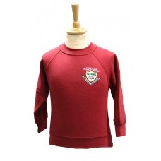
School Uniform
School uniform is expected to be worn by all children as a
matter of School Policy and there is a separate Dress Code
that pupils need to follow.
The advantages of wearing School Uniform are:
- a pride in the school and developing a sense of community
- less competition between those who can afford highly
expensive clothing and those who cannot
- less of a tussle in the mornings on "What shall we wear today?"
- school uniform is hard wearing and more cost effective.

Our uniform provider is ‘The famous by Monkhouse’

Pupil Dress Code
TRAINERS, BOOTS and SHOES
Trainers are NOT permitted as part of the school uniform and should only be brought to school for use in PE and after school activities.
- Plain black ankle boots may be worn during the colder months and during poor weather.
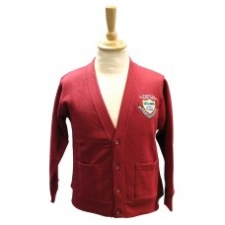
- Shoes should be black and suitable for running around the playground.

HAIR CUTS & HAIR ACCESSORIES
The school has very clear views on suitable haircuts and hair colourings for pupils who attend the school. Extreme haircuts that detract from the smart appearance of the school uniform are not permitted.
- Pupils should not have multi-coloured hair unless specified in support of fundraising.
- Pupils should not have shaved heads.
- Long hair should be tied back neatly.
- Pupils should not have patterns or tram-lines cut into their hair.
- Pupils should not have bleached streaks in hair.
- In addition, pupils should not have ‘radical’ styles such as a Mohican.
- Girls should not have extravagant decorations in their hair. Hair bands should be plain, flat to the head and in a simple colour that corresponds to the school uniform colours.
SCHOOL SHIRTS/TOPS
- School jumpers and cardigans do not have to have the school logo, but should be burgundy/red.
- Hoodies and fashionable sweatshirts are not permitted.
- Either a white polo shirt or cotton shirt are permitted.
SKIRTS, PINAFORES and DRESSES
- Girls’ skirts should be of suitable length (knee length), not be tight fitting or with slits to maintain dignity both in the classroom and whilst at play.
- School dresses should be burgundy/red and white checked.
- Black or grey pinafores are permitted.
- Please use your discretion to consider whether a skirt, pinafore or dress is appropriate for school.
LEG WEAR
- Girls should not wear leggings as a replacement for trousers.

- Children should not wear excessively tight or baggy fitting trousers.
- Trousers should be black or grey.
- Black or grey shorts can be worn. Please use your discretion regarding the suitable length of the shorts.
- Girls are permitted to wear black or grey culottes.
JEWELLERY
- Pupils should not wear jewellery to school. Only small plain studs may be worn by pupils in ear lobes. Stud earrings MUST be removed for PE or covered with either a plaster or tape.
- Pupils can wear a simple watch.
- Fitbits and pedometers are not permitted.
MAKE-UP
- Make up, including nail varnish is not permitted even for Year 6 pupils. If pupils come to school wearing make-up or nail varnish they will be asked to
remove it / will be helped to remove it. Pupils with acrylic nails will be sent home and asked to have them removed.

SOCKS
Pupils should wear only black, grey or white socks or tights for school.

PE Kits
All children should have both an indoor and outdoor PE kit in school every day. Although PE is timetabled for specific days, there will be occasions when a slot is switched, or an additional opportunity for PE presents itself.

Outdoor P.E Kit:
- Plain white unbranded t-shirt
- Plain black/grey unbranded tracksuit bottoms Plain black unbranded tracksuit top
- Plain white/grey sports socks Sports Trainers (children will not be allowed to participate in outdoor P.E in pumps).
Indoor PE Kit:
- Indoor PE kit: Plain white unbranded t-shirt.
- Plain *white/black/grey unbranded shorts.
- Plain white/grey sports socks.
- Black pumps
- *Y5 and Y6 children can choose to wear black track suit bottoms
The PE kit should be brought to school on a Monday morning and may be taken home on Friday afternoon.

The Curriculum
The curriculum within the Primary School setting is divided into 3 stages:
- Foundation Stage – EYFS (4-5yrs)
- Key Stage 1 – Year 1 & 2 (5-7yrs)
- Key Stage 2 – Year 3-6 (7-11yrs)

Foundation Stage:
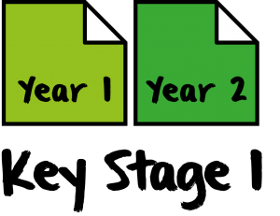
There are 7 areas of learning and development. These are split into the 3 Prime Areas and the four Specific Areas.
The 3 Prime Areas are:
- Communication and Language
- Physical Development
- Personal, Social and Emotional Development
The 4 Specific Areas are:
- Literacy
- Understanding of the world
- Expressive arts and design
Continuous assessment enables our class teachers to track each child’s individual progress throughout EYFS.

KS1 and KS2

All children from Y1 onwards are taught the National Curriculum.
The core subjects include:
English, Maths, Science, Computing and Religious Education (RE)
Foundation Subjects include:
Design and Technology (DT), Music, History, Geography, Physical Education (PE), Art and French
Other Subjects include:
Personal, Social, Health and Spiritual Education (PSHE)

All areas of the Curriculum are given status in their own right, and have had a complete overhaul in line with the New Curriculum that came into effect in September 2014. The curriculum from September 2020 has been totally revitalized and updated in line with the changes to the school structure.

In line with Government regulations, a period of 23 hours 20 minutes per week is spent on actual teaching time for Key Stage 2 children and 21 hrs 15 minutes for Key Stage 1 children.

Swimming
All of the children in Y3 and Y4 have the opportunity to have swimming lessons. The goal is for the children to be able to swim 25 metres by the end of KS2. However, children who can already swim this distance will have the opportunity to improve their strokes and skills.

Physical Education
All children participate in PE lessons, which will include aspects of dance, educational gymnastics, games, swimming and adventurous outdoor activities (walking and orienteering). Children will participate in both indoor and outdoor session. Children are expected to change for physical education lessons into a PE kit. For safety reasons, hair should be tied back and no jewellery is permitted to be worn.

Sex and Relationship Education
From September 2020, Sex and Relationship Education became statutory. However, it is a subject that can cause parents and carers concern. We deliver Sex and Relationship education as directed by the DFE, through PSHE and Science. All of the sexual aspects are taught through Science, therefore parents do not have the right to withdraw their children.

SRE is taught from Reception to Yr6 using the Jigsaw scheme of work. Parents will be invited to a meeting before this time to review the coverage. The Headteacher, Deputy Headteacher or the PSHE Co-ordinator will be pleased to discuss any aspects of PSHE and SRE with you should you so wish.

The school works closely with the Swindon Healthy School’s Team and school nursing service to provide a range of lessons and activities. The overall aim of which is to inform children so that they can make sensible choices for a healthy life.

Religious Education and Collective Worship
As we are not a church School we have no denominational affiliations. We believe in educating the children for life in multicultural Britain. RE is a core subject, each class follows the R.E. Swindon Agreed Syllabus, which the Local Authority has drawn up to comply with the 1944 Education Act.

Children will hear bible stories as well as stories from other religions in assemblies and in the classroom. Their relevance to our everyday life will be discussed. It is important to show by our behaviour that we care for others, the environment around us and our world. We encourage our children to ask questions which will help them make sense of their world.

We have whole school assemblies to help develop a sense of community and belonging. These take different forms: exploring a moral or religious theme, singing, celebrating children's work and achievements. Staff and special visitors take the acts of worship.

Out of School Activities
Teachers organise a number of clubs out of school hours. Most take place after school, but one or two are held at lunch time.

These activities vary but will usually include:
- Cycling Proficiency (Summer)
- Football
- Tag Rugby
- Athletics (Summer Term only)
- Homework Club
- Choir
- Premier Sports Clubs

Mostly, after school activities finish at 4.15 p.m. although physical activities may go on a little longer.

Charging Policy
From time to time the children will be offered the chance to take part in an activity where parents will be asked to make a contribution. These could include: day visits to places of educational interest, concerts or theatre visits either on the school premises or at an outside venue. We may ask for a contribution towards the cost of materials used in craft or cooking activities, where the children can take home the finished item. However, under the charging policy we would like to make clear:
- There is no obligation for a parent or carer to contribute and contributions are voluntary
- Pupils will not be treated differently according to whether a contribution has been made
- The school reserves the right to cancel any proposed activity if there are insufficient contributions

Educational Visits
During the year, all the children will be taken to places of interest and enjoyment connected with work they are doing at school. We actively encourage as many first hand experiences as we can, as we believe that this is the route to meaningful learning and motivated children. We are, however, aware of financial restrictions and limit visits to a maximum of two a term - keeping costs to a minimum whenever possible.

Legally we have to use the term ‘voluntary payment’ when asking for payment from parents which is very misleading, as without payment, trips are not able to go ahead. If your child receives pupil premium we are able to help your costs. Please see a member of the school office, or the Headteacher to discuss your concerns early. We will always do what we can to help our families.

Transfer to Secondary School
Our children in Yr. 6 have a range of Secondary Schools to apply to:
Lydiard Park Academy (formerly Greendown Community School)
The Ridgeway School, Wroughton
Commonweal
Abbey Park School
The Royal Wootton Bassett Academy
The Deanery
Swindon Academy
Regional Grammar Schools

Meetings and opportunities for parents and children to visit each school are held during the autumn term preceding your child's admission. Every help will be given to parents by the school in making this important decision.

Parents and School
We value the close working relationship we have with our parents. In order that this partnership is as effective as possible, we begin our contact with the children from the age of three when they begin to attend pre-school – the children regularly visit school and our teachers regularly visit pre-school.

All meetings with the Head Teacher and the Deputy Head Teacher are by appointment only, therefore it is unlikely that Parents will be able to just ‘drop in’. Please see the class teacher first. If the class teacher feels that a senior member of staff needs to be involved then an appointment will be made.

We wish you as parents to have very high expectations of us as a school, in serving your children with the very best education possible and in turn to offer your commitment in supporting your child's learning.

On a week by week basis parents can become involved in their child’s homework To ensure parents feel confident to do this, evening and daytime workshops are offered from time to time highlighting different curricular areas, helping parents to gain an insight into aims, objectives, classroom organisation, progression, resourcing and delivery of various subjects.

At parent discussion interviews during the Autumn and Spring, you will be given an opportunity to share the targets set for your child and also an opportunity to discuss your child's progress. In July, the end of year report is sent home.

Our first priority is your child’s welfare and therefore there may be occasions when our concern about your child means that we have to consult other agencies

before we contact you. If you want to know more about this procedure, please speak to the Head Teacher who is the designated lead Child Protection Officer.

Finally, parents can offer support by helping in school. We welcome parents to assist with the library, cookery, listening to readers, accompanying visits, swimming and working in classrooms. Training will be offered and all help will be greatly appreciated. If you are unable to spend time in school during the day, perhaps you would like to assist with fund raising or serving on the Friends of Westlea Committee itself.

School Grounds
During the life of Westlea School a lot of thought, effort and expense has been put into developing our school grounds. Teachers use the grounds extensively in their lessons. We are constantly looking to develop and enhance our environment.

Dogs
Dogs are not allowed on the school premises or on the school field.

Smoking

The Governors of the school have made Westlea School a No Smoking environment. Therefore it is illegal to smoke anywhere on the school property.

Bikes and Scooters
We try to encourage as many children to walk to school. Children are also able to ride both bikes and scooters, but must dismount at the school gates and walk them on to the premises. Parents are responsible for the child’s safety when riding to and from school. Children should wear a helmet and the bikes/scooters need to be regularly maintained and in working order. Motorised scooters,
boards and bikes are not permitted on the school site for safety reasons. The
children should lock their bike/scooter in the bike shed and the school does not take any responsibility for any loss or damage.

Conduct on the School Site
Please note we do not tolerate abusive language or behaviour from any parent on our school site. We will aim to sort any concern or issue you may have. We have the right to ban parents if their conduct is not acceptable from our site.

GDPR
GDPR came into force on 25th May 2018 and Westlea is working fully compliant. The DPO is outsources to an external company School Pro TLC.
Bad Weather/Academy Closure Information
During extreme weather, school will keep parents informed via our text service. Information will also be posted on our website. It is vital we are informed if your mobile number changes.

Discipline Procedures
Our main aim is to encourage self-discipline, consideration and respect for other people and for property. We have few rules and our main aim is to ‘treat others as we would like to be treated’. The rules we have relate mainly to safety, respect and leading by example.

A high expectation of good manners and courtesy prevails through the school at all times. When necessary, punishment, which usually takes the form of a reprimand or the withdrawal of a privilege, is administered by a teacher, a senior member of staff or the Head Teacher. If there is concern regarding a child's behaviour the parents are invited into school to discuss the problem.

Complaints Procedure
Please see our complaints policy on our website. The first instance is always to talk to the teacher, then the Key Stage Leader/SENCO, then the Deputy Head (by appointment only) and finally the Headteacher (by appointment only).

Always make an appointment with the class teacher in the first instance if you want to discuss something important.

Equal Opportunities Statement

At Westlea School, we believe that all individuals are equal and are therefore equally valued. All pupils will be offered equal opportunities and learning experiences whatever their sex, ability, ethnic background or social circumstances and we will continually seek to develop their self-image, self-esteem and self-confidence.

The school is physically designed for equal access and all materials, such as reading books and classroom equipment will reflect our policy of equal opportunity, ensuring no child is discriminated against.

Any incidence of racism, homophobia or sexism will be dealt with immediately, both on a personal level and through whole school discussion. It is the school's expectation that all parents and staff will fully support school policy through their own actions, expectations, attitudes and life-styles in school and at home.

Equality of opportunity will naturally be offered to all staff and this is reflected in the school's clear practice that every member of staff is equally valued and respected and no hierarchy therefore exists in terms of individual importance.



