Monday | Guided Reading  Please read the text below |  |  | English  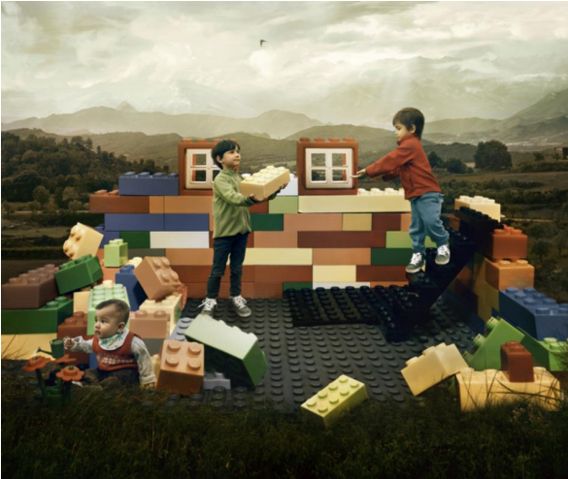  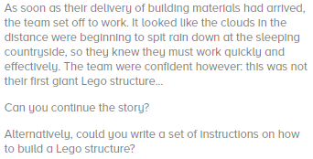 |  |  |  |  |  |  |  |  |  |  | PE  Re-cap the five steps. 1st, 2nd, 3rd, 4th and 5th and your Plie’s.  https://www.youtube.com/watch?v=dcjPEo_R3xg&safe=active  Please watch the video above. You are going to teach yourself how to perform Port de bras combination. This movement is very beautiful and requires a lot of concentration. You also need to control your breathing whilst performing a port de bras. Keep trying stopping and starting the video until you feel confident that you can perform the whole thing from start to finish.  DT  This week and next week are a challenge – using things you can find in your home or garden design a shelter that you could get into/ under. This week is about designing it, next week you will build your shelter! You can use anything – table, chairs and a sheet, clothes airer and blanket, tree and bin bags.
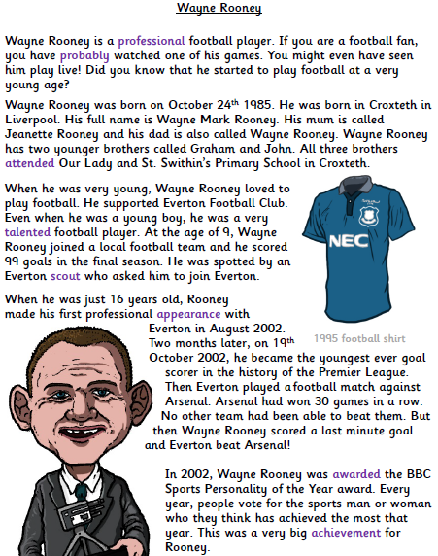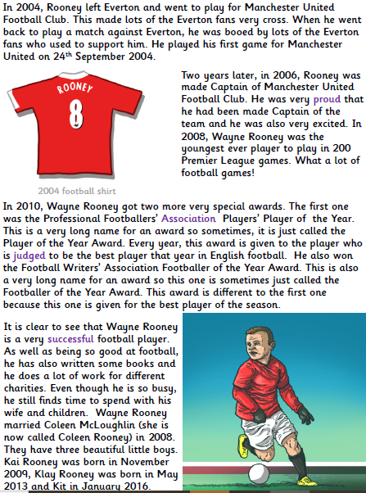
Miss Webster and Mrs Batchelor Maths Please complete these questions in your book.  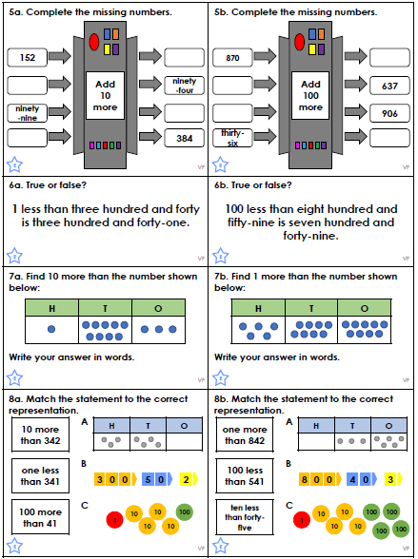  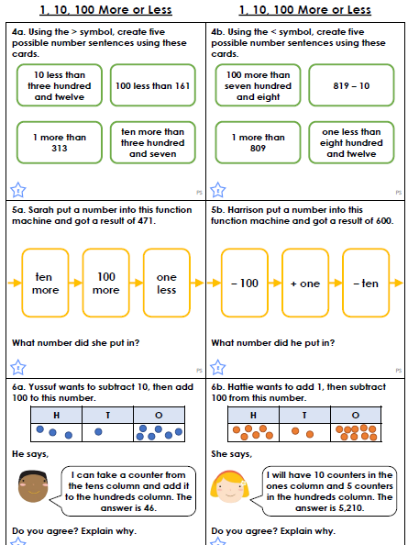 |  |  |  |  |  |  |  |  |  |  |  |  | Mr Bagley Maths  We are going to answer some questions about properties of shape to get further in depth with them.
Tuesday | Guided Reading  Please answer these questions about the text you read yesterday.  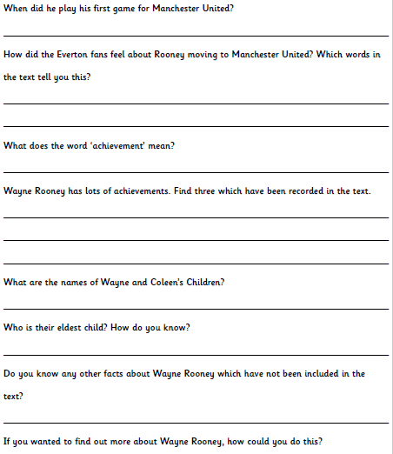 |  |  |  |  |  |  |  | English  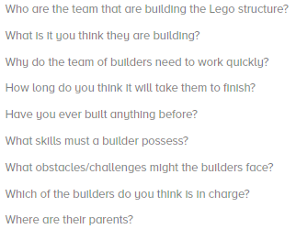
Science
Today we are going to be looking at Electromagnets.
What is an electromagnet?
A magnet is a special type of object. It produces an area of magnetic force around itself, called a magnetic field.​
If certain materials enter this magnetic field, they will be attracted to the magnet. This will cause the materials to stick to the magnet.​

An electromagnet is powered by electricity. It is a temporary magnet that only works when electricity is flowing through a wire.​
Copper wire is coiled around an iron rod. Both ends of the wire are connected to a power source, such as a battery. ​When the wires are connected, electricity flows through the wire. The iron rod and the coils of wire will become magnetised and the electromagnet can be used to attract magnetic materials. When the connection to the power source is broken, electricity no longer flows through the wire and the iron rod and coils of wire lose their magnetism. The electromagnet will not attract any magnetic materials.​

The first electromagnets were created in the 1820s. Several scientists contributed to the discovery of electromagnetism and developed its use. Other scientists have since refined and adapted the original electromagnets to make full use of their power.​

Using the internet can you locate as much information about the first electromagnets and then cut information and put them in order to create a timeline.

Miss Webster and Mrs Batchelor’s Maths –  Please complete these questions in your book.  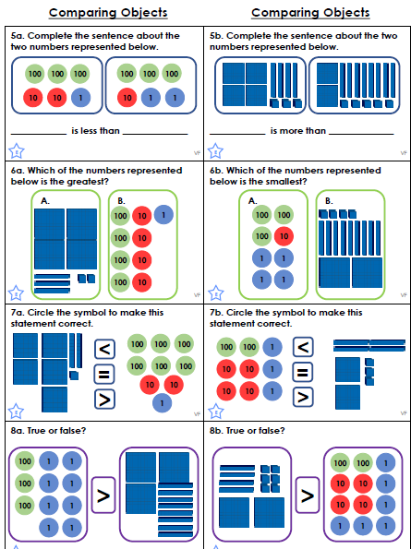  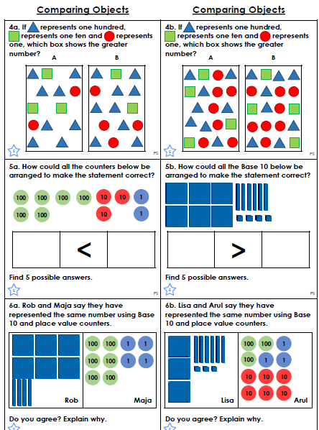 |  |  |  |  |  |  |  | Mr Bagley’s Maths  Please complete the following questions, these are continuing from yesterday.
Wednesday |  |  | Guided Reading |  |  |  | English  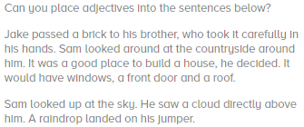
Different groups of people had different experiences of the war. For Jewish people and other groups, like gypsies and the disabled, the war was even harder than it was for everyone else.
Re-write the story of Anne Frank in your own words. Could be in paragraphs, a timeline, poster…
Miss Webster and Mrs Batchelor’s Maths –Please complete these questions in your book.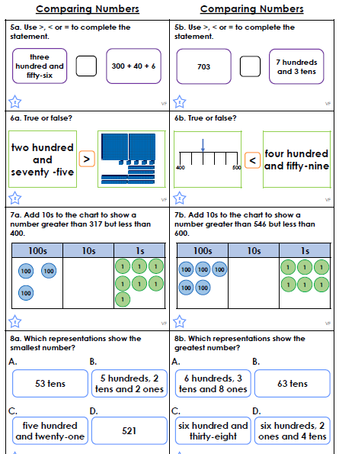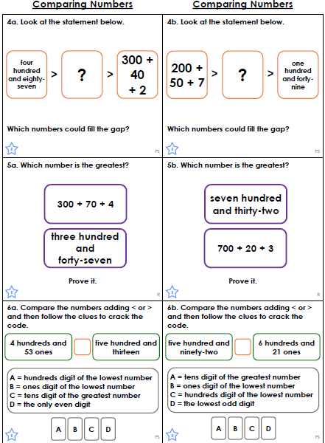 |  |  |  |  |  |  |  |  |  |  | Mr Bagley Maths  Answer the questions below.
Thursday |  | Guided Reading  Please write the sentences below in your book.  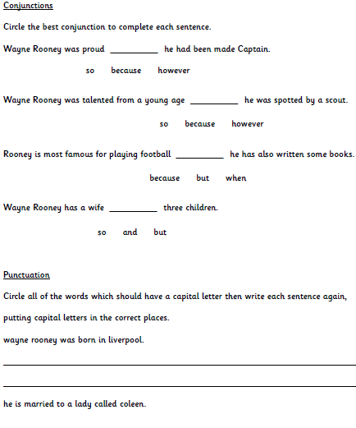 |  |  |  |  |  |  |  |  |  | English  Draw a picture of what you think the Lego House would look like when it’s finished. Be as creative as you like! |  | Music  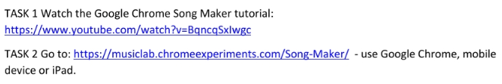  Look back at what you composed last week, can you improve what you have done or add to it.  Computing  Thank you for your posters for staying safe online.  If you haven’t sent one in, please do as your work could make it on display for everyone in the school to see!  Make a poster – using Purple Mash, pen and paper, or any other app on your computer/tablets – all about your most favourite thing to do using technology. Consider how you stay safe whilst doing so and include those safety tips on your poster.  It’s been so lovely reading lots of your emails on Purple Mash and seeing pictures of your work or generally what you’re getting up to at home! Keep sending them as I love seeing what you’re doing; it makes me smile to know that you’re all happy and keeping busy!
Miss Webster and Mrs Batchelor Maths Please complete these questions in your book.  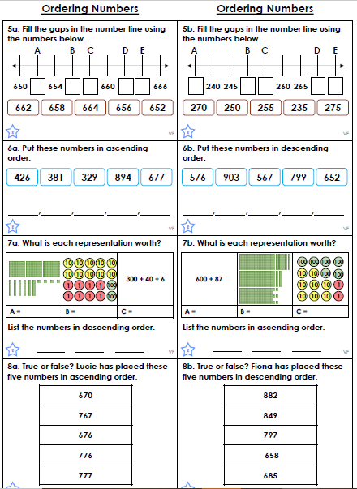  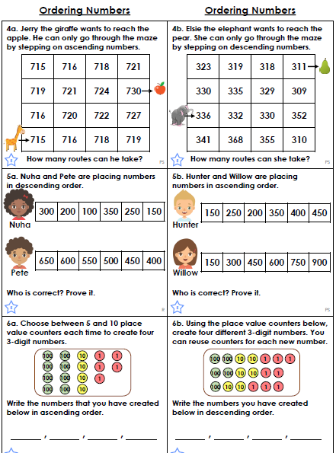 |  |  |  |  |  |  | Mr Bagley Maths  Please complete the follow question about symmetry.
Friday | French  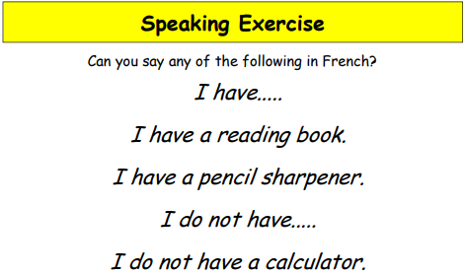  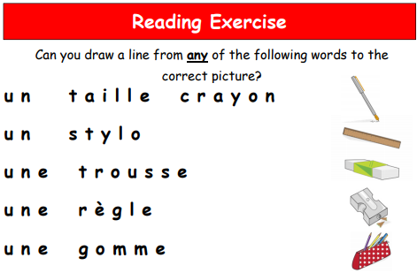  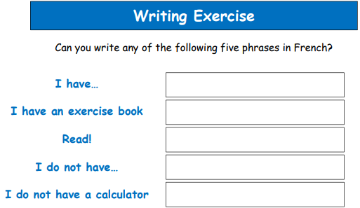 |  |  |  |  | English  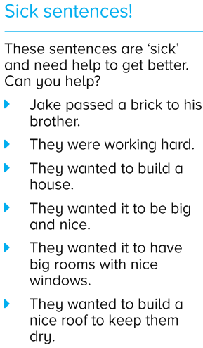 |  |  |  |  |  | PSHE  I would like you to complete the follow questions. Once you have put your answers in place, go and talk to a trusted adult in your home about what you have put and why you have put that.  RE  Jesus’ teachings about worship.  Mark 4:21-25 - Jesus said to let your light shine, don’t hide it.  Matthew Ch 6: 5-7 “When you pray, don’t be like the hypocrites who love to pray publicly on street corners and in the synagogues where everyone can see them. I tell you the truth that is all the reward they will ever get. But when you pray, go away by yourself, shut the door behind you, and pray to your Father in private.  In your books answer the following questions:  What do you think about what Jesus was trying to say in each of the two situations?  What do they tell Christians about the importance of going to church?  Which one would you agree with Mark or Matthew? Why do you agree with that one and not the other?
Miss Webster and Mrs Batchelor Maths - Please complete these questions in your book.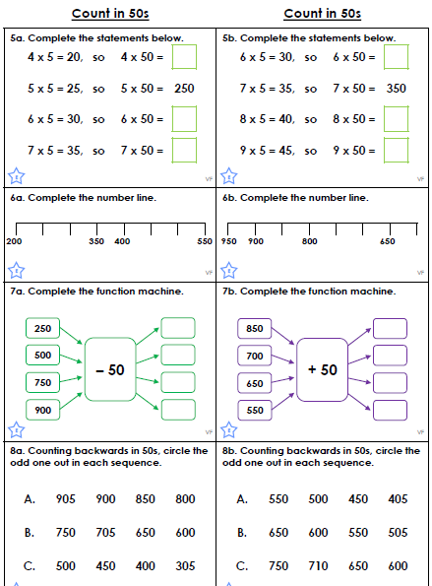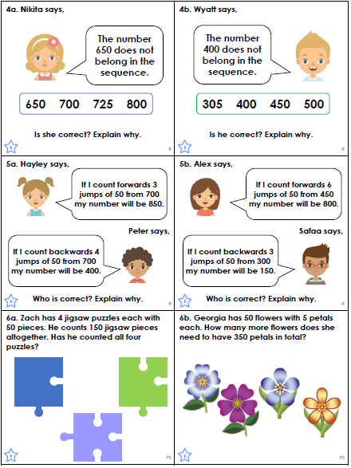 |  |  |  |  |  |  |  |  |  | Mr Bagley Maths  Time for an easier Friday. Let practise our times tables.

- You should be reading at home at least three times a week and filling in your reading record. You can choose the book you would like to read as well.
  - Read to a grown up, read to a sibling, read to one of your toys, read to a pet, read to yourself.
  - Can your parent ask you some questions about what you are reading, either before, during or after you have read?

- You should be practising your times tables at least three times a week.
  - Write them out in order
  - Write them out, out of order
  - Listen to songs on YouTube
  - Play games online (eg Hit the Button)
  - Make up your own songs

