Monday | Guided Reading  Read chapter 5 | English  Watch this short film:  https://www.literacyshed.com/shirtmachine.html  Answer these questions in your books, giving reasons for your answers:  - Do you think the machine is a clever invention?  - Would you want a shirt of your own?  - Which shirt would you choose and why?  - If the Shirt Machine was your own invention, would you do anything differently?  Write a series of questions that you would like to ask the Uncle about the machine  .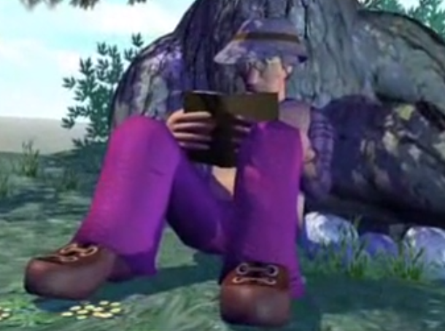  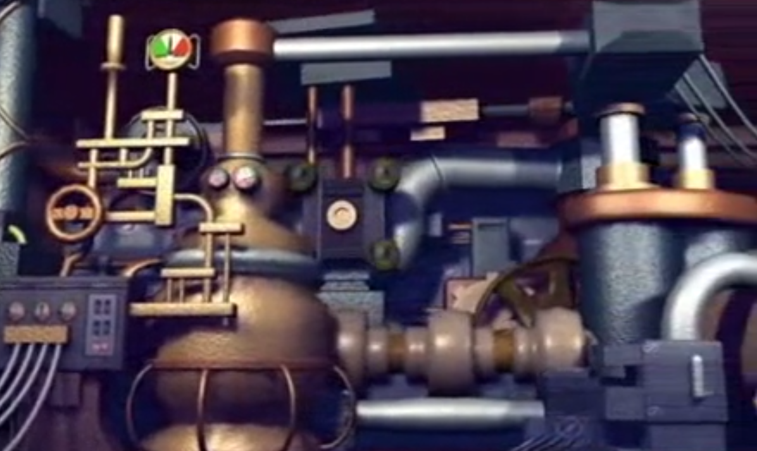  Try to think of some open questions that require a more detailed answer.  Some sentence starters to help:  - Who  - Where  - When  - What  - Why  - Have you…  Questions need a question mark at the end instead of a full stop. |  | PE  Warm up – 15 star jumps, 10 squats, 10 arm circles, 15 high knees.  You have 4 balls, 6 cones and 2 skipping ropes – create your own game, including instructions on how to play and if you can play with a member of your household.  Art  This week you are looking at planning your own story book – you can write a new story or use one you already know. Complete the plan below.  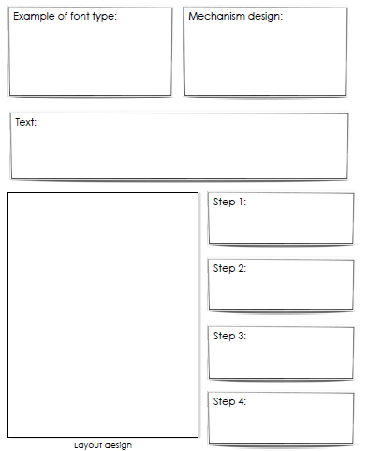
Miss Webster and Mrs Batchelor Maths  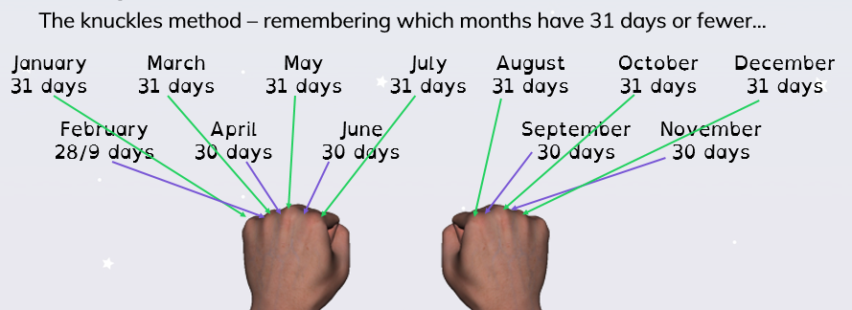  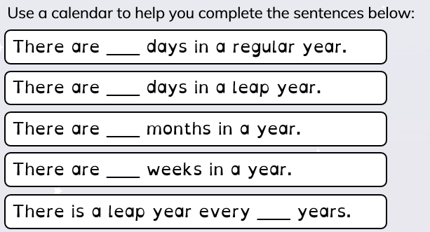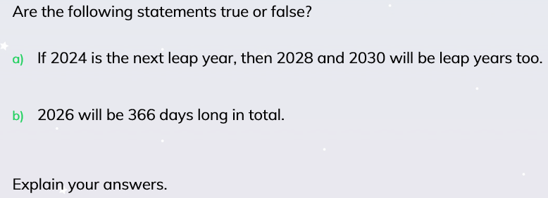  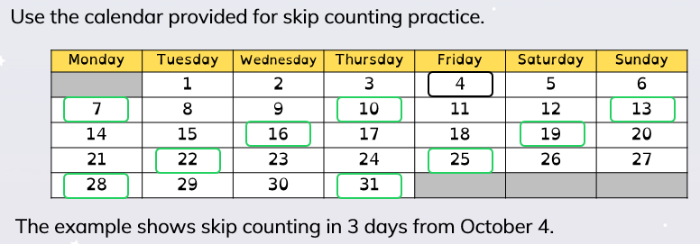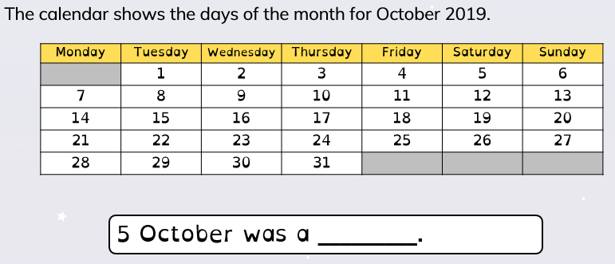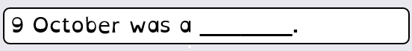  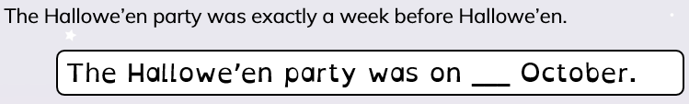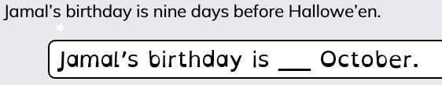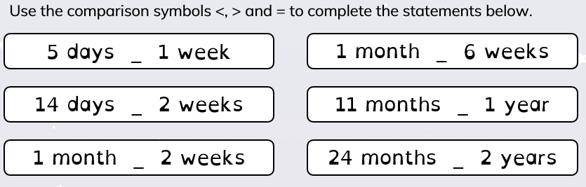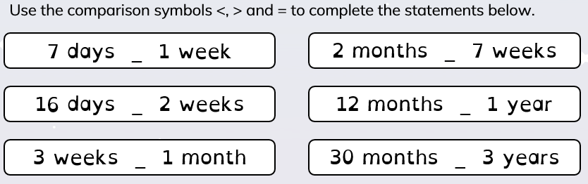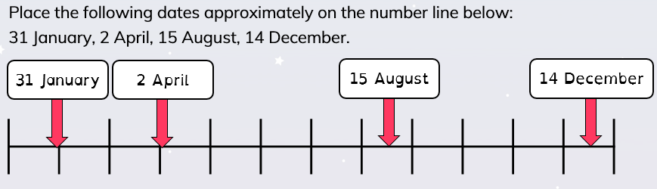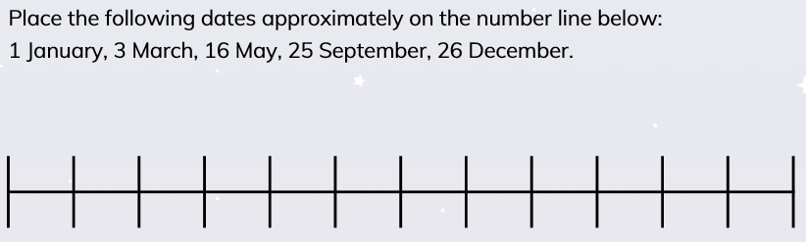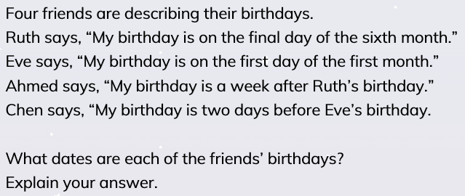 |  |  | Mr Bagley Maths

Tuesday | Guided Reading  Read chapter 6. | English  Take another look at the Shirt Machine. What does it look like? Think about all of the different parts that make the machine.  The Shirt Machine made the Edible Shirt, Flying Shirt, Invisible Shirt and Musical Shirts. What will your machine design?  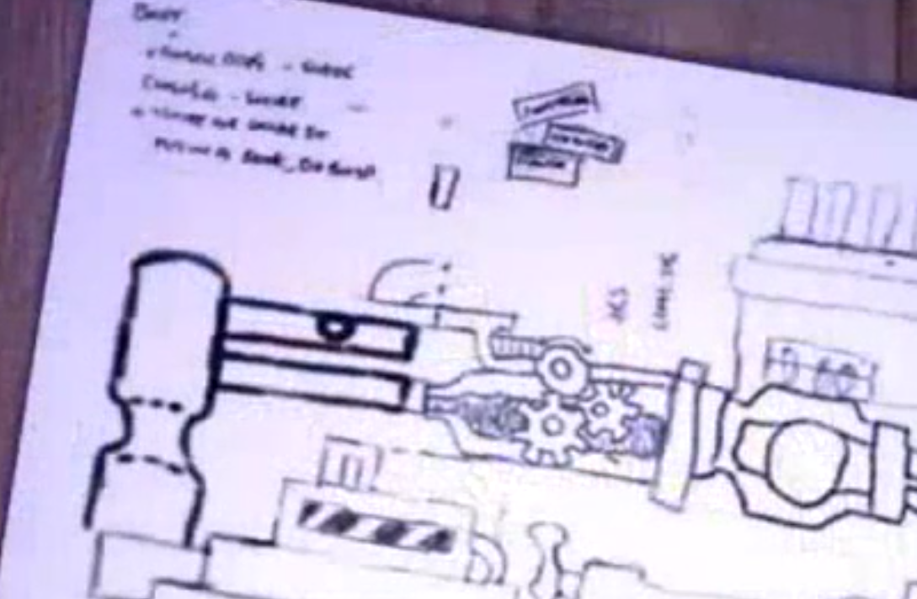  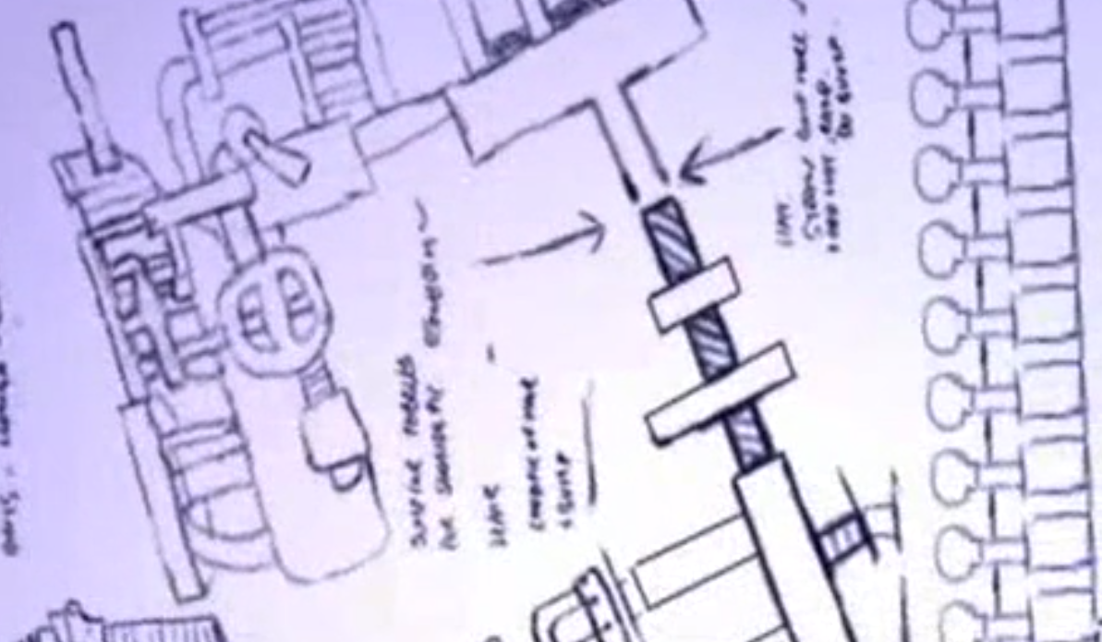  Design your own clothing machine similar to the Shirt Machine.  You could create a machine that makes socks, trousers, shoes, jumpers or shorts. Choose 1 type of clothing to focus on.  Draw what it looks like and add labels to describe what the different parts look like and do. You can even colour your machine in.  There are some words you could use at the end of this plan! |  | Science  Read through the Fantastic Flowers information.  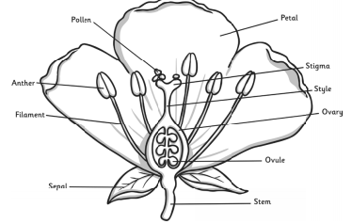  Draw this picture in your books.  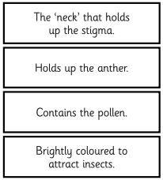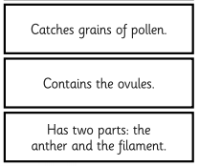  Match the parts of the flower to the job that they do.  At the end of this plan you will find the Pollination Process. Put the sentences into the right order and write them into your books.
Miss Webster and Mrs Batchelor’s Maths –  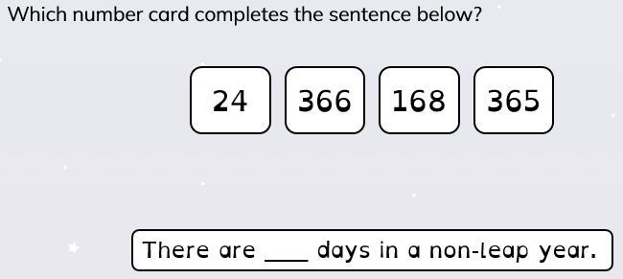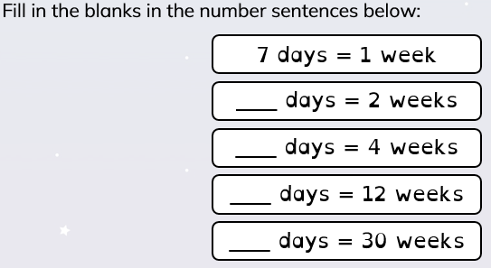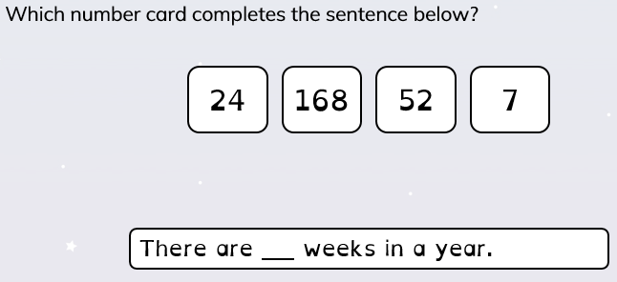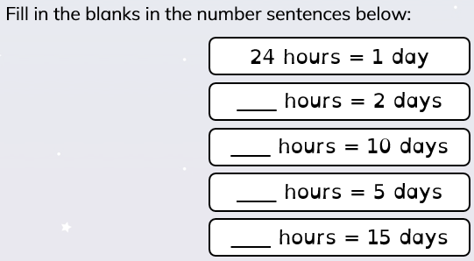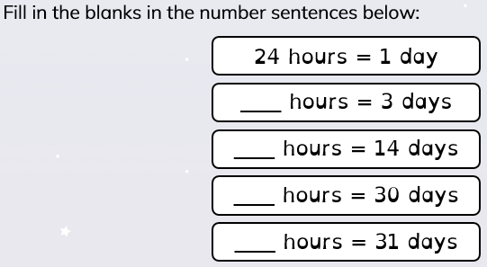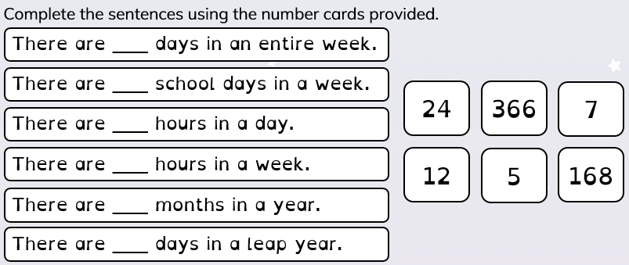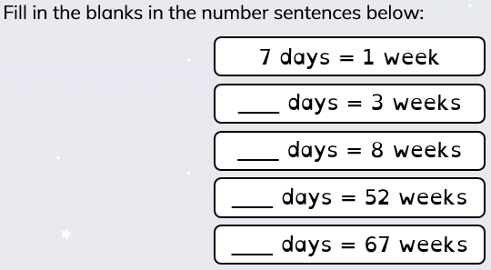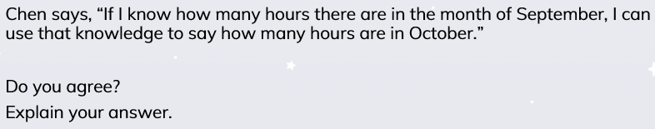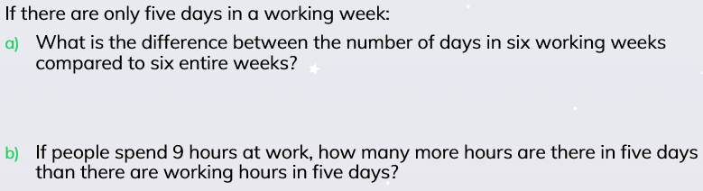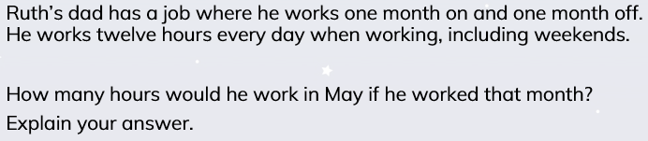 |  |  | Mr Bagley’s Maths

Wednesday | Guided Reading  Read chapter 7. | English  Look back at your clothing machine. Think about how your machine actually works.  You’re going to be writing an explanation about how your clothing machine works. First you need to write some instructions.  Important features of instructions:  - Title – How to…/How the…  - Equipment list  - Numbered list  - Chronological order  - Imperative verbs (bossy verbs – put/switch to start a sentence)  Use these features to write your set of instructions about how your clothing machine works. Write in numbered steps that go in the order they need to be done.  Include as much detail as you can. Imagine you’re writing instructions for an alien and you want them to use the machine correctly! |  | Topic  Use the ‘Saving the Rainforest’ information at the bottom of this plan and any other information that you can find to answer these questions:
Miss Webster and Mrs Batchelor Maths  Today we’re going to re-cap telling the time to the nearest 15 minutes.  Look at the times on the clocks below and write your answers in to your book.  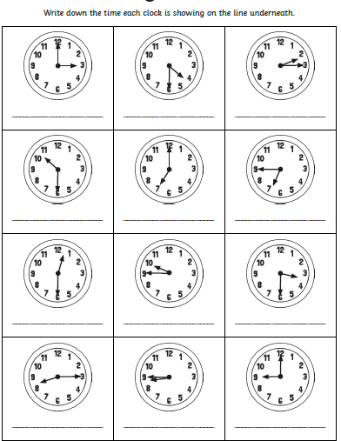  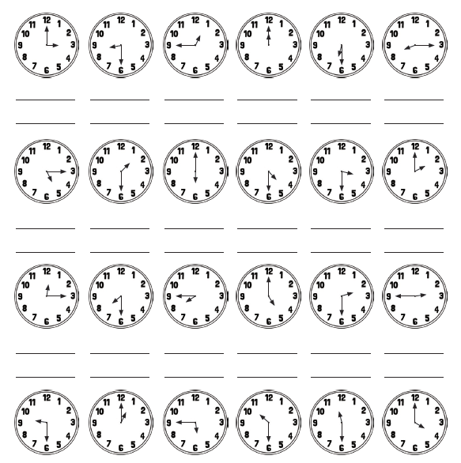 |  |  | Mr Bagley Maths  Using the example of a day, write your day up in words specify what you have been doing that day.

Thursday | Guided Reading  - What did you like/ dislike about his book?  - Would you recommend this book to a friend? Why/not?  - Imagine you are a book rep. You want the local bookshop to stock this book and you need to persuade the shop owner to buy it. Write a script. | English  Create some expanded noun phrases to describe the appearance of the Shirt Machine.  Expanded noun phrase - A noun phrase expanded by the addition of modifying adjectives, nouns or preposition phrases.  Noun - A naming word for things, animals, people, places and feelings.  Adjective – A word which describes a noun.  Prepositional phrase - A phrase which usually includes a preposition, a noun or pronoun and may include an adjective. It does not include a verb. An example would be ‘beneath the duvet’.  If you want to use more than 1 adjective, use a comma to list them (shiny, silver pipe)  Choose a noun  - Pipe  Think of adjectives  - Shiny  Expanded noun phrase = shiny pipe  Add a prepositional phrase  - under the rectangular switch  = The shiny pipe under the rectangular switch.  How many interesting sentences including expanded noun phrases can you come up with? |  | Music  This week is your choice – choose a song you like and answer the following questions about it.  1. Does the music tell a story?  2. What musical instruments can you hear?  3. What do you think the style of the music is?  4. How does the music make you feel?  5. Do you like the song and why?  Computing  You have been set 2do’s on purple mash.  Can you use the 2email app to send someone in the class an email?
Miss Webster and Mrs Batchelor Maths  Today we’re looking at telling the time to the nearest 5 minutes. Use the diagrams to help you and write your answers in your book.  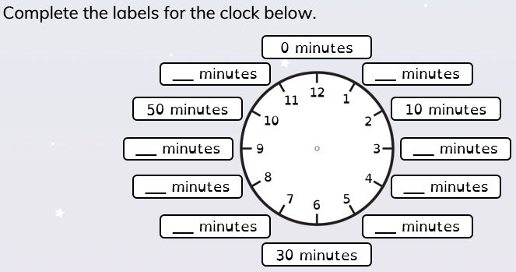  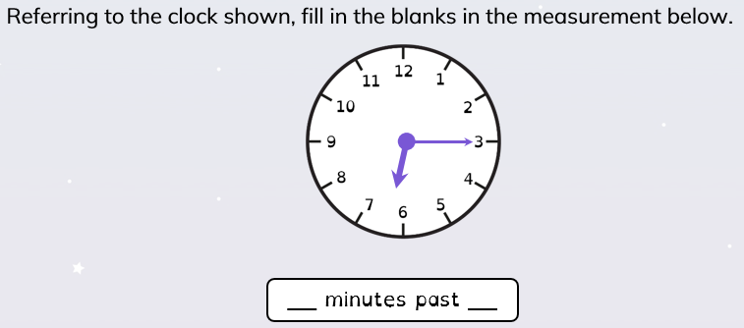  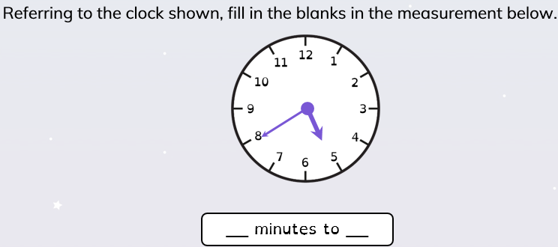  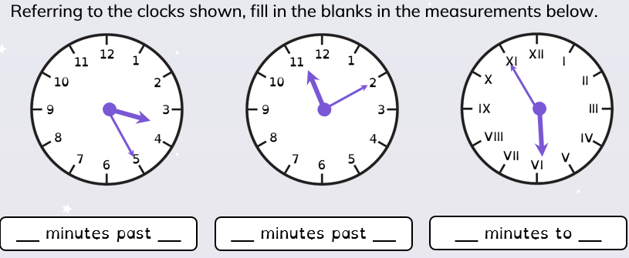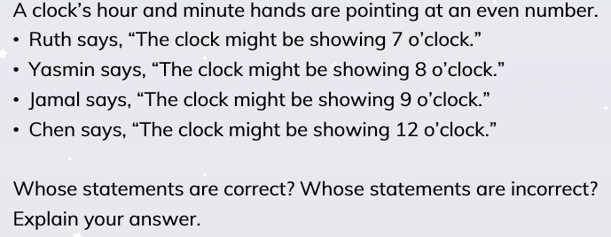 |  |  | Mr Bagley Maths

Friday | French  Use these French family words, or use the words you have learnt in the past few weeks. Draw your family tree, labelling who is who, in French, just like this one.  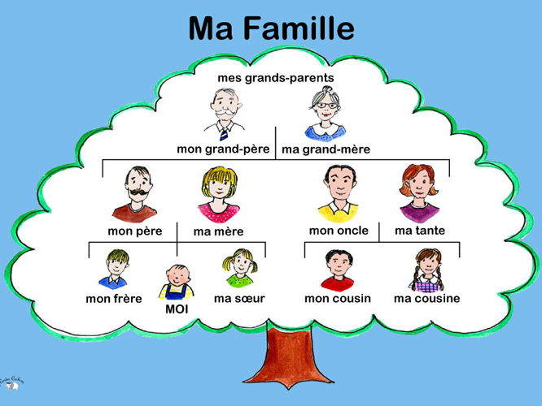  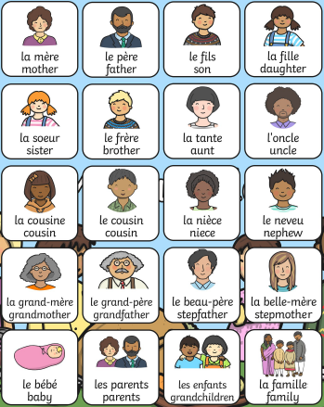 | English  Write an explanation about how your machine works. You might want to think about who created it and write a bit about them like the Shirt Machine spoke about the Uncle.  You’ll need to explain what the machine looks like, what it’s made from, how it works and what it makes.  Write in full sentences using capital letters and full stops.  You could include some pictures and diagrams of your machine, maybe draw specific parts to ensure the alien knows what you’re talking about.  Include expanded noun phrases to add detail and description.  Should be a detailed explanation, explaining to an alien/anyone else how your machine works in chronological order. |  | PSHE  Think about someone or a pet who is special to you.  Still thinking about this person write down the following things:  - A colour that reminds you of them  - A word that reminds you of them  - A symbol that reminds you of them  RE  Think back to the work you have previously done about Christianity and use the research you have done over the past few weeks about Judaism to compare the similarities and difference between the celebrations observed by each religion.
Miss Webster and Mrs Batchelor Maths  Today we’re looking at telling the time to the nearest minutes. Use the diagrams below and write your answers in your book.  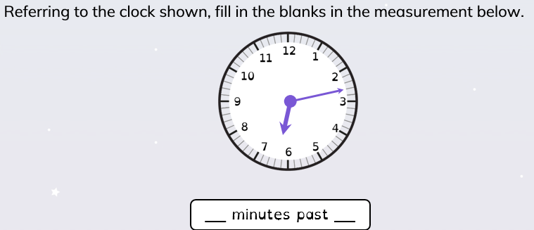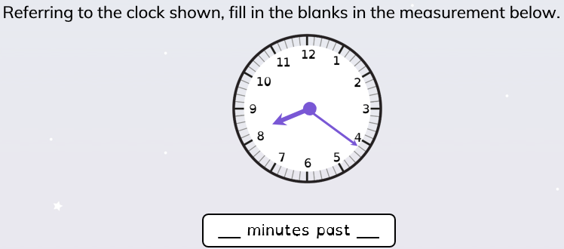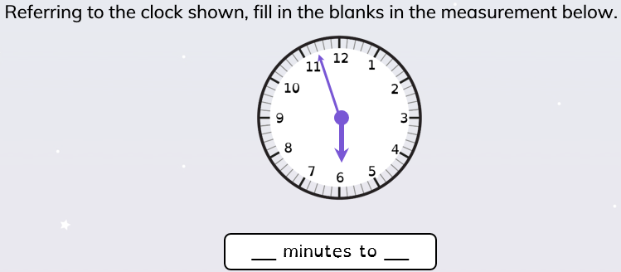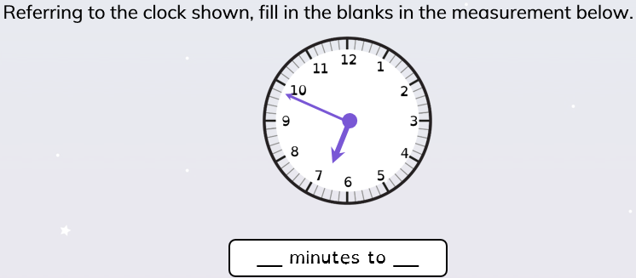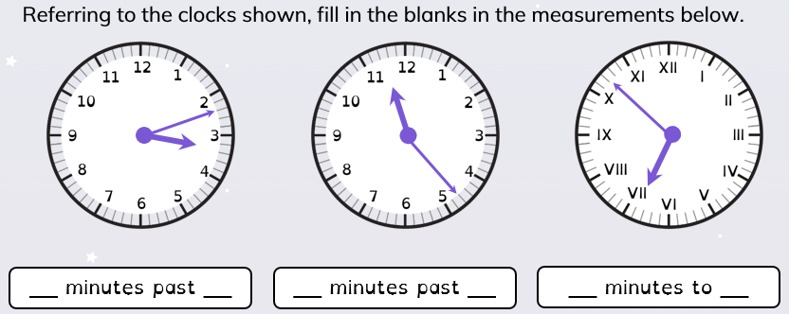  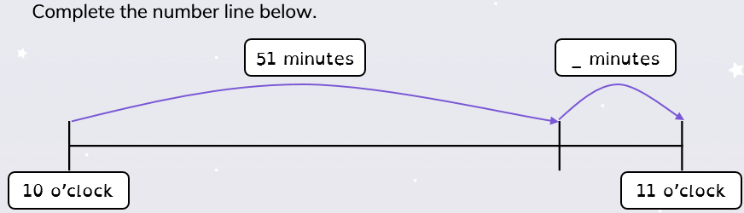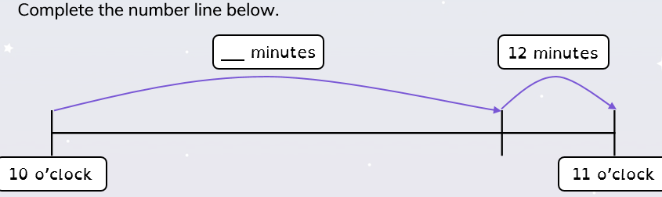  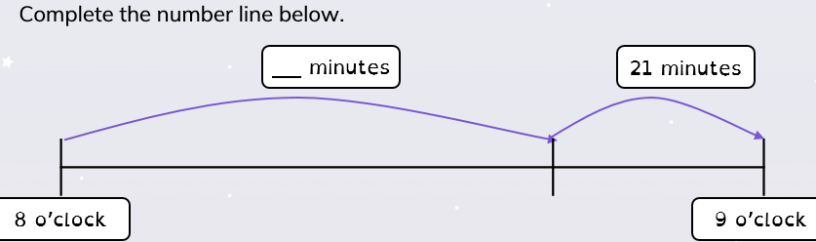  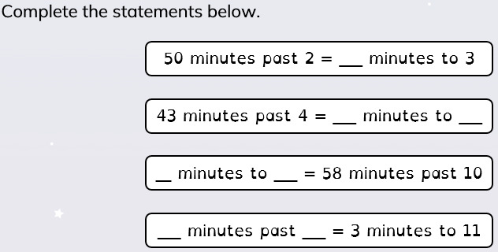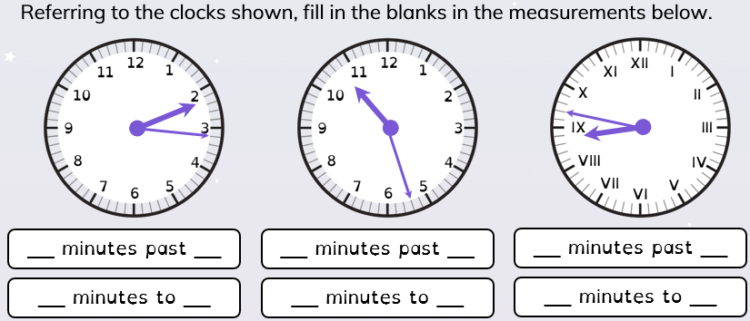 |  |  | Mr Bagley Maths

The Pollination Process  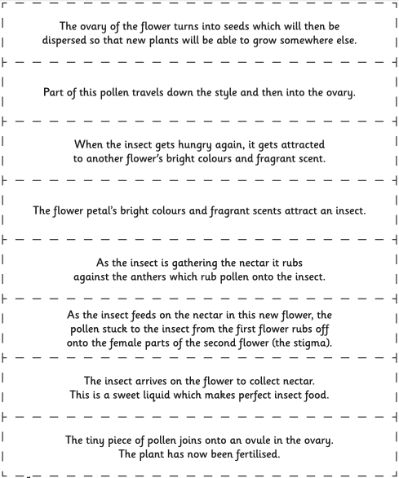 | Answers!  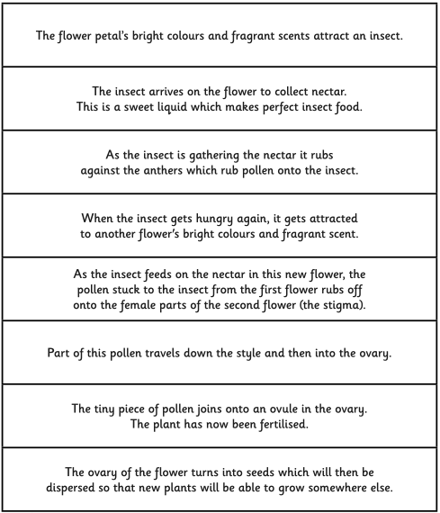
Topic  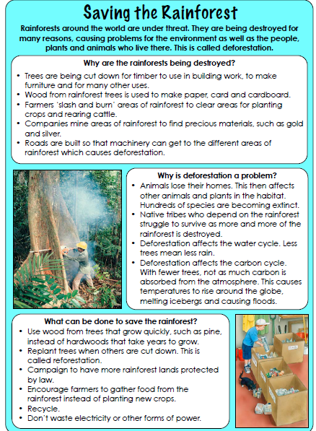 | English  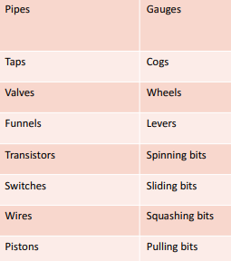  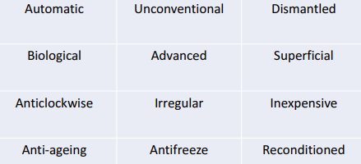  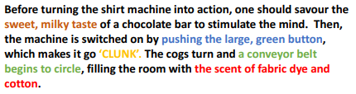

- On spelling shed I have uploaded common misspelt words and have assigned them to you. You are required to complete this three times a week.
- You should be reading at home at least three times a week and filling in your reading record. You can choose the book you would like to read as well.
- You should be practising your times tables at least three times a week as well. I have helped by putting this on to purple mash for you. This will be updated weekly with a new timetable.

