Mrs Mathias’ year 1 homework plan.
Dear children
I hope that you are all well and are staying safe. It has been a while since we all saw each other and I bet you have all grown lots.
I have been reading lots of books and hope to share some of the stories with you. It would be wonderful if you all had a story that you could share with someone.
I have included work for both year 1 and year 2 this week for English. If your child is with Miss Rew for maths they should be following the maths work from Miss Rew which is different to what my maths group are currently working on.
Take care
Mrs Mathias

Monday
English
This week we are going to look at comprehension
Take a look at the picture below and talk to an adult about what you can see or what you think is happening.
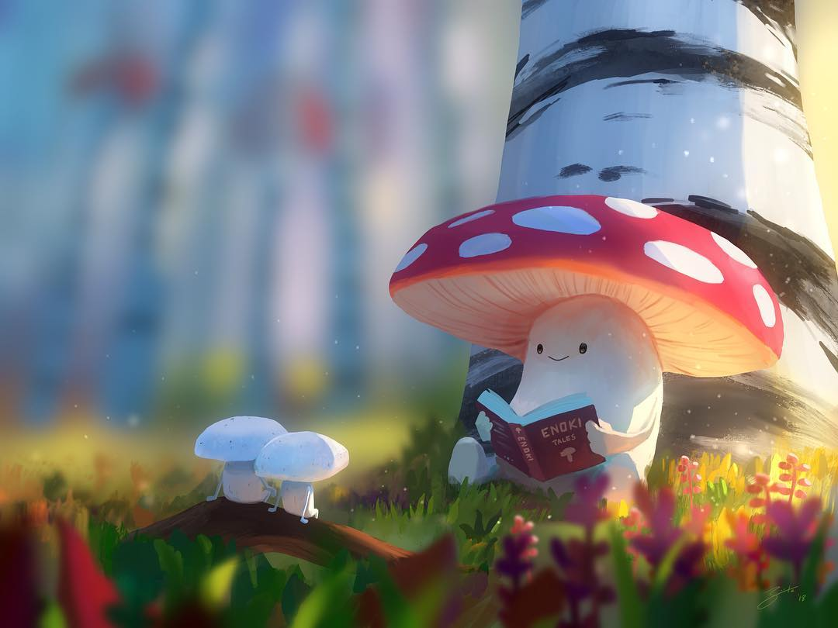

Maths
This week we are going to do some more work on directions.

Can you remember which way is clockwise and which is anti-clockwise?

Music
Go outside and listen to see what magical sounds you can hear.
Can you hear the birds singing?
Can you hear the wind rustling through the leaves?
Can you hear branches creaking?

Your task today is to try and recreate what you can hear outside. You can make an instrument from bottles, rice, pasta or use pots and pans. Have fun and see what you can create.

Story time
Snuggle down and read a story

Tuesday
English
Look at the picture below and have a go at answering the questions in your book.

Year 1
What is happening?
Where are they?
Do the smaller mushrooms know the larger one?
What do you think might happen next?

Year 2
What is happening?
Have they done this before? How do you know?
What is the larger mushroom reading? What kind of thing might you find in this book?
Write a story that you might find in the book.

Maths
Have a go at the below game with a partner. It can be with an adult or brother or sister.

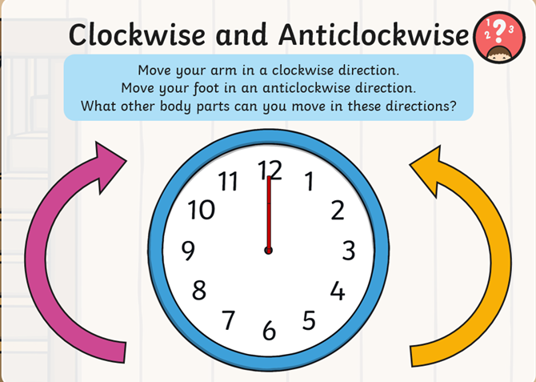

ICT
Over the last 2 weeks we have been looking at directions.
Have a go at putting into practice what you have learnt with these direction games.

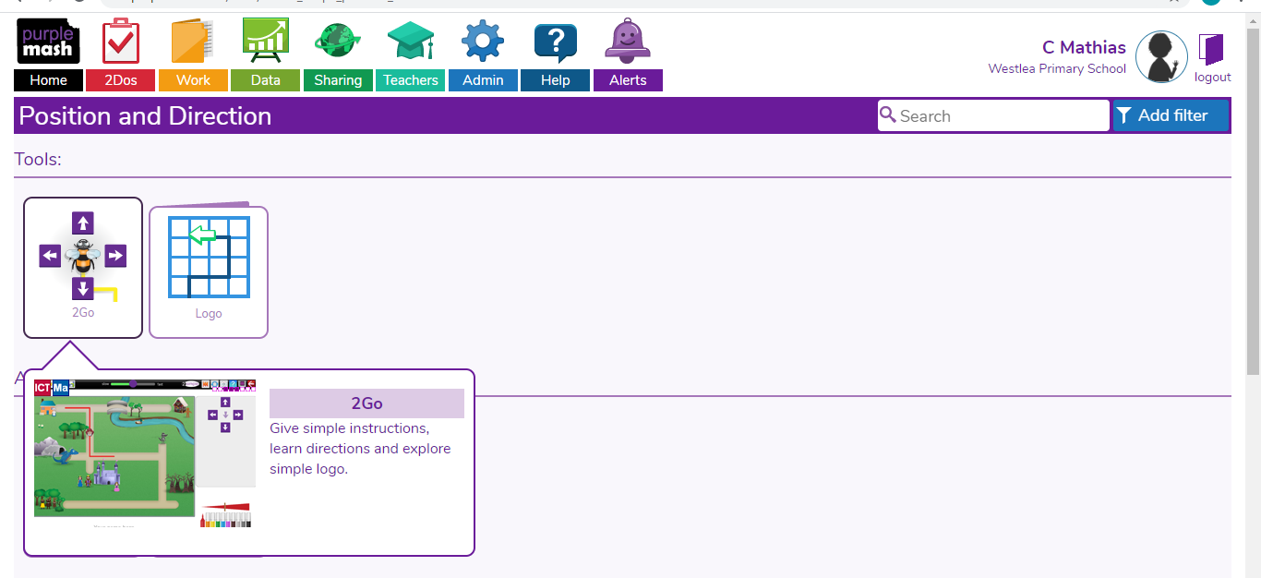

Wednesday
English
Today we are going to have a look at a comprehension activity.
Year 1
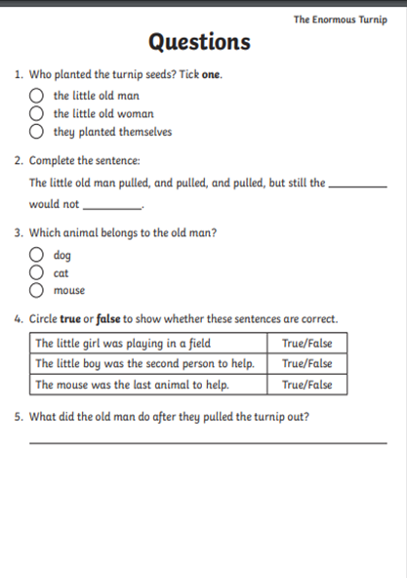

Have a go at answering the questions in your book. Just put the question number and copy the correct answer.

Year 2

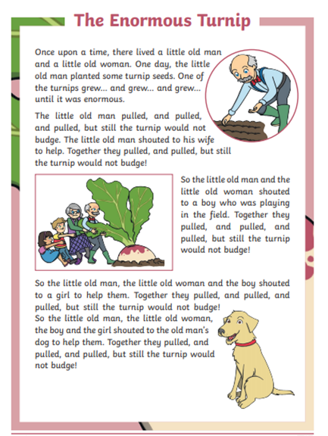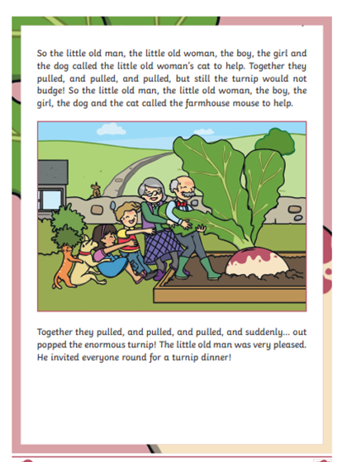

Have a go at answering the questions in your book. Your answers must be in full sentences.

Maths
Can you work out what turn has been made?

What direction has the turn been made?

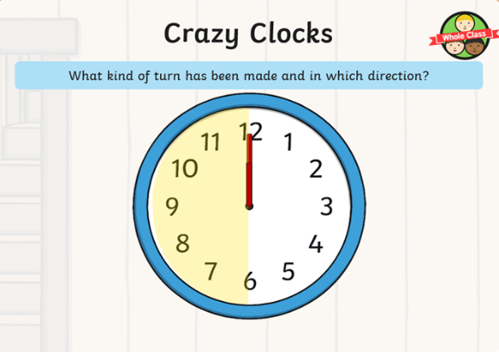

Have a practice at making different kinds of turns remembering which way is clockwise and which way is anti-clockwise.
Science
This week we are going to go on a tree hunt.
You will need a bag to collect leaves in, a pencil and a piece of paper.

There are lots of different trees around the country but we are going to hunt for trees in our local area.

Have a look for leaves that are on the floor and try identify which tree they are from. How many different ones can you find?

Here are some pictures to help you.

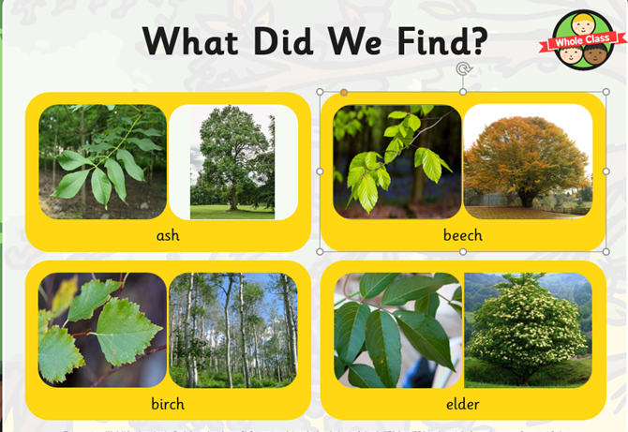

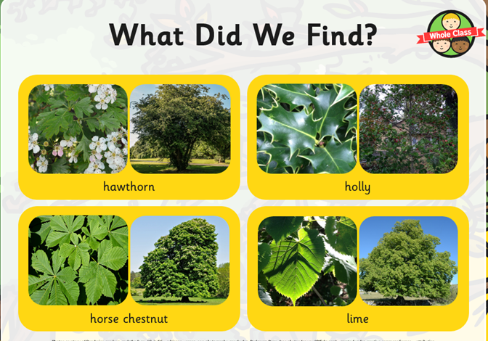

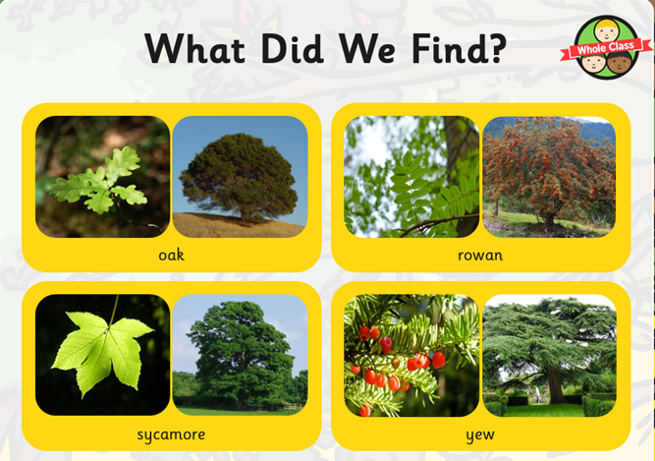

Thursday
English
Today I would like you to read a story to someone.

Maths
Can you work out what kind of turn would be made if the hand went the whole way around the clock?

Geography
Geography – Wonderful weather
This week we are going to be looking at cold countries.
What do you think it would be like to live in a cold country?

Can you find some different facts out about the artic?
What animals live there?
Do people live in the artic?
Can you find where the arctic is on a map?
Are there any other countries like the artic?

Friday
English
It’s the last day of term. Snuggle down in your pj’s and watch a movie.

Maths
Take sometime today to practice counting in 2’s, 5’s and 10’s
Do you know the times tables for these numbers?
Can you make a song up with or without actions to help you remember them?

PE
This week you can choose an exercise or activity that you enjoy.

You could go for a walk with a family member, run around the garden, make your own obstacle course, create a dance for a favourite song or kick the football around with a family member.

Spellings to practise for the week
looked
was
they
children
saw

