Year 1 home learning plan wb 6th July 2020
Dear Children
We cannot believe how fast the time is going! We only have a few weeks left and then it is the Summer holidays! It has been lovely to see that you have been emailing us! We really appreciate it and love seeing what you have been doing. We hope that you enjoy this week’s story! We really miss you all!
Take care and stay safe
Mrs Blewett and Mrs Mathias
Please note: Please check any you tube links given before your child watches them. Sometimes the adverts are unpredictable.

Monday 6th July 2020
English
The Tin Forrest by Helen Ward & Wayne Anderson
Listen to the story.
https://www.youtube.com/watch?v=_j_XPFxy5js&safe=active

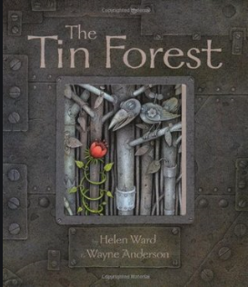
What did you think of the story?
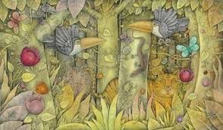
Look at the picture. What is happening? What can you see? Write about the picture.
Maths
This week we are going to take another look at time.
Can you tell the time to O clock?
Art and Design
Collect together some junk materials for junk modelling. Create an animal of your choice using junk materials. Take a photograph of it and it email it for us to see.
Or
Paint a picture of the rainforest from the story!
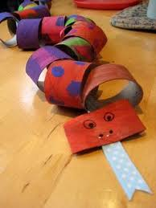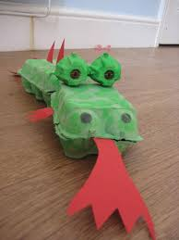

Tuesday 7th July 2020
English
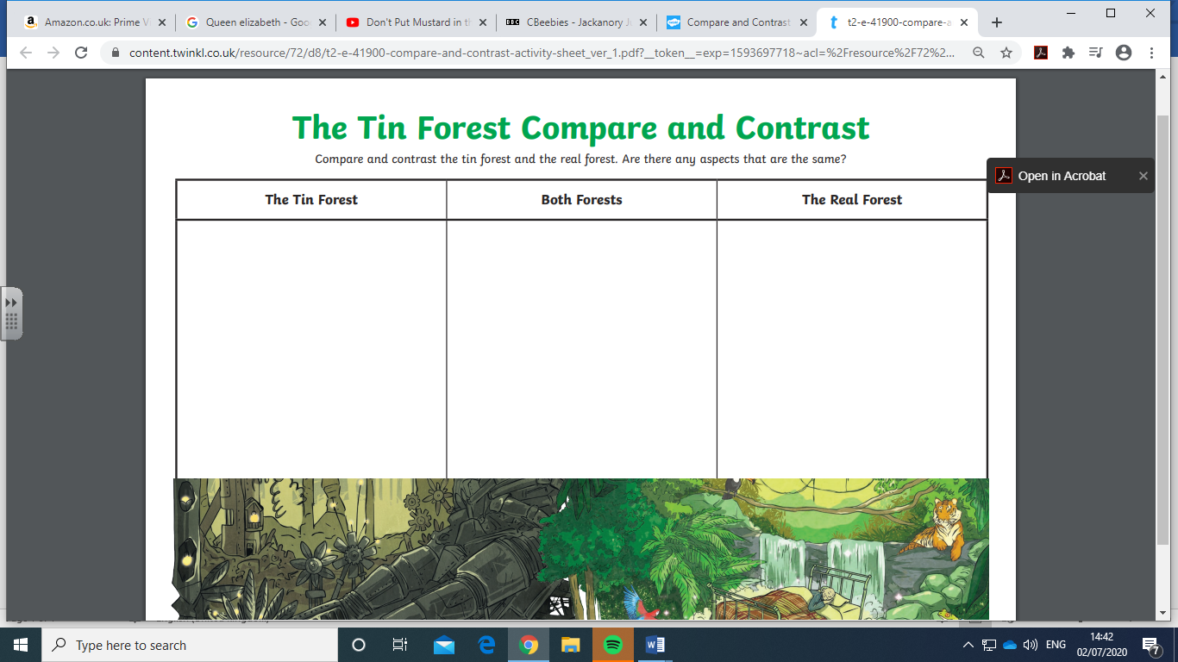
Maths
Can you tell the time to half past the hour?

(You can enlarge these on the word document)

Science
This week we are going to be looking at Recycling. I would like you to investigate what recycling is and design a poster to encourage the people in your house to recycle.
What is recycling?
What can we recycle?
How do we recycle?

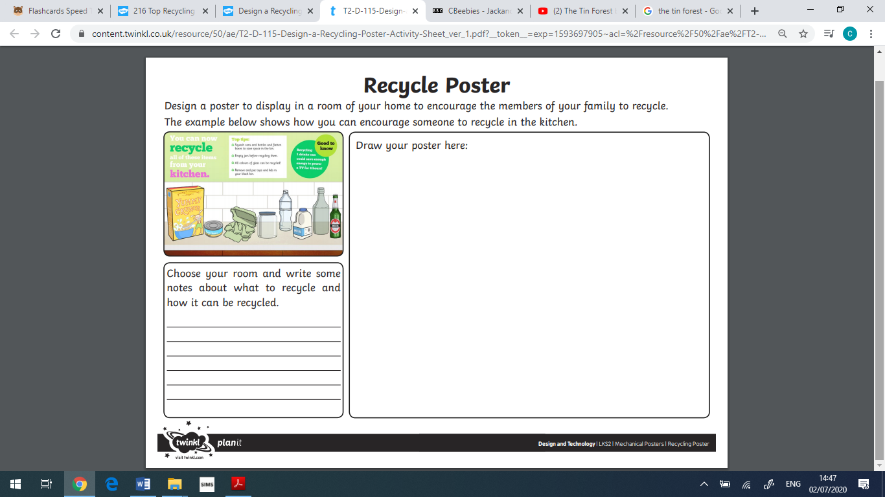

Wednesday 8th July 2020
English Read the adjectives below. Which adjectives describe the tin forest? Colour them in. Choose 5 and write a sentence for each one.
Amazing | Fantastic
Lovely | Wild
Colourful | Little
Breezy | Wet
Windy | Incredible
Huge | Tangled
Tall | Bright
Scary | Gigantic
Sunny | Soft
Great | Small
Fresh | Creeping
Perfect | Birdsong
Magnificent
Noisy | Creepy
Dangerous | Lush
Calm | Massive
Leafy | Beautiful
Jungle | Moist

Maths
Can you spot the mistakes?

PSHE
What are your hopes and dreams for the future? Write about them and illustrate your work.

Thursday 9th July 2020
English – Can you write your own story set in a wild place? Can you illustrate it?
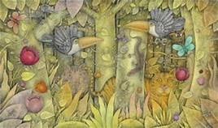

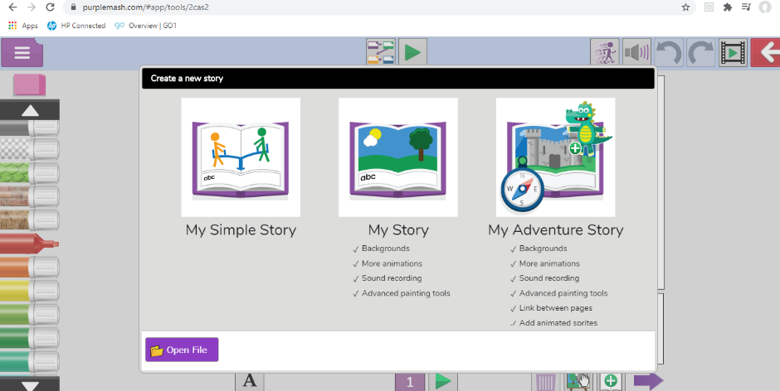
ICT
Use 2 create a story on Purple mash.

Maths
Can you solve the problems below?

(Enlarge in word file)

Geography
Can you find out about the Rainforests around the world?

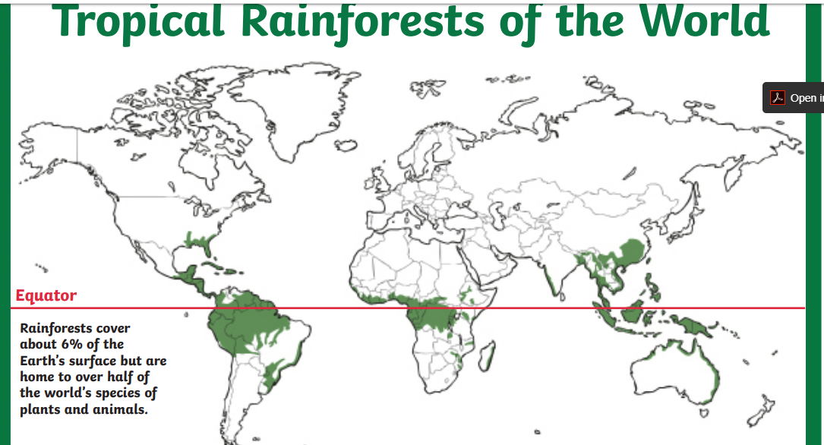
Can you find out 5 facts about tropical rainforests of the world. Again we would love to see what you have been doing!

Listen to the sounds of the rainforest using the link below. What can you hear?
https://www.youtube.com/watch?v=pPrO2jlay40&safe=active

Friday 10th July 2020
SPAG lesson
Months of the year. Can you practise spelling the months of the year ready for Year 2?
Perhaps you could create a poster to remind you of the spelling patterns. We would love to see them! Please take a photograph and email them to us.
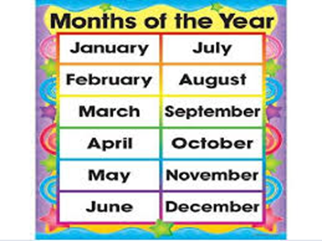

Maths
Colour the pattern of 2s, 5s and 10s on the 100 squares.
Practice counting in 2 5 and 10’s
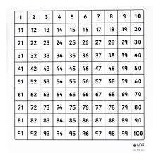

PE
Play Dario G sunchyme (link below)
. Can you make your own animal dance up for the song?
https://www.youtube.com/watch?v=yFKhgF_vkgs

