Miss Rew’s Class – Home Learning – Term 5 Week 4

Term 5 Topic – Bloomin’ Marvellous!
*** If you have problems logging in to Purple Mash, Maths Shed or Spelling Shed, please contact school to obtain your login details ***
Monday | Phonics/Spelling  Mrs Blewett’s Group  Complete Daily Letters and Sounds lesson (Year 1): https://www.youtube.com/channel/UCP_FbjYUP_UtldV2K_-niWw/playlists  OR  Revise Phase 3 sounds playing games on Phonics Play: https://new.phonicsplay.co.uk/resources  /phase/3/buried-treasure  https://new.phonicsplay.co.uk/resources  /phase/3/dragons-den  Mrs Wardrop’s Group + Mrs Mathias’ Group  Alternative pronunciations for /a/.  https://www.phonicsplay.co.uk/member-only/Sneaky_Squirrels.html  Mrs Young’s Group + Miss Rew’s Group  We are looking at using an apostrophe for contractions.  Can you shorten these words by adding an apostrophe? Which letters have been omitted when you use the apostrophe? |  | English  Grammar Lesson  We will be learning about adjectives and why they are important to sentences.  Work through the information here: http://resources.hwb.wales.gov.uk/VTC/ngfl/english/caerphilly/adjectives/index.htm  Then write 5 super sentences using adjectives.  Remember to include:  - capital letters  - full stops  - conjunctions  - finger spaces  - adjectives | Maths – Problem Solving and Efficient Methods  Task  Create a poster to help someone learn the efficient method of addition:  Column Method for Addition:  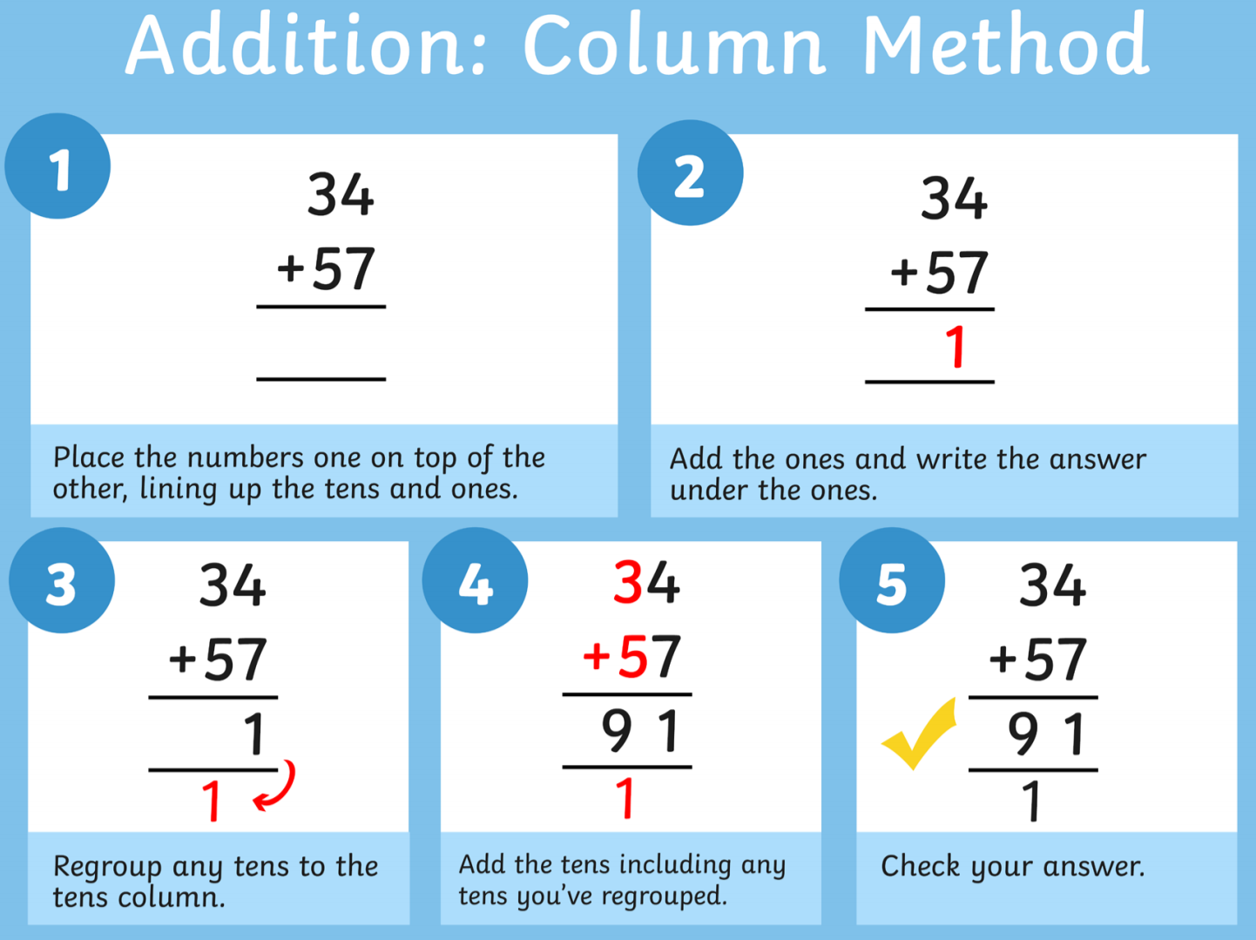 |  |  |  | Science  Draw a picture of a plant, then label the different parts with their name and function:  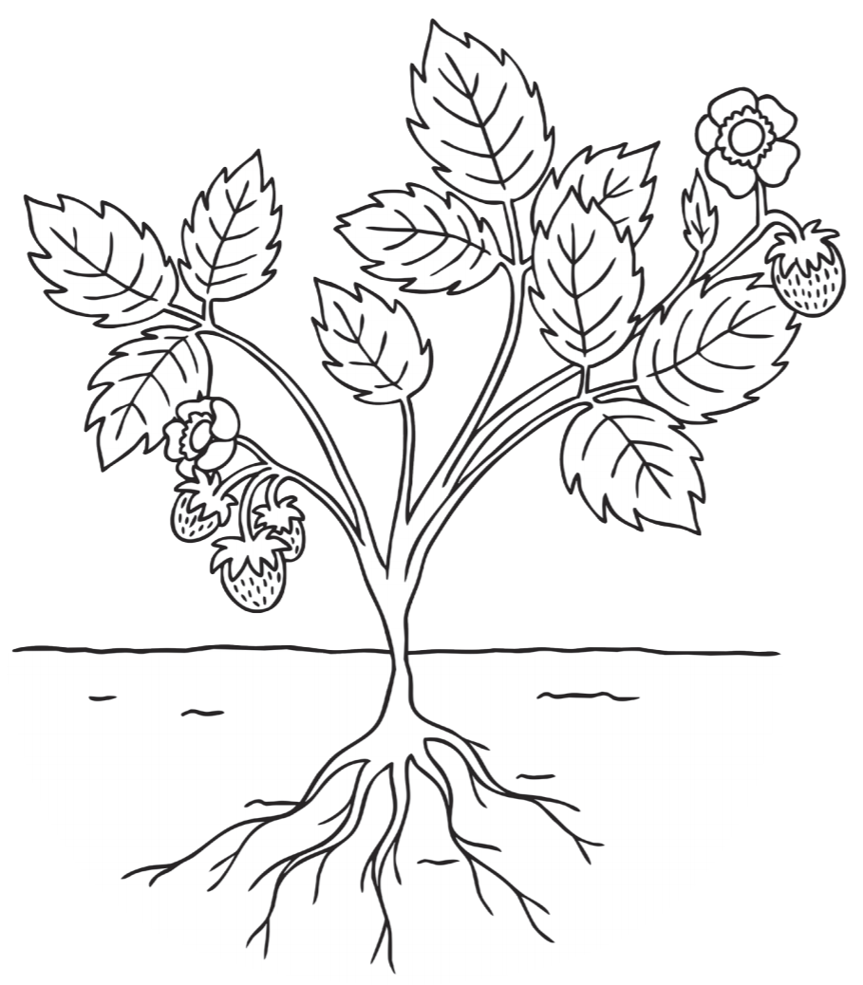  (Resource Sheet Available)
Computing

Send an email to someone in your class, using 2email on Purple Mash: https://www.purplemash.com/#tab/2email
 | - can not  - did not  - has not  - could not | - would not  - should not  - was not  - it is
Reading
Please continue to read at home at least 5 times a week and record in your reading record.
https://www.oxfordowl.co.uk/ has a great range of ebooks!
Tuesday | Phonics/Spelling  Mrs Blewett’s Group  Complete Daily Letters and Sounds lesson (Year 1): https://www.youtube.com/channel/UCP_FbjYUP_UtldV2K_-niWw/playlists  OR  Revise Phase 3 sounds playing games on Phonics Play: https://new.phonicsplay.co.uk/resources  /phase/3/buried-treasure  https://new.phonicsplay.co.uk/resources  /phase/3/dragons-den  Mrs Wardrop’s Group + Mrs Mathias’ Group  Alternative pronunciations for /y/.  https://www.phonicsplay.co.uk/member-only/Sneaky_Squirrels.html  Mrs Young’s Group + Miss Rew’s Group  We are looking at using an apostrophe for contractions.  Practice your spellings using rainbow writing:  Resource Sheets Available  Example: |  | English  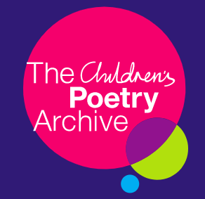  This week we will be learning about poetry.  Follow the link below and listen to some of the poems about plants:  https://childrens.poetryarchive.org/explore/?key=&type=&poet=&theme=162&form=&age=  How do the poems make you feel?  Do you like them? Why? Why not?  Do any of them rhyme? | Maths – Problem Solving and Efficient Methods  Task  Create a poster to help someone learn the efficient method of subtraction:  Column Method for Subtraction (with or without exchanging from the tens column):  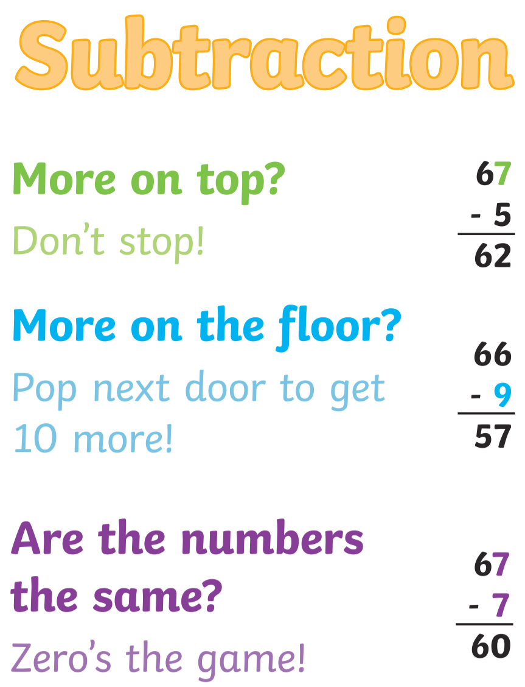 |  | PE  Design a new sport, which combines two existing sports (Resource Sheet Available)  Extension:  Can you create a simple yoga routine of your own?  Why not ask an adult to take a few pictures of you performing and add them, with instructions, to the Year 2 Blog on Purple Mash?  https://www.purplemash.com/blog#/app/blog/5e79e6e00318eb5c66561c88/
Reading
Please continue to read at home at least 5 times a week and record in your reading record.
https://www.oxfordowl.co.uk/ has a great range of ebooks!
Wednesday | Phonics/Spelling  Mrs Blewett’s Group  Complete Daily Letters and Sounds lesson (Year 1): https://www.youtube.com/channel/UCP_FbjYUP_UtldV2K_-niWw/playlists  OR  Revise Phase 3 sounds playing games on Phonics Play: https://new.phonicsplay.co.uk/resources  /phase/3/buried-treasure  https://new.phonicsplay.co.uk/resources  /phase/3/dragons-den  Mrs Wardrop’s Group + Mrs Mathias’ Group  Alternative pronunciations for /ch/.  https://www.phonicsplay.co.uk/member-only/Sneaky_Squirrels.html  Mrs Young’s Group + Miss Rew’s Group  We are looking at using an apostrophe for contractions.  Choose 5 of this week’s spelling words to write into sentences.  Remember to include:  - capital letters  - full stops  - conjunctions  - finger spaces  - adjectives |  | English  Listen to the poem Winter to Spring (available on the school website)  Draw an illustration to go along with this poem.  A written version of the poem is available for you to print and illustrate if you prefer to complete the task this way. (Resource Sheet Available) |  | Maths – Problem Solving and Efficient Methods  Task  Create a poster to help someone learn how to multiply numbers. Perhaps focus on one of the multiplication tables, rather than many!  You may want to demonstrate these methods for multiplication:  Arrays  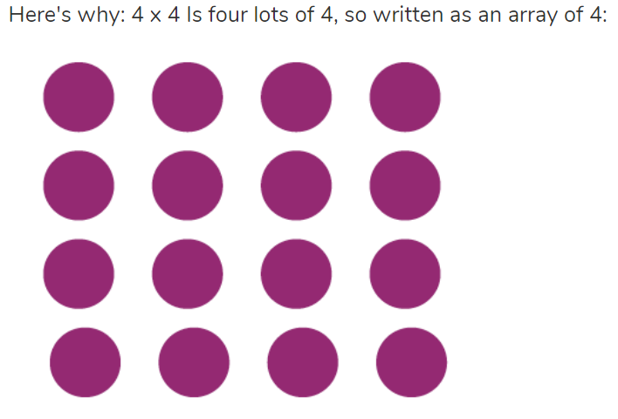  Repeated addition  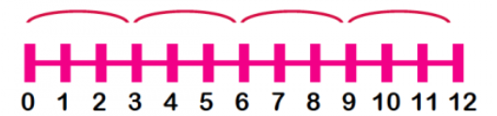 |  |  | Art  This week in Art we are going to continue practising our observational drawing.  Go into your garden and find a bug to sketch (you may need a grown up to take a picture of it first) then sketch what you see.  Remember to add as much detail as you can and try to shade the colours with light and dark  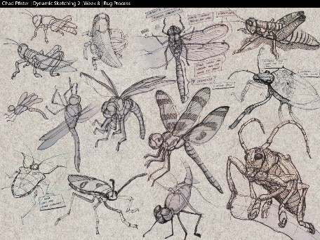
Reading
Please continue to read at home at least 5 times a week and record in your reading record.
https://www.oxfordowl.co.uk/ has a great range of ebooks!
Thursday | Phonics/Spelling  Mrs Blewett’s Group  Complete Daily Letters and Sounds lesson (Year 1): https://www.youtube.com/channel/UCP_FbjYUP_UtldV2K_-niWw/playlists  OR  Revise Phase 3 sounds playing games on Phonics Play: https://new.phonicsplay.co.uk/resources  /phase/3/buried-treasure  https://new.phonicsplay.co.uk/resources  /phase/3/dragons-den  Mrs Wardrop’s Group + Mrs Mathias’ Group  Alternative pronunciations for /ou/.  https://www.phonicsplay.co.uk/member-only/Sneaky_Squirrels.html  Mrs Young’s Group + Miss Rew’s Group  We are looking at using an apostrophe for contractions.  Complete the spelling assignment on Spelling Shed - https://www.spellingshed.com/en-gb |  | English  Write your own poem about all the wonderful things that you see in the Spring time.  Remember you can use your senses to help you to think of words.  What can you see?  What can you smell?  What does it feel like?  What can you hear?  Using our senses, often helps us to think of words to help us with our poems. | Maths – Problem Solving and Efficient Methods  Task  Create a poster to help someone learn how to divide numbers. Perhaps focus on one of the multiplication tables, rather than many!  You may want to demonstrate these methods for division:  Making Equal Groups using Sharing  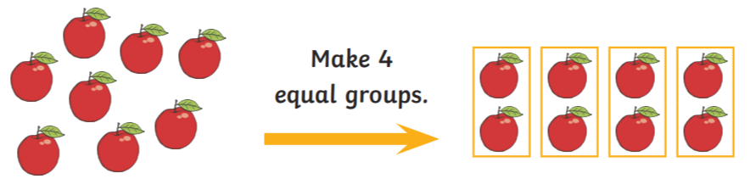  Repeated Subtraction  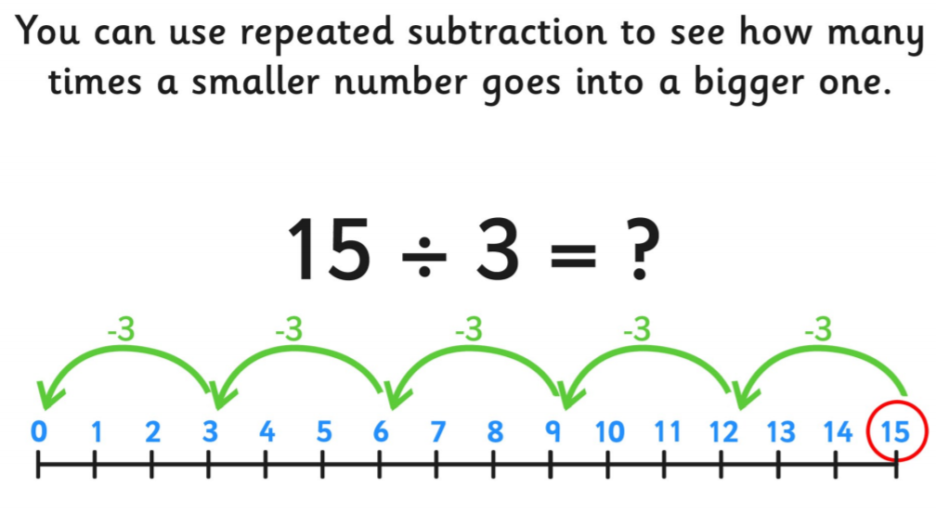 |  |  | RE – Islam (community and belonging)  Task:  Watch the BBC clip about Muslim prayer: https://www.bbc.co.uk/bitesize/clips/zsqvcdm  Discuss the different aspects of the prayer routine with an adult.
PSHE – Relationships

We are learning to identify some of the things that cause conflict with my friends.
When you are in school, what might cause you to fall out with a friend?
What could be done differently to ensure that doesn’t happen again?
Reading
Please continue to read at home at least 5 times a week and record in your reading record.
https://www.oxfordowl.co.uk/ has a great range of ebooks!

Friday | Phonics/Spelling  Mrs Blewett’s Group  Complete Daily Letters and Sounds lesson (Year 1): https://www.youtube.com/channel/UCP_FbjYUP_UtldV2K_-niWw/playlists  OR  Revise Phase 3 sounds playing games on Phonics Play: https://new.phonicsplay.co.uk/resources  /phase/3/buried-treasure  https://new.phonicsplay.co.uk/resources  /phase/3/dragons-den  Mrs Wardrop’s Group + Mrs Mathias’ Group  We are learning to read the tricky words: many, laughed, because, different, any, eyes, friends, once, please  Mrs Young’s Group + Miss Rew’s Group  We are looking at using an apostrophe for contractions.  Ask an adult to dictate 5 sentences to you. Ensure they contain this week’s spelling words and some of the Year 2 Common Exception Words (see resource sheet) | English  Today you are going to perform the poem you wrote yesterday!  Create an invitation to invite people in your house to watch your performance of your poem.  Remember to give your poem a name and remember to include the time of your performance.  Perhaps you could dress up for your grand performance?  Ask an adult to take a picture of you performing and add it to the Year 2 Class Blog on Purple Mash:  https://www.purplemash.com/blog#/app/blog/5e79e6e00318eb5c66561c88/ | Maths – Problem Solving and Efficient Methods  Task  Complete the Year 2 SATs Revision Mat  (Resource Sheet Available)  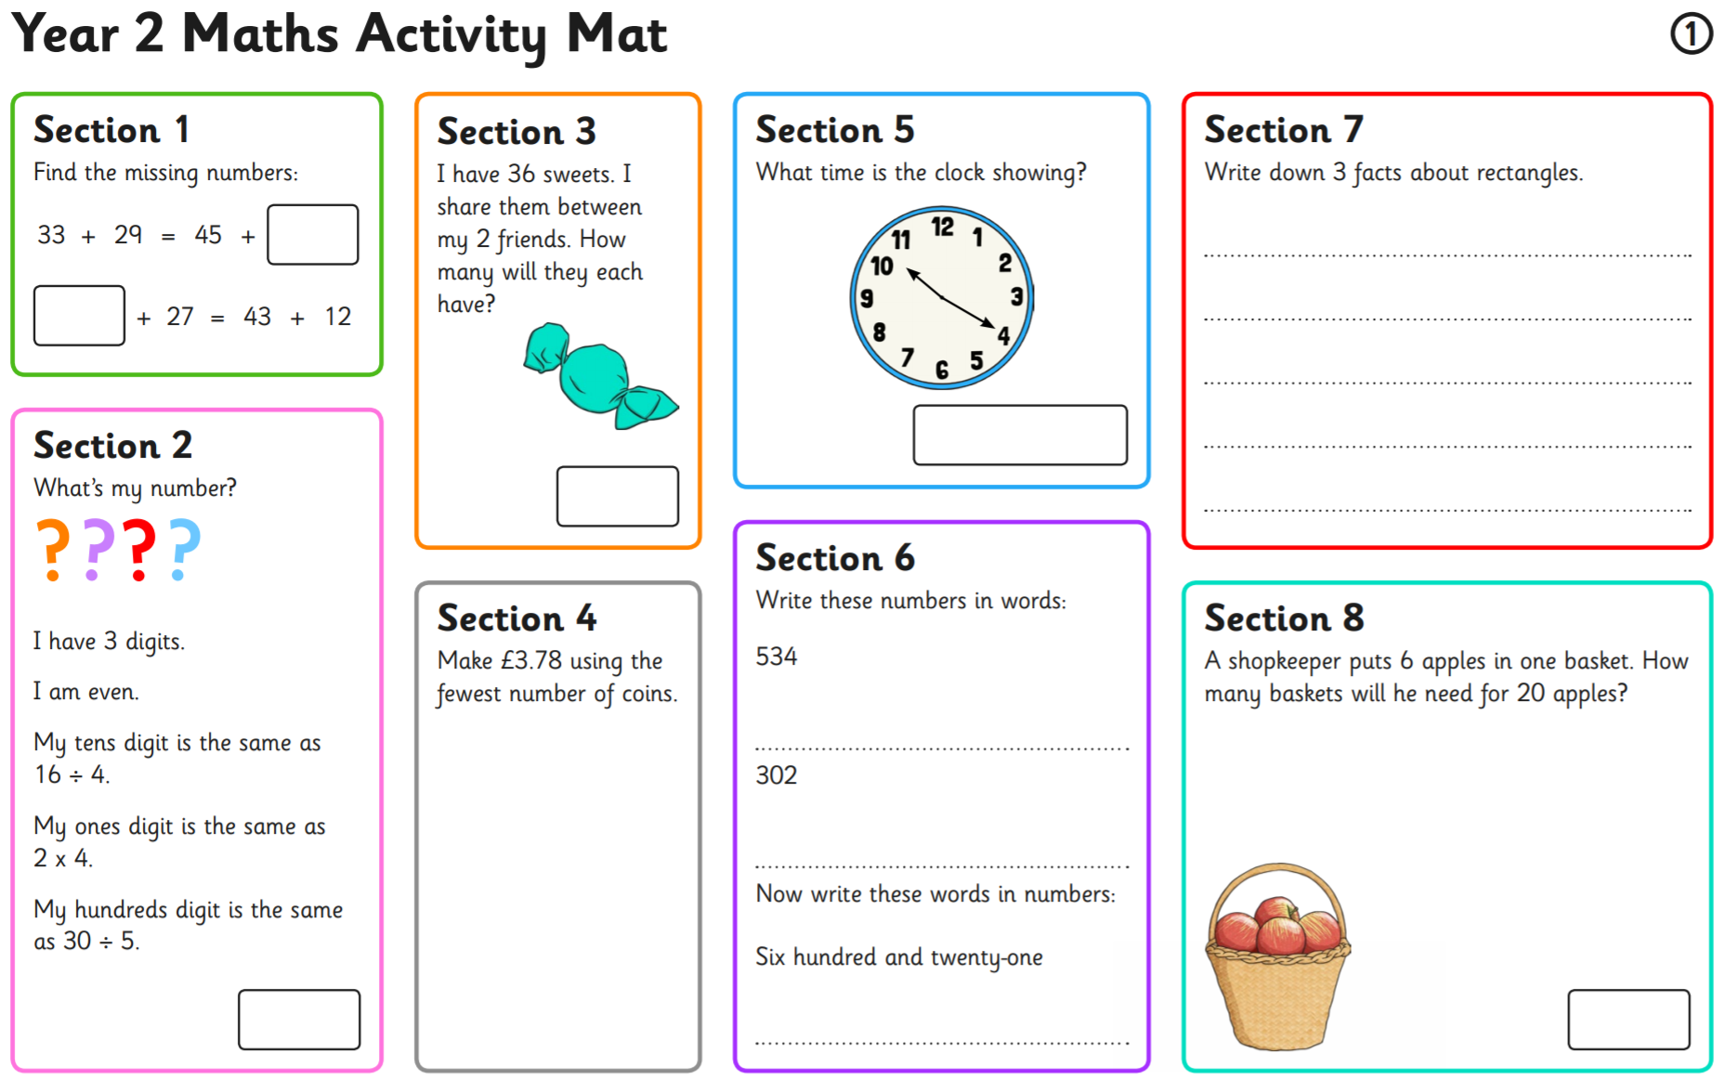 | Topic - Weather  Weather can be very dangerous sometimes.  Can you research the following weather words and create your own glossary of dangerous weathers?  - Hurricane  - Typhoon  - Drought  - Heatwave  - Flood  - Tornado
Music

Can you make a musical instrument that sounds like a type of weather?

Perhaps a rain stick or a thunder maker?
Reading
Please continue to read at home at least 5 times a week and record in your reading record.
https://www.oxfordowl.co.uk/ has a great range of ebooks!

Weekly Tasks
Keep checking Purple Mash for new ToDo’s – these will be updated weekly!
2do: Spelling Quiz - https://www.purplemash.com/#app/diyjs/y2_Autumn2_Week3_Week
2Do: 2x Table Speed Test - https://www.purplemash.com/#app/games/tabletoons/Speedtest_2x
Year 2 Blog – Create a post on the Year 2 Class Blog - https://www.purplemash.com/blog#/app/blog/5e79e6e00318eb5c66561c88/

Other Useful Resources:

Twinkl is an amazing resource, which we use often in school. They have made all their resources free for parents. Follow this link: www.twinkl.co.uk/offer and enter the code CVDTWINKLHELPS. Click on KS1 and a subject that you wish to explore. If you want to print any activities off, please stick these in your child’s yellow book. The grammar and arithmetic activities are especially useful for Year 2!

