Log on to  spelling shed and practise your spellings – week 5.  10 words linked to Year 5/6 spelling lists. | English:  Read the attached instructional text. Go through the stages and pick out the key features that make it an instructional text.  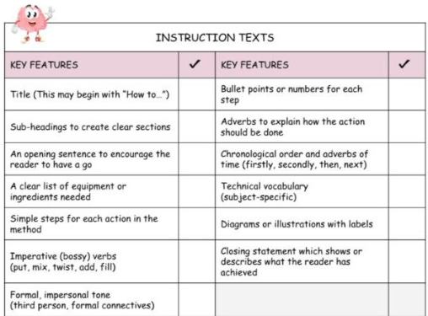  Challenge 1:  Create a den/shelter in the house/garden – with your family’s permission. Ensure that you are able to get in and out this den/shelter and have hidden features.  Challenge 2:  Take a photo of your base and send it to your teachers on Purple Mash.  Challenge 3:  Create a set of instructions for making the perfect den/shelter. | Break time. | WALT: find and express a one-step rule.  Example:  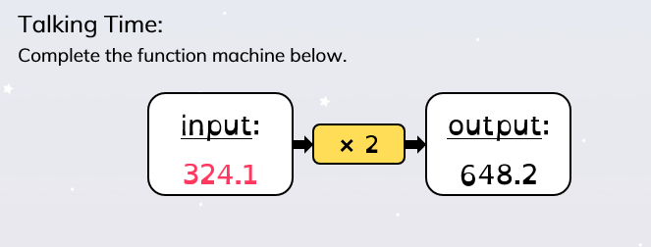  Activity:  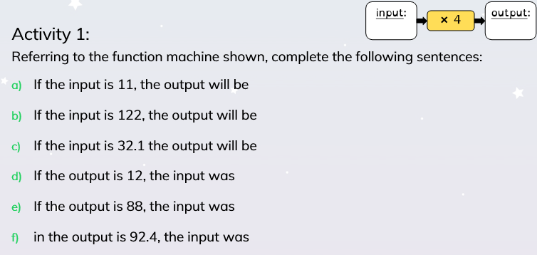  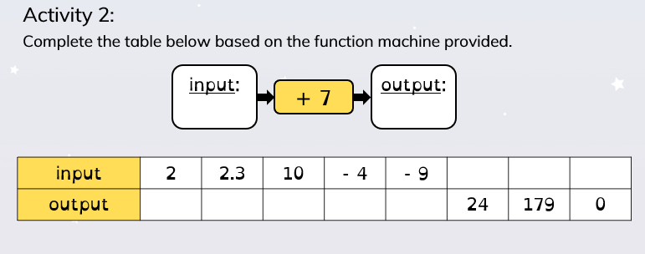  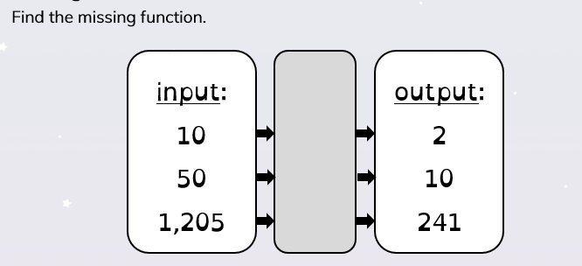  Challenge:  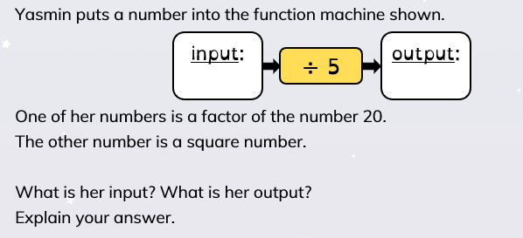 | Lunch hour. | ART:  Many artists create portraits of themselves. Look up artists such as Frida Kaho, Pablo Picasso, Vincent Van Gogh and Andy Warhol and decide which style you like best and why.  Activity:  Grab a mirror, some paper and a pencil and create your own self-portrait in a style of your choice.  Don’t forget to email your portraits to your teachers on PurpleMash- we love seeing your work!
Read the information on Rio Olympics 2016  Complete the comprehension in your book.  Go through the answers to check your accuracy. | English:  Look at the image:  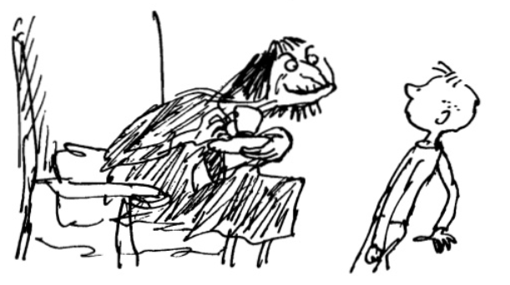  This is from George’s Marvellous Medicine. What does it tell us about the relationship between Grandma and George? Discuss and record in your books.  Load the website  https://www.slideshare.net/SharenGanesh/georges-marvellous-medicine  It is a slide share for the book George’s Marvellous Medicine.  Read pages 14 to 30.  It details the ingredients that George used to create the medicine.  Task:  Predict what you think will happen to Grandma when she drinks the medicine. Expand your answer fully and support your ideas with evidence supported from the text. | Break time. | WALT find and express a two-step rule.  Example:  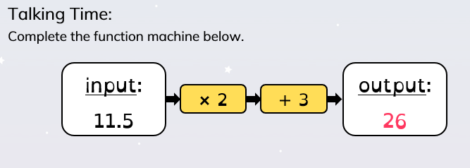  Activity:  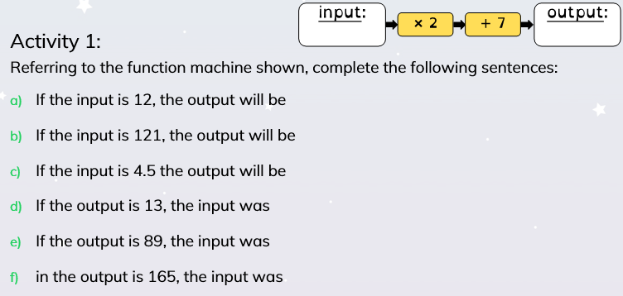  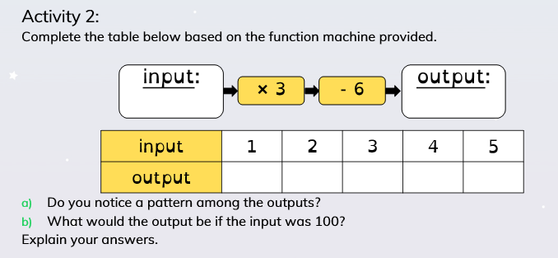  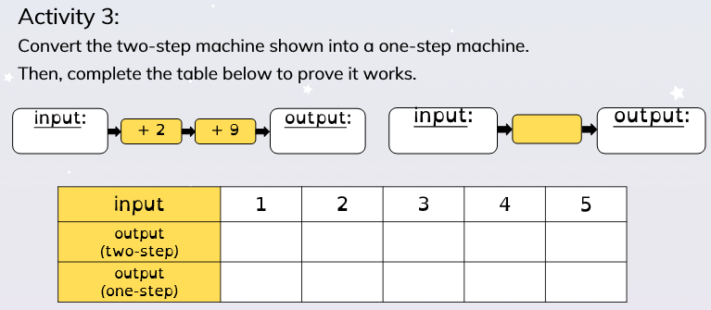  Challenge:  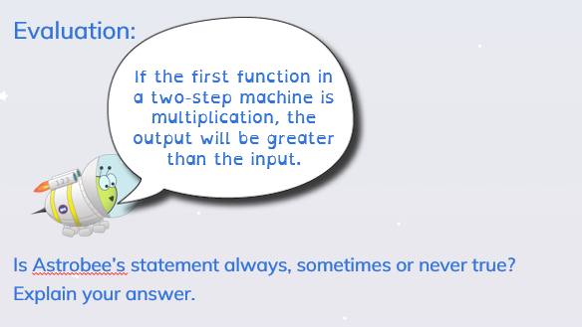 | Lunch hour. | Geography:  Rivers in Britain.  What rivers are we aware of? Record in your books.  Where do we find the following rivers?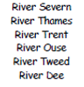  Label the following map with these rivers.  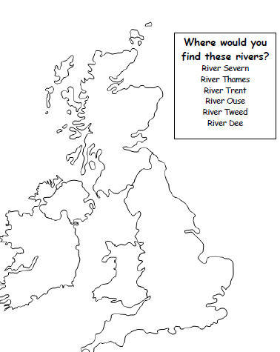  Task: 2  Create a mini fact file linked to one of the rivers you have labelled. It must include a minimum of 6 facts about it.
Look at the image – who is it?  It is Adam Peaty. He won gold at Rio 2016.  Research him and record 10 facts about Adam Peaty. | English:  Recap the predictions made yesterday.  Read the next chapter on slide share:  https://www.slideshare.net/SharenGanesh/georges-marvellous-medicine  P31 – 40.  Were your predictions correct? Did the reaction make George happy? Discuss.  Challenge:  Your aim is to plan a set of instructions.  Possible ideas could be:  - The perfect schoolteacher.  - The greatest meal in history.  - How to be a model child for your parents.  - Be the greatest gamer in history.  Or you could plan instructions for a topic of your choice using a format similar to the one below:  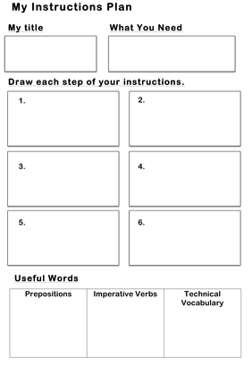 | Break time. | WALT: form algebraic expressions.  Example:  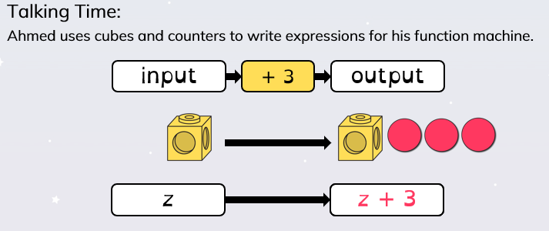  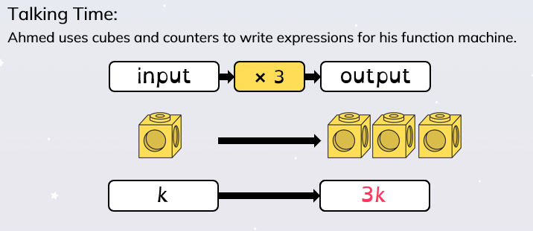  Activity:  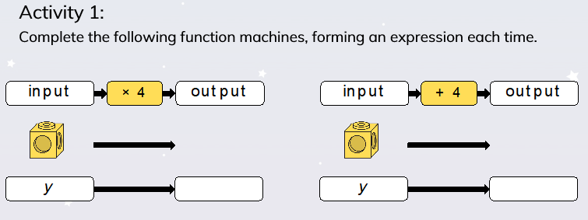  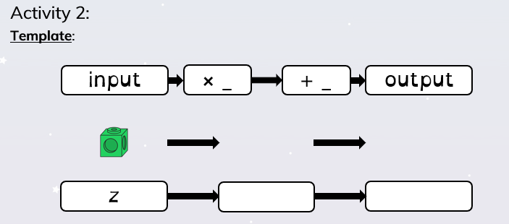  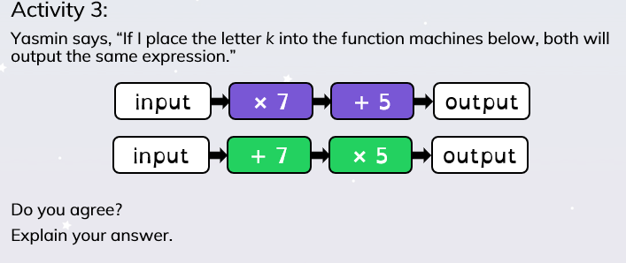 | Lunch hour. | ICT:  Log in to Purple mash and type in 2code. You need to click on  Explore and use the range of games available below:  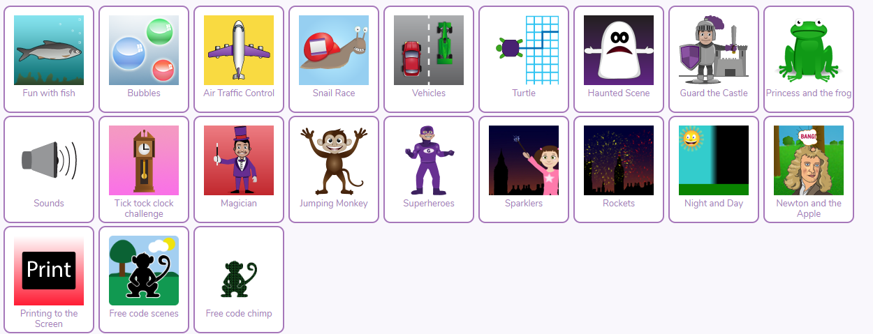  Once you have played them, try the following task:  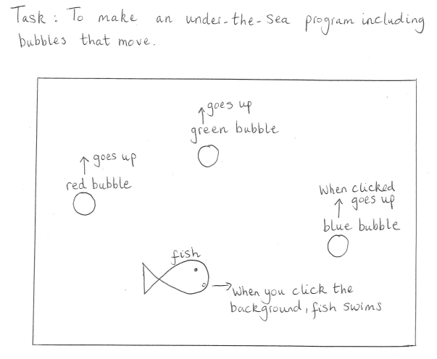  If you are successful, forward it to your teacher.
Using the letters:  T E I M S A L D  How many words can you make?  Can you crack the 8 letter word?  Can you get over 35 words? (3 letters or more.) | English:  Go over your plans for your set of instructions.  Task:  Write a set of instructions that meets the success criteria from Monday’s planning. Ensuring that they are at the expected standard for a Year 6 child.  A large minute reminder – read the revolting recipe good example.  Children write their instructions planned in the previous lesson. | Break time. | WALT: use symbols and letters for substitution.  Activity:  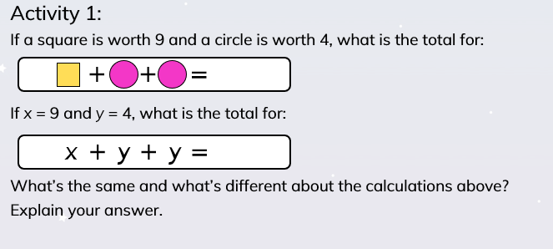  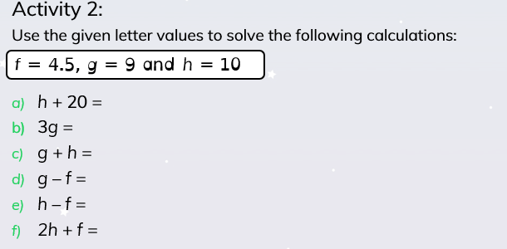  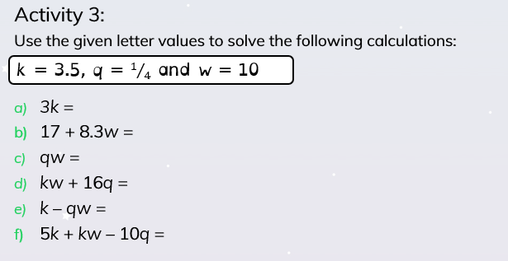 | Lunch hour. | PSHE: Memories of Westlea  Over your time spent in Westlea, you will have experienced many different things, from new teachers to experiences outside of the school.  What will you remember from you time at Westlea so far? Think about and discuss with a family member. What are their memories of Westlea and your journey through there? Share.  Using an example like this, create a memory tree, adding in your memories of Westlea so far.  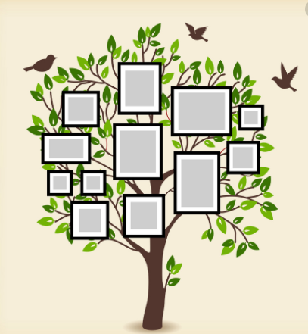  Please photo the finished product and send it to your clas steacher via Purple Mash.
Riddles:  What's really easy to get into, and hard to get out of?  What word contains 26 letters, but only has three syllables?  I am often following you and copying your every move. Yet you can never touch me or catch me. What am I?  What has hands, but can't clap?  Email your answers to your teachers on Purple Mash. | English  - Use spelling shed to go over the spellings that have been set for you.  - Use items that you can find around the house or in the garden and complete your spellings using them, for example: arrange items like felt pens to spell out the words.  - Take a photo of the spellings and then post on purple mash and email to your teachers.  - Take a photo of yourself reading in an unusual place and post it on Purple Mash and email to your teachers | Break time. | Play some maths games online:  Maths shed  ICT games  Education City |  | DT:  Design your own cupcakes or cookies to share with your family.  With parental permission, make and bake your creations, remembering to take a photo before eating them.  Remember to take into consideration who will be eating your goodies when you are designing them- can you create a different to design to represent each person living in your house

- On spelling shed, I have uploaded common misspelt words and have assigned them to you. You are required to complete this three times a week.
- You should be reading at home at least four times a week and filling in your reading record. You can choose the book you would like to read as well.

