Monday | Log on to spelling shed and practise your spellings – week 4  10 words linked to Year 5/6 spelling lists.  Play the games and top the leader boards! | Read chapter 1 of The Lambton Worm.  Create a mind map and record your:  -likes  -dislikes  -questions  -feelings  -connections (to other myths/stories) | Break time. | WALT: calculate angles on a straight line.  Example:  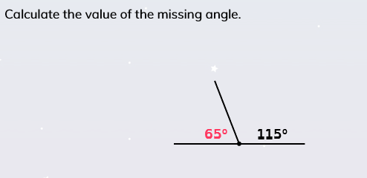  Remember: angles on a straight line equal 180°  Activity:  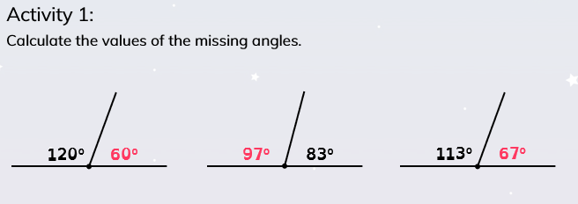  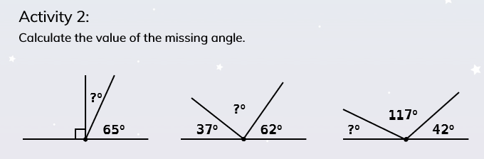  Challenge:  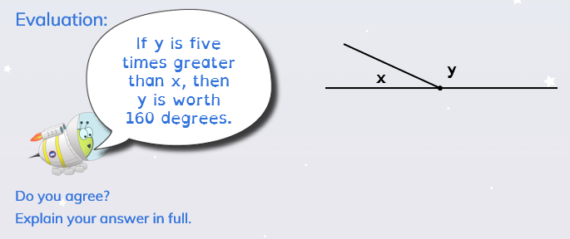 |  | Science  Earth and Space  Research and create a mini biography of Galileo, focusing in on his discoveries of space.  (See attached sheet to use if you would like to)
Tuesday | Read chapter 2 of The Lambton Worm (see this weeks resources). | Imagine you lived in/near the castle. Create a plan to rid the castle of the creature. Write your plan as a set of instructions.  Try to include:  - Title  - A clear list of equipment  - Imperative (bossy) verbs  - Bullet points or numbers  - Adverbs for how the actions should be done  - Chronological order  - Adverbs of time (firstly, next, finally)  - Diagrams or illustrations with labels  Closing statement |  | WALT: calculate angles around a point.  Example:  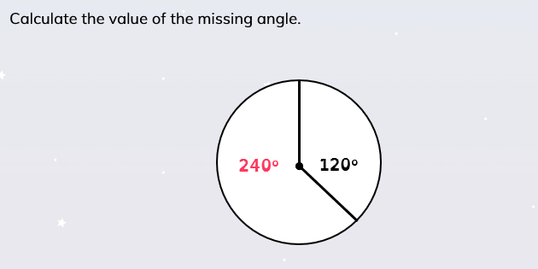  Remember angles around a point equal 360°  Activity:  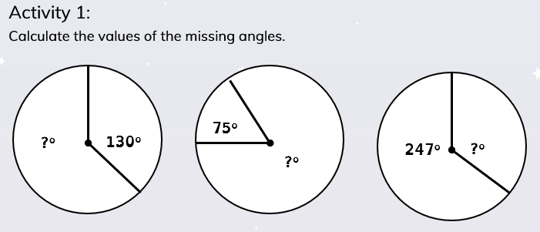  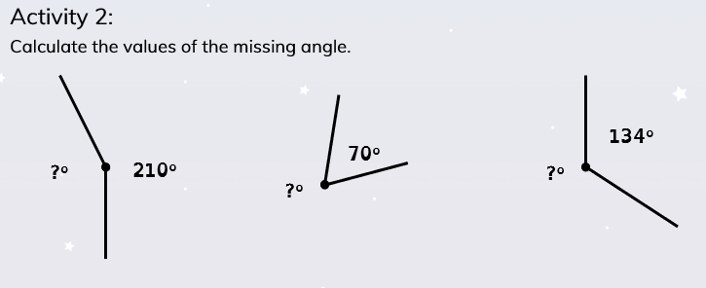  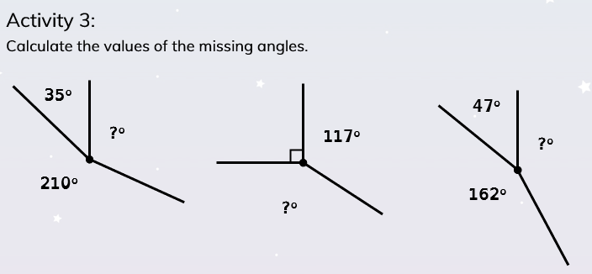 |  | Art/DT  Design and make your own spacecraft using things in your house.  Remember to take a photo and email it to your teachers!
Wednesday | Science think starter:  Look at the Science starter attached, give your opinion about what you think.  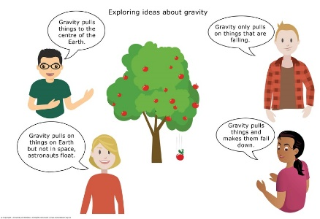 | Read chapter 3 of The Lambton Worm and answer the questions below (in full sentences so that they make sense).  - There are many words which describe the Lambton Worm in the story so far. Write 4 of the adjectives and find a more impressive synonym for each word.  - What sort of fish was Lambton fishing for?  - Explain what the village people felt or did when the creature was in their area.  - Are the following statements true or false?  - The river Lambton fished in was the river Tyne.  - John was fishing on a Sunday.  - The Lambton Worm ate cows.  - Lambton lived in Scotland. |  | WALT: calculate lengths and angles in shapes.  Example:  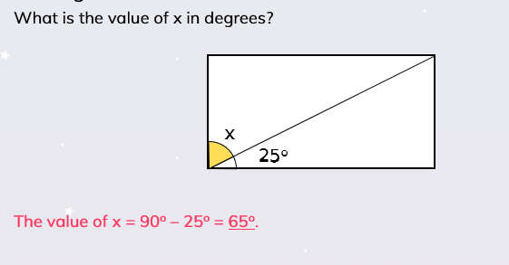  Activity:  Draw some rectangles in your book. Split them in two and measure one of the angles with a protractor. Without using the protractor fill in the missing angles. |  | Geography  Rivers  (See attached sheet)  Have a go at labelling the different parts of the river. Some of them are easier than others.  Any words that you are unsure of and can’t label correctly, find out what they mean and create a glossary.
Thursday | Read chapters 4 and 5 of The Lambton Worm. | There are many words in the text to say what the Lambton worm might look or behave like. Re-read the story and find them then write them down. Can you add even more of your own to describe the creature?  Using these words, draw a picture of what the Lambton Worm may have looked like. |  | WALT: calculate lengths and angles in shapes.  Example:  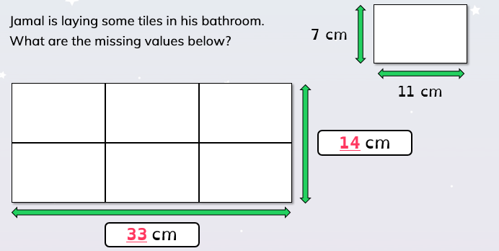  Activity:  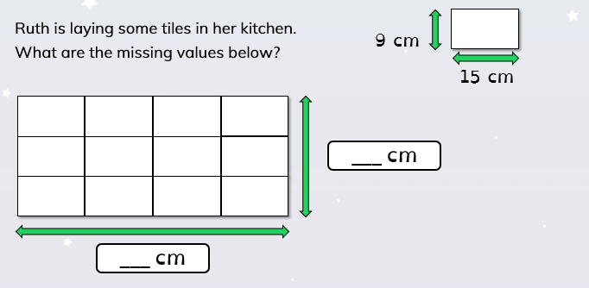  Ask an adult to draw some similar questions for you to solve. |  | RE  This week’s RE is about one of the most famous parables of Jesus; the Good Samaritan.  See the attached resources for the Bible story and related questions about how we might use this story to think about how to treat others today.  https://www.bbc.co.uk/bitesize/clips/zcyr87h (Animated version of the Good Samaritan)
Friday | Choose a book (either a new one or one you have read before) and read aloud for 10 or 15 minutes. | Write 8 sentences that each have a fronted adverbial to re-tell the story. Once you have done this, add in a picture for each sentence to create a story map.  Remember to use a comma after a fronted adverbial! |  | Play some maths games online:  Maths shed  ICT games  Education City |  | PSHE  Read through the situations and think about whether the issues in the friendship can be solved. Record the what you would do/say in order to repair the relationship.  (See attached sheet).

