Miss Rew’s Class – Home Learning – Term 6 Week 6

Term 6 Topic – Habitats
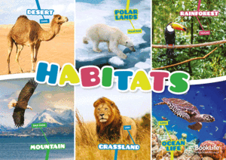

*** If you have problems logging in to Purple Mash, Maths Shed or Spelling Shed, please contact school to obtain your login details ***
Monday | Phonics/Spelling  Mrs Blewett’s Group  Revise Phase 3 and 4 sounds playing games on Phonics Play: https://new.phonicsplay.co.uk/resources  /phase/3/buried-treasure  https://new.phonicsplay.co.uk/resources  /phase/4/dragons-den  Mrs Wardrop’s Group + Mrs Mathias’ Group  Alternative spellings for ‘igh’.  Complete the phoneme spotter activity: https://www.phonicsplay.co.uk/resources/phase/5/alt-spellings-igh  Mrs Young’s Group + Miss Rew’s Group  For the next 2 weeks, I would like you to complete activities from the Term 6 Spelling Activity Booklet.  Resource Sheets Available | English  Complete the lesson on Oak National Academy – Expanded Noun Phrases:  https://classroom.thenational.academy/lessons/to-identify-and-use-expanded-noun-phrases-503195 (Up to 11:44)  Can you write some expanded noun phrases to describe different types of habitats?  Example:  Underneath the cold, damp log.  Remember to separate your adjectives using a comma. | Maths  Digit Card Investigation  Resource Sheets Available  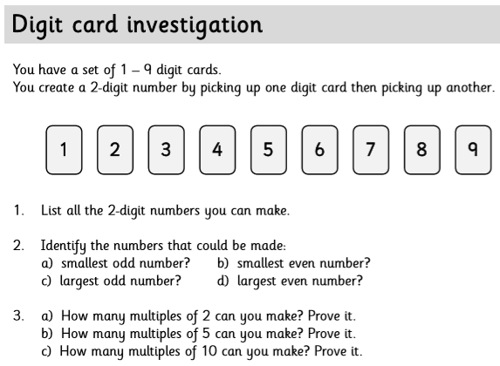 | Science  Cut out the plants and animal sorting cards, then arrange them to make as many food chains as possible.  Resource Sheets Available  What is the longest/shortest food chain you can make?
Computing

Send an email to someone in your class, using 2email on Purple Mash: https://www.purplemash.com/#tab/2email
Reading
Please continue to read at home at least 5 times a week and record in your reading record.
https://www.oxfordowl.co.uk/ has a great range of ebooks!
Tuesday | Phonics/Spelling  Mrs Blewett’s Group  Revise Phase 3 and 4 sounds playing games on Phonics Play: https://new.phonicsplay.co.uk/resources  /phase/3/buried-treasure  https://new.phonicsplay.co.uk/resources  /phase/4/dragons-den  Mrs Wardrop’s Group + Mrs Mathias’ Group  Alternative spellings for ‘igh’.  Complete the word sort activity: https://www.phonicsplay.co.uk/resources/phase/5/alt-spellings-igh  Mrs Young’s Group + Miss Rew’s Group  For the next 2 weeks, I would like you to complete activities from the Term 6 Spelling Activity Booklet.  Resource Sheets Available | English  Think of an animal that would live in your favourite habitat.  Draw a picture of your animal then write some expanded noun phrases to describe it. | Maths  Number Frames Investigation  Resource Sheets Available  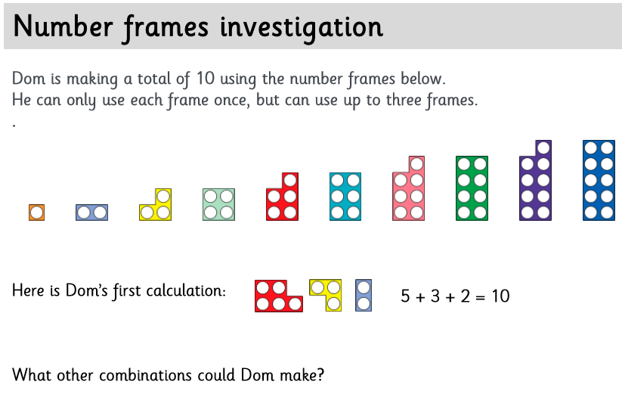 | PE  With us unable to get together for a sports day, we will have an alternative one at home!  Your task is to complete one activity each week. Ask an adult to time/score you, then submit your time via email on Purple Mash:  https://www.purplemash.com/#tab/2email  All the times/scores will be recorded and e-certificates will be awarded to 1st, 2nd, and 3rd place for each event.  This Week’s Event is:  Peel a banana using only your toes!  Extension  Add a picture of yourself completing the activity to the Year 2 Class Blog!  https://www.purplemash.com/blog#/app/blog/5e79e6e00318eb5c66561c88/
Reading
Please continue to read at home at least 5 times a week and record in your reading record.
https://www.oxfordowl.co.uk/ has a great range of ebooks!

Wednesday | Phonics/Spelling  Mrs Blewett’s Group  Revise Phase 3 and 4 sounds playing games on Phonics Play: https://new.phonicsplay.co.uk/resources  /phase/3/buried-treasure  https://new.phonicsplay.co.uk/resources  /phase/4/dragons-den  Mrs Wardrop’s Group + Mrs Mathias’ Group  Alternative spellings for ‘igh’.  Complete the phoneme spotter activity or word sort activity from previous days: https://www.phonicsplay.co.uk/resources/phase/5/alt-spellings-igh  Mrs Young’s Group + Miss Rew’s Group  For the next 2 weeks, I would like you to complete activities from the Term 6 Spelling Activity Booklet.  Resource Sheets Available | English  Plan an adventure story for the animal you described yesterday.  Fantastic stories include:  - Beginning – Where does the story start? Who is in your story?  - Build up – What happens before the main action? Does you character go somewhere?  - Problem – What happens to your character? How do they feel?  - Resolution – How does you character solve the problem? How do they feel now?  - Ending – How does you story end? Try to avoid quick endings like ‘…and then they woke up and discovered it was just a dream’ or ‘…and they lives happily every after.’  Remember to include each of these elements in your story plan. | Maths  Dice Investigation  Resource Sheets Available  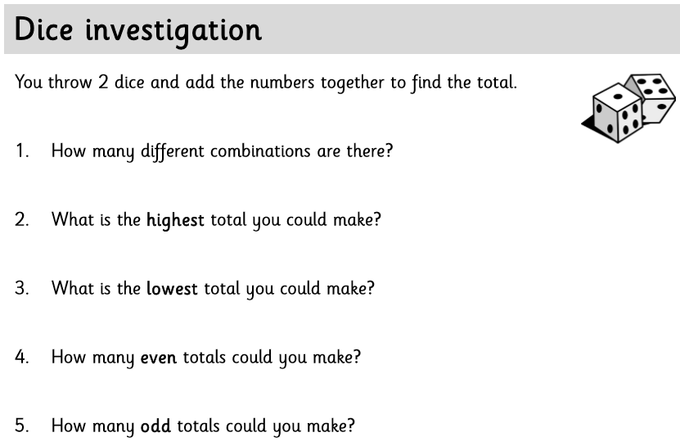 | Design Technology  This term we will be focussing on making 3D sculptures of minibeasts using paper mache.  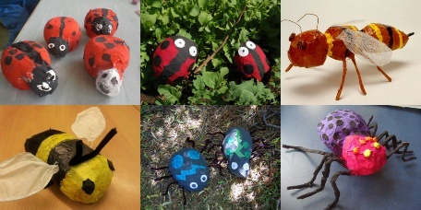  The final stage in the process is to evaluate your finished minibeast model.  How does it compare to your original plan?  What went well?  What would you do differently next time?  We are looking to brighten up the school, ready for September. It would be great if you were able to bring your completed model into school so it could be displayed.  Please only do this if it is safe for you to do so!
Reading
Please continue to read at home at least 5 times a week and record in your reading record.
https://www.oxfordowl.co.uk/ has a great range of ebooks!

Thursday | Phonics/Spelling  Mrs Blewett’s Group  Revise Phase 3 and 4 sounds playing games on Phonics Play: https://new.phonicsplay.co.uk/resources  /phase/3/buried-treasure  https://new.phonicsplay.co.uk/resources  /phase/4/dragons-den  Mrs Wardrop’s Group + Mrs Mathias’ Group  Alternative spellings for ‘f’.  Write the words fix, cliff, phone, cough. Ask children to read the words aloud to each other and soundtalk them. Which phoneme do all of these words contain?  Ask children to help you write a sentence on the whiteboard.  The dolphin flaps his fins.  The fox huffs and puffs and coughs.  Get off the phone!  Mrs Young’s Group + Miss Rew’s Group  For the next 2 weeks, I would like you to complete activities from the Term 6 Spelling Activity Booklet.  Resource Sheets Available | English  Use you learning about expanded noun phrases and you story plan to write a descriptive story about your chosen animal.  Try to write at least 2 or 3 sentences for each section of your story.  Challenge:  Can you write your story in paragraphs?  Can you include some dialogue in your story? | Maths  Money Investigation  Resource Sheets Available  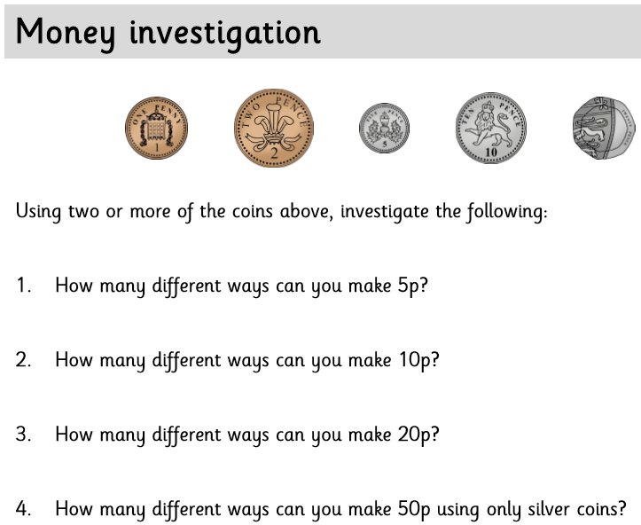 | PSHE  This term our PSHE focus will be positive mental health and wellbeing.  Have regular brain breaks during the day.  Why not try out some of the activities on Go Noodle?  https://family.gonoodle.com/
Reading
Please continue to read at home at least 5 times a week and record in your reading record.
https://www.oxfordowl.co.uk/ has a great range of ebooks!

Friday | Phonics/Spelling  Mrs Blewett’s Group  Revise Phase 3 and 4 sounds playing games on Phonics Play: https://new.phonicsplay.co.uk/resources  /phase/3/buried-treasure  https://new.phonicsplay.co.uk/resources  /phase/4/dragons-den  Mrs Wardrop’s Group + Mrs Mathias’ Group  Alternative pronunciations for the ‘igh’  Can you write these words, thinking carefully about the spelling for the ‘igh’ sound.  might, bright, strike, kite, behind, cried, dry, reply  Mrs Young’s Group + Miss Rew’s Group  For the next 2 weeks, I would like you to complete activities from the Term 6 Spelling Activity Booklet.  Resource Sheets Available | English  Edit and improve you story.  Read it aloud and check for missing punctuation:  - Capital letters  - Full stops  - Commas  - Speech marks  Check your story makes sense.  Try and improve some of the vocabulary choices you have made. | Maths  Array Investigation  Resource Sheets Available  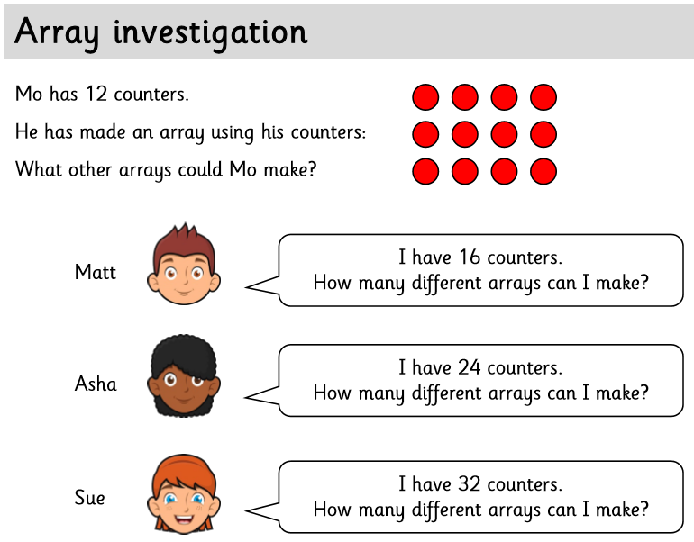 | Topic  Over the next two weeks, I would like you to complete one of the following activities:  Create a travel brochure for one of the 7 continents.  Resource Sheets Available  Imagine you trying to get people to visit your continent, tell them as many interesting facts as you can and draw maps, flags and pictures to help them find out more.  Use atlases, maps, the Internet and books to help create your continent travel brochure!  Or  Create a fantastic papier mâché globe with the seven continents and five oceans of the world.  Resource Sheets Available
Reading
Please continue to read at home at least 5 times a week and record in your reading record.
https://www.oxfordowl.co.uk/ has a great range of ebooks!

Weekly Tasks
Keep checking Purple Mash for new ToDo’s – these will be updated weekly!

