Miss Rew’s Class – Home Learning – Term 5 Week 5

Term 5 Topic – Bloomin’ Marvellous!
*** If you have problems logging in to Purple Mash, Maths Shed or Spelling Shed, please contact school to obtain your login details ***
Monday | Phonics/Spelling  Mrs Blewett’s Group  Complete Daily Letters and Sounds lesson (Year 1): https://www.youtube.com/channel/UCP_FbjYUP_UtldV2K_-niWw/playlists  OR  Revise Phase 3 sounds playing games on Phonics Play: https://new.phonicsplay.co.uk/resources  /phase/3/buried-treasure  https://new.phonicsplay.co.uk/resources  /phase/3/dragons-den  All other Year 2 Groups  We are looking at common exception words.  Follow the instructions on the challenge cards to help you learn these spellings. (Resource Sheet Available) |  | English  Had we been in school this week, it would have been the week where we sat our SATs papers.  This week I would like you to have a go at answering the questions in the Reading papers from 2019.  Paper 1 – a combined paper with text and questions. (Resource Sheet Available)  Paper 2 – a separate paper for the text and the questions. (Resource Sheet Available)  Please work through these throughout the week – don’t try to do them all at once!  Take lots of breaks and try your best!  These do not need to be sat in test conditions however you should try to do them independently.  Parents – If you would like paper copies of the test papers, these will be available from school on Monday 18th May. | Maths  Had we been in school this week, it would have been the week where we sat our SATs papers.  This week I would like you to have a go at answering the questions in the Maths papers from 2019.  Paper 1 – a paper of arithmetic questions (Resource Sheet Available)  Paper 2 – a problem solving and reasoning paper. (Resource Sheet Available)  Please work through these throughout the week – don’t try to do them all at once!  Take lots of breaks and try your best!  These do not need to be sat in test conditions however you should try to do them independently.  Parents – If you would like paper copies of the test papers, these will be available from school on Monday 18th May. |  |  | Science  We have some to the end of our Science unit about plants – How much have you learnt about plants and trees?  Try to answer the questions in the Science Quiz!  (Resource Sheet Available)
Computing

Send an email to someone in your class, using 2email on Purple Mash: https://www.purplemash.com/#tab/2email
 | - any  - many  - clothes  - water  - pretty | - Christmas  - beautiful  - busy  - poor  - kind
Reading
Please continue to read at home at least 5 times a week and record in your reading record.
https://www.oxfordowl.co.uk/ has a great range of ebooks!
Tuesday | Phonics/Spelling  Mrs Blewett’s Group  Complete Daily Letters and Sounds lesson (Year 1): https://www.youtube.com/channel/UCP_FbjYUP_UtldV2K_-niWw/playlists  OR  Revise Phase 3 sounds playing games on Phonics Play: https://new.phonicsplay.co.uk/resources  /phase/3/buried-treasure  https://new.phonicsplay.co.uk/resources  /phase/3/dragons-den  All other Year 2 Groups  We are looking at common exception words.  Practice your spellings using rainbow writing:  Resource Sheets Available  Example: |  | English  Had we been in school this week, it would have been the week where we sat our SATs papers.  This week I would like you to have a go at answering the questions in the Reading papers from 2019.  Paper 1 – a combined paper with text and questions. (Resource Sheet Available)  Paper 2 – a separate paper for the text and the questions. (Resource Sheet Available)  Please work through these throughout the week – don’t try to do them all at once!  Take lots of breaks and try your best!  These do not need to be sat in test conditions however you should try to do them independently.  Parents – If you would like paper copies of the test papers, these will be available from school on Monday 18th May. | Maths  Had we been in school this week, it would have been the week where we sat our SATs papers.  This week I would like you to have a go at answering the questions in the Maths papers from 2019.  Paper 1 – a paper of arithmetic questions (Resource Sheet Available)  Paper 2 – a problem solving and reasoning paper. (Resource Sheet Available)  Please work through these throughout the week – don’t try to do them all at once!  Take lots of breaks and try your best!  These do not need to be sat in test conditions however you should try to do them independently.  Parents – If you would like paper copies of the test papers, these will be available from school on Monday 18th May. |  | PE  Warm up – 15 star jumps, 10 squats, 10 arm circles, 15  high knees.  Main task  Create your own Jo Wicks style work out, you need at least 6 exercises, you complete the exercise for 30 seconds then rest for 30 seconds before moving onto the next exercise. Once you’ve done all 6 you rest for 2 minutes before repeating your circuit at least twice.  Ensure your exercises use different parts of the body and raise your heart rate.  Cool down  Once you’ve finished take some time to lay flat on your back, stretch your arms and legs out as you take some deep breaths and let your breathing  return to normal.
Reading
Please continue to read at home at least 5 times a week and record in your reading record.
https://www.oxfordowl.co.uk/ has a great range of ebooks!
Wednesday | Phonics/Spelling  Mrs Blewett’s Group  Complete Daily Letters and Sounds lesson (Year 1): https://www.youtube.com/channel/UCP_FbjYUP_UtldV2K_-niWw/playlists  OR  Revise Phase 3 sounds playing games on Phonics Play: https://new.phonicsplay.co.uk/resources  /phase/3/buried-treasure  https://new.phonicsplay.co.uk/resources  /phase/3/dragons-den  All other Year 2 Groups  We are looking at using an apostrophe for contractions.  Choose 5 of this week’s spelling words to write into sentences.  Remember to include:  - capital letters  - full stops  - conjunctions  - finger spaces  - adjectives |  | English  Had we been in school this week, it would have been the week where we sat our SATs papers.  This week I would like you to have a go at answering the questions in the Reading papers from 2019.  Paper 1 – a combined paper with text and questions. (Resource Sheet Available)  Paper 2 – a separate paper for the text and the questions. (Resource Sheet Available)  Please work through these throughout the week – don’t try to do them all at once!  Take lots of breaks and try your best!  These do not need to be sat in test conditions however you should try to do them independently.  Parents – If you would like paper copies of the test papers, these will be available from school on Monday 18th May. |  | Maths  Had we been in school this week, it would have been the week where we sat our SATs papers.  This week I would like you to have a go at answering the questions in the Maths papers from 2019.  Paper 1 – a paper of arithmetic questions (Resource Sheet Available)  Paper 2 – a problem solving and reasoning paper. (Resource Sheet Available)  Please work through these throughout the week – don’t try to do them all at once!  Take lots of breaks and try your best!  These do not need to be sat in test conditions however you should try to do them independently.  Parents – If you would like paper copies of the test papers, these will be available from school on Monday 18th May. |  | Art  Follow this link to draw a great folding surprise flower!  https://www.youtube.com/watch?v=_J_9aZ75vM8
Reading
Please continue to read at home at least 5 times a week and record in your reading record.
https://www.oxfordowl.co.uk/ has a great range of ebooks!

Thursday | Phonics/Spelling  Mrs Blewett’s Group  Complete Daily Letters and Sounds lesson (Year 1): https://www.youtube.com/channel/UCP_FbjYUP_UtldV2K_-niWw/playlists  OR  Revise Phase 3 sounds playing games on Phonics Play: https://new.phonicsplay.co.uk/resources  /phase/3/buried-treasure  https://new.phonicsplay.co.uk/resources  /phase/3/dragons-den  All other Year 2 Groups  We are looking at common exception words.  Complete the spelling assignment on Spelling Shed - https://www.spellingshed.com/en-gb | English  Had we been in school this week, it would have been the week where we sat our SATs papers.  This week I would like you to have a go at answering the questions in the Reading papers from 2019.  Paper 1 – a combined paper with text and questions. (Resource Sheet Available)  Paper 2 – a separate paper for the text and the questions. (Resource Sheet Available)  Please work through these throughout the week – don’t try to do them all at once!  Take lots of breaks and try your best!  These do not need to be sat in test conditions however you should try to do them independently.  Parents – If you would like paper copies of the test papers, these will be available from school on Monday 18th May. | Maths  Had we been in school this week, it would have been the week where we sat our SATs papers.  This week I would like you to have a go at answering the questions in the Maths papers from 2019.  Paper 1 – a paper of arithmetic questions (Resource Sheet Available)  Paper 2 – a problem solving and reasoning paper. (Resource Sheet Available)  Please work through these throughout the week – don’t try to do them all at once!  Take lots of breaks and try your best!  These do not need to be sat in test conditions however you should try to do them independently.  Parents – If you would like paper copies of the test papers, these will be available from school on Monday 18th May. | Geography  Watch a TV or online wether forecast for two days.  Ask an adult to show you where Swindon is on the weather map.  Listen to what the forecaster says and look at the weather symbols.  Record the weather for your area on the two days.  Compare how the weather has changed.  (Resource Sheet Available)  Geography  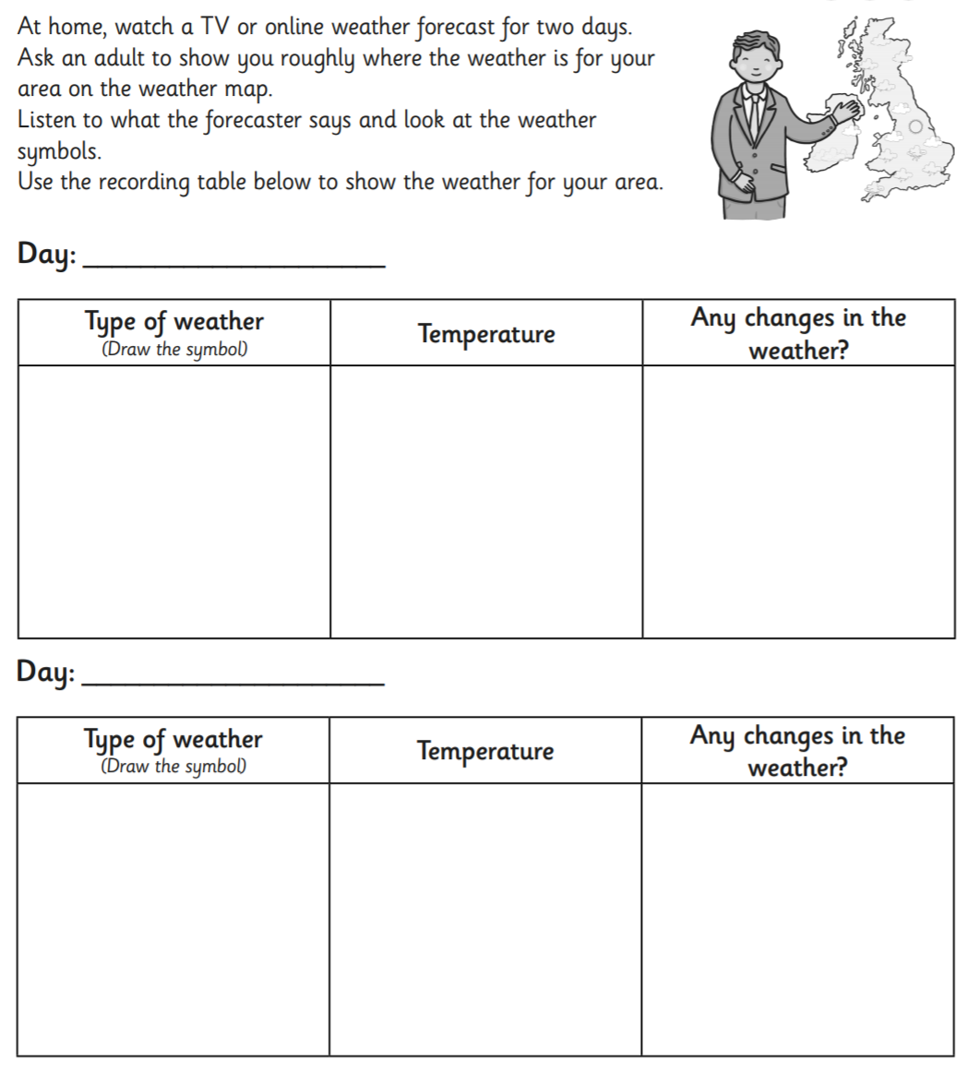
Reading
Please continue to read at home at least 5 times a week and record in your reading record.
https://www.oxfordowl.co.uk/ has a great range of ebooks!

Friday | Phonics/Spelling  Mrs Blewett’s Group  Complete Daily Letters and Sounds lesson (Year 1): https://www.youtube.com/channel/UCP_FbjYUP_UtldV2K_-niWw/playlists  OR  Revise Phase 3 sounds playing games on Phonics Play: https://new.phonicsplay.co.uk/resources  /phase/3/buried-treasure  https://new.phonicsplay.co.uk/resources  /phase/3/dragons-den  All other Year 2 Groups  We are looking at common exception words.  Ask an adult to dictate 5 sentences to you. Ensure they contain this week’s spelling words and some of the other Year 2 Common Exception Words (see resource sheet) | English  Had we been in school this week, it would have been the week where we sat our SATs papers.  This week I would like you to have a go at answering the questions in the Reading papers from 2019.  Paper 1 – a combined paper with text and questions. (Resource Sheet Available)  Paper 2 – a separate paper for the text and the questions. (Resource Sheet Available)  Please work through these throughout the week – don’t try to do them all at once!  Take lots of breaks and try your best!  These do not need to be sat in test conditions however you should try to do them independently.  Parents – If you would like paper copies of the test papers, these will be available from school on Monday 18th May. | Maths  Had we been in school this week, it would have been the week where we sat our SATs papers.  This week I would like you to have a go at answering the questions in the Maths papers from 2019.  Paper 1 – a paper of arithmetic questions (Resource Sheet Available)  Paper 2 – a problem solving and reasoning paper. (Resource Sheet Available)  Please work through these throughout the week – don’t try to do them all at once!  Take lots of breaks and try your best!  These do not need to be sat in test conditions however you should try to do them independently.  Parents – If you would like paper copies of the test papers, these will be available from school on Monday 18th May. | Golden Time!  Well done Year 2 – you have been great this week!  I am amazed at how much work you have completed at home, and have been really impressed with how you have tackled tasks on Purple Mash!  Have a lovely half-term and stay safe!
Reading
Please continue to read at home at least 5 times a week and record in your reading record.
https://www.oxfordowl.co.uk/ has a great range of ebooks!

Weekly Tasks
Keep checking Purple Mash for new ToDo’s – these will be updated weekly!
2do: Spelling Quiz - https://www.purplemash.com/#app/diyjs/y2_Autumn2_Week3_Week
2Do: 2x Table Speed Test - https://www.purplemash.com/#app/games/tabletoons/Speedtest_2x
Year 2 Blog – Create a post on the Year 2 Class Blog - https://www.purplemash.com/blog#/app/blog/5e79e6e00318eb5c66561c88/

Other Useful Resources:

Twinkl is an amazing resource, which we use often in school. They have made all their resources free for parents. Follow this link: www.twinkl.co.uk/offer and enter the code CVDTWINKLHELPS. Click on KS1 and a subject that you wish to explore. If you want to print any activities off, please stick these in your child’s yellow book. The grammar and arithmetic activities are especially useful for Year 2!

