Freedom of Information Policy

Westlea Primary School

October 2020

Explanatory Notes
Governing bodies are responsible for ensuring that schools comply with the Freedom of Information Act 2000 (FoIA). Some aspects, such as charging are at the discretion of the governing body.

Contents
1. Introduction 2
2. Background 2
3. Scope 3
4. Obligations and Duties 3
5. Publication Scheme 3
6. Dealing With Requests 3
7. Exemptions 4
8. Public Interest Test 4
9. Charging 4
10. Responsibilities 4
11. Complaints 4
Appendix 1: Procedure for Dealing with Requests 5
Process Map 1 for Dealing with Requests 10
Process Map 2 for Dealing with Requests 11
Appendix 2 11
Appendix 3 17
Appendix 4 19
Appendix 5 21
…………………………………………………………………………………………………………………….

1. Introduction
Westlea Primary School is committed to the Freedom of Information Act 2000 and to the principles of accountability and the general right of access to information, subject to legal exemptions. This policy outlines our response to the Act and a framework for managing requests. The School will make every effort to meet its obligations under the respective legislation and will regularly review procedures to ensure that it is doing so.
The underlying principle of this policy is that the public have a right to access to recorded information held by the School and that the School should seek to promote an open regime regarding access to information, subject to the exemptions contained within the relevant legislation.

2. Background
The Freedom of Information Act 2000 (FOI) came fully into force on the 1st January 2005. Under the Act, any person has a legal right to ask for access to information held by the school. They are entitled to be told whether the school holds the information, and to receive a copy, subject to certain exemptions.
The information which the school routinely makes available to the public is included in the Publication Scheme. Requests for other information should be dealt with in accordance with the statutory guidance. While the Act assumes openness, it recognises that certain information is sensitive. There are exemptions to protect this information.
The Act is fully retrospective, so that any past records which the school holds are covered by the Act. The DfE has issued a Retention Schedule produced by the Records Management Society of Great Britain, to guide schools on how long they should keep school records. It is an offence to wilfully conceal, damage or destroy information in order to avoid responding to an enquiry, so it is important that no records that are the subject of an enquiry are amended or destroyed.
Requests under FOI can be addressed to anyone in the school; so all staff need to be aware of the process for dealing with requests – see point 10. Requests must be made in writing, (including email), and should include the enquirers name and correspondence address, and state what information they require. They do not have to mention the Act, nor do they have to say why they want the information. There is a duty to respond to all requests, telling the enquirer whether or not the information is held, and supplying any information that is held, except where exemptions apply. There is no need to collect data in specific response to an FOI enquiry. There is a time limit of 20 days excluding school holidays for responding to the request.

3. Scope
The FOI Act joins the Data Protection Act (2018) and the Environmental Information Regulations (2004) as legislation under which anyone is entitled to request information from the school.
This policy applies to all recorded information held by the School that relates to the business of the School. This includes:
- Information created and held by the School
- Information created by the School and held by another organisation on our behalf
- Information held by the School provided by third parties, where this relates to a function or business of the School (such as contractual information) and
- Information held by the School relating to Governors where the information relates to the functions or business of the School
Requests for personal data are still covered by the Data Protection Act (DPA). Individuals can request to see what information the school holds about them. This is known as a Subject Access Request and must be dealt with accordingly.
Requests for information about anything relating to the environment – such as air, water, land, the natural world or the built environment and any factor or measure affecting these – are covered by the Environmental Information Regulations (EIR). They also cover issues relating to Health and Safety. For example, queries about chemicals used in the school or on school land, phone masts, car parks etc., would all be covered by the EIR. Requests under EIR are dealt with in the same way as those under FOI, but unlike FOI requests, they do not need to be written and can be verbal.
If any element of a request to the school includes personal or environmental information, these elements must be dealt with under DPA or EIR. Any other information is a request under FOI, and must be dealt with accordingly

4. Obligations and Duties
The school recognises its duty to:
- provide advice and assistance to anyone requesting information. We will respond to straightforward verbal requests for information and will help enquirers to put more complex verbal requests into writing so that they can be handled under the Act.
- tell enquirers whether or not we hold the information they are requesting (the duty to confirm or deny) and provide access to the information we hold in accordance with the procedures laid down in Appendix 1.

5. Publication Scheme
Westlea Primary School has adopted the Model Publication Scheme for Schools approved by the Information Commissioner.
The Publication Scheme and the materials it covers will be readily available from the school. It will also be published on our website at www.westleaprimary.co.uk

6. Dealing With Requests
We will respond to all requests in accordance with the procedures laid down in Appendix 1.
We will ensure that all staff are aware of the procedures.

7. Exemptions
Certain information is subject to either absolute or qualified exemptions. The exemptions are listed in Appendix 2.
When we wish to apply a qualified exemption to a request, we will invoke the public interest test procedures to determine if public interest in applying the exemption outweighs the public interest in disclosing the information.
We will maintain a register of requests where we have refused to supply information, and the reasons for the refusal. The register will be retained for 5 years.

8. Public Interest Test
Unless it is in the public interest to withhold information, it has to be released. We will apply the Public Interest Test before any qualified exemptions are applied.
For information on applying the Public Interest Test see Appendix 3.

9. Charging
The three information regimes contain different provisions that permit charges to be made for responding to information requests. The Governing Body may charge a fee for complying with requests, as calculated in accordance with FOI regulations. If a charge is to be made, the School will give written notice to the applicant before supplying the information requested.
The School will only charge for the cost of copying and transmitting information, not for time taken in reaching decisions regarding whether information is covered by an exemption.
Where the School estimates that the cost of locating the information will exceed the statutory threshold of £450, it will consider whether or not to comply with the request. The School is not obliged to comply with such a request but may choose to do so.
Further information with regards to charging can be found in Appendix 4.

10. Responsibilities
The Governing body has delegated the day-to-day responsibility for compliance with the FOI to the Headteacher. Freedom of Information enquiries should be sent in writing to the Headteacher.

11. Complaints
Any comments or complaints will be dealt with through the school’s normal complaints procedure.
We will aim to determine all complaints within 10 days of receipt. We will publish information on our success rate in meeting this target. The school will maintain records of all complaints and their outcome.
If on investigation the school’s original decision is upheld, then the school has a duty to inform the complainant of their right to appeal to the Information Commissioner’s office.
Appeals should be to the Information Commissioner’s office. They can be contacted at: https://ico.org.uk/make-a-complaint/official-information-concerns-report/official-information-concern/

Appendix 1: Procedure for Dealing with Requests
Note: This Appendix is adapted from the DfES Guide for Maintained Schools on Full Implementation from January 2005, with the exception of paras 17 – 21 which have been changed to reflect amended guidance.
- To handle a request for information the governing body or delegated person will need to ask themselves a series of questions.
Is it a FOI request for information?
- A request for information may be covered by one, or all, of three information rights:
  - Data Protection enquiries (or subject access requests) are ones where the enquirer asks to see what personal information the school holds about the enquirer. If the enquiry is a Data Protection request, we will follow our existing school DPA guidance.
  - Environmental Information Regulations enquiries are ones which relate to air, water, land, natural sites, built environment, flora and fauna, and health, and any decisions and activities affecting any of these. These could therefore include enquiries about recycling, phone masts, school playing fields, car parking etc. If the enquiry is about environmental information, we will follow the guidance on the IC’s website or the DEFRA website.
  - FOI enquiries are concerned with all other information and the reasoning behind decisions and policies. The request does not have to mention the FOI Act. All requests for information that are not data protection or environmental information requests are covered by the FOI Act.

Is this a valid FOI request for information?
- An FOI request should:
  - be in writing, including email or FAX;
  - state the enquirer’s name and correspondence address (email addresses are allowed);
  - describe the information requested – there must be enough information to be able to identify and locate the information; and
  - not be covered by one of the other pieces of legislation.
- Verbal enquiries are not covered by the FOI Act. Such enquiries can be dealt with where the enquiry is relatively straightforward and can be dealt with satisfactorily. However, for more complex enquiries, and to avoid disputes over what was asked for, we will ask the enquirer to put the request in writing or email, when the request will become subject to FOI.

Does the school hold the information?
- “Holding” information means information relating to the business of the school:
  - the school has created, or
  - the school has received from another body or person, or
  - held by another body on the school’s behalf.
- Information means both hard copy and digital information, including email.
- If the school does not hold the information, we do not have to create or acquire it just to answer the enquiry, although a reasonable search should be made before denying that we have got information the school might be expected to hold.

Has the information requested already been made public?
- If the information requested is already in the public domain, for instance through our Publication Scheme or on our website, we will direct the enquirer to the information and explain how to access it.

Is the request vexatious or manifestly unreasonable or repeated?
- The Act states that there is no obligation to comply with vexatious requests. This is taken to mean a request which is designed to cause inconvenience, harassment or expense rather than to obtain information, and would require a substantial diversion of resources or would otherwise undermine the work of the school. This, however, does not provide an excuse for bad records management.

Can the school transfer a request to another body?
- If the information is held by another public authority, such as our local authority, we will first check with them that they hold it, then transfer the request to them. We must notify the enquirer that we do not hold the information and to whom we have transferred the request. We will answer any parts of the enquiry in respect of information our school does hold.

Could a third party’s interests be affected by disclosure?
- Consultation of third parties may be required if their interests could be affected by release of the information requested, and any such consultation may influence the decision. We do not need to consult where we are not going to disclose the information because we will be applying an exemption.
- Consultation will be necessary where:
  - disclosure of information may affect the legal rights of a third party, such as the right to have certain information treated in confidence or rights under Article 8 of the European Convention on Human Rights;
  - the views of the third party may assist us to determine if information is exempt from disclosure, or
  - the views of the third party may assist us to determine the public interest.

Does an exemption apply?
- The presumption of the legislation is that we will disclose information unless the Act provides a specific reason to withhold it. There are more than 20 exemptions. They are set out in Appendix 2 and are mainly intended to protect sensitive or confidential information.
- Only where we have real concerns about disclosing the information will we look to see whether an exemption might apply. Even then, where the potential exemption is a qualified exemption, we need to consider the public interest test to identify if the public interest in applying the exemption outweighs the public interest in disclosing it. Therefore, unless it is in the public interest to withhold the information, it has to be released. Appendix 3 contains guidance on conducting a public interest test.

What if the request is for personal information?
- Personal information requested by the subject of that information is exempt under the FOI Act as such information is covered by the Data Protection Act. Individuals must, therefore, continue to make a ‘subject access request’ under the Data Protection Act if they wish to access such information.

What if the details contain personal information?
- Personal information requested by third parties is also exempt under the FOI Act where release of that information would breach the Data Protection Act. If a request is made for a document (e.g. Governing Body minutes) which contains personal information whose release to a third party would breach the Data Protection Act, the document may be issued by blanking out the relevant personal information as set out in the redaction procedure. The procedure for redaction is here.

How much can we charge?
- The Act allows governing bodies to charge for providing information. For further information, see Appendix 4.
- The first step is to determine if the threshold (currently £450) would be exceeded. Staff costs should be calculated at £25 per hour. We can take account of the costs of determining if the information is held, locating and retrieving the information, and extracting the information from other documents. We cannot take into account the costs involved in determining whether information is exempt.
- If a request would cost less than the appropriate limit, (currently £450) we can only charge for the cost of informing the applicant whether the information is held and communicating the information to the applicant (e.g. photocopying, printing and postage costs).
- If a request would cost more than the appropriate limit, (£450) we can turn the request down, answer and charge a fee, or answer and waive the fee. If we decide to charge a fee, and do not have other powers to do so, we can charge on the basis of the costs outlined in Appendix 4.
- We may wish to consider whether calculating the cost of the fee outweighs the cost of providing the information. In practice, we will aim to respond to straightforward enquiries free of charge and charge where the costs are significant.
- If we are going to charge, we must send the enquirer a fees notice and do not have to comply with the request until the fee has been paid. Appendix 4 gives more information on charging.

Is there a time limit for replying to the enquirer?
- Compliance with a request must be prompt and certainly within the legally prescribed limit of 20 working days, excluding school holidays. Failure to comply could result in a complaint to the Information Commissioner. The response time starts from the time the request is received. Where we have asked the enquirer for more information to enable us to answer, the 20 days start time begins when this further information has been received.
- If a qualified exemption applies and we need more time to consider the public interest test, we should reply within the 20 days stating that an exemption applies but include an estimate of the date by which a decision on the public interest test will be made. This should be within a “reasonable” time – in practice, it is recommended by the Department that normally this should be within 10 working days.
- Where we have notified the enquirer that a charge is to be made, the time period stops until payment is received and then continues again once payment has been received.

What action is required to refuse a request?
- If the information is not to be provided, the person dealing with the request must immediately contact the person in the school with delegated responsibility for FOI to ensure that the case has been properly considered and the reasons for refusal are sound. If it is decided to refuse a request, we need to send a refusals notice, which must contain
  - the fact that the responsible person cannot provide the information asked for;
  - which exemption(s) we are claiming apply;
  - why the exemption(s) apply to this enquiry (if it is not self-evident);
  - reasons for refusal if based on cost of compliance (see Appendix 4)
  - in the case of non-absolute exemptions, how we have applied the public interest test, specifying the public interest factors taken into account before reaching the decision (see Appendix 3)
  - reasons for refusal on vexatious or repeated grounds
  - the internal complaints procedure.
- For monitoring purposes and in case of an appeal against a decision not to release the information or an investigation by the Information Commissioner, the responsible person must keep a record of all enquiries where all or part of the requested information is withheld and exemptions are claimed. The record must include the reasons for the decision to withhold the information. Records should be retained for 5 years. There are no requirements to keep records where we have supplied the information requested.

What do we do if someone complains?
- Any written (including email) expression of dissatisfaction - even if it does not specifically seek a review – should be handled through the school’s existing complaints procedure which should be fair and impartial. The procedure should be clear and non-bureaucratic. Wherever practicable, the review should be handled by someone not involved in the original decision. The Governing Body should set and publish a target time for determining complaints and information on the success rate in meeting the target. The school should maintain records of all complaints and their outcome.
- When the original request has been reviewed and the outcome is that the information should be disclosed, this should be done as soon as practicable. When the outcome is that procedures within the school have not been properly followed, the school should review procedures to prevent any recurrence. When the outcome upholds the school’s original decision or action, the applicant should be informed of their right to appeal to the Information Commissioner. The appeal should be made in writing to:
FOI Compliance Team (Complaints)
Wycliffe House, Water Lane, Wilmslow, Cheshire. SK9 5AF

Process Map 1 for Dealing with Requests
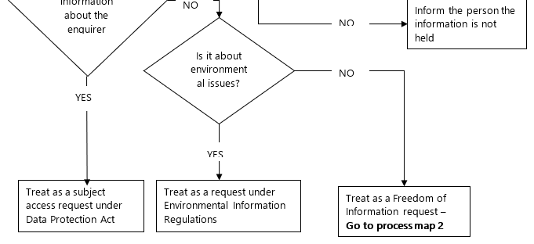
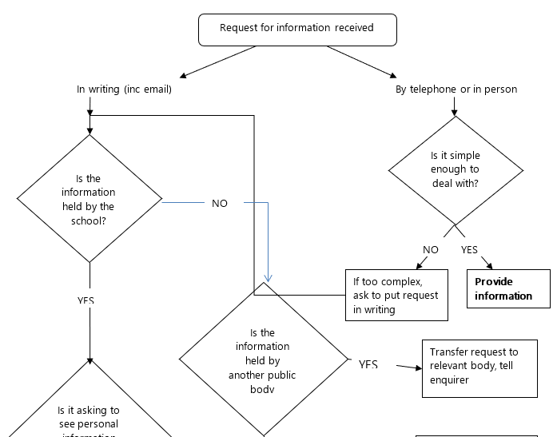

Process Map 2 for Dealing with Requests

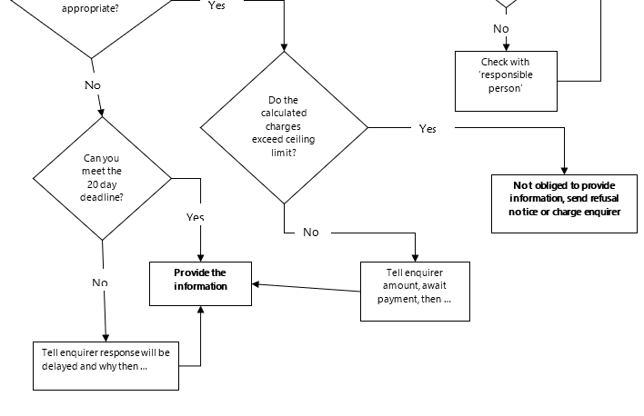
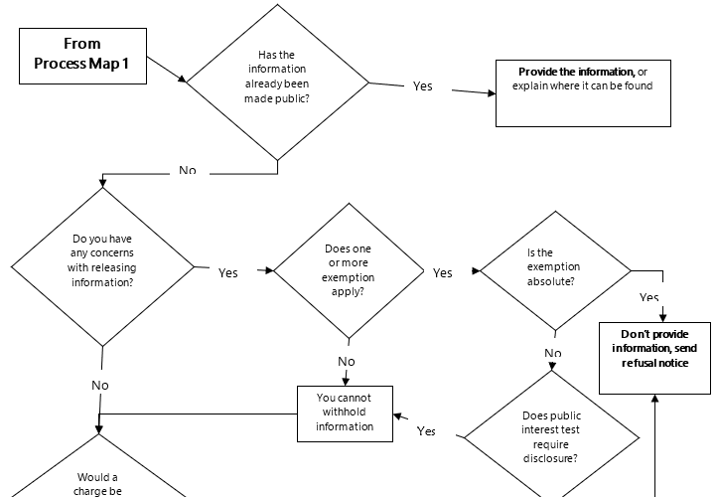
Appendix 2

Exemptions
Note: This Appendix is taken from the DfES Guide for Maintained Schools on Full Implementation from January 2005.
- Although decisions on disclosure should be made on a presumption of openness, the FOI Act recognises the need to preserve confidentiality and protect sensitive material in some circumstances.
- We cannot withhold information in response to a valid request UNLESS one of the following applies:-
  - an exemption to disclosure, or
  - the information sought is not held, or
  - the request is considered vexatious or repeated or
  - the cost of compliance exceeds the threshold (see Appendix 4)

The duty to confirm or deny
- A person applying for information has the right to be told if the information requested is held by the school, and if that is the case to have the information sent (subject to any of the exemptions). This obligation is known as the school’s “duty to confirm or deny” that it holds the information. However, the school does not have to confirm or deny if:-
  - the exemption is an absolute exemption (see paragraph 6), or
  - in the case of qualified exemptions (see paragraph 8), confirming or denying would itself disclose exempted information

Exemptions
- A series of exemptions are set out in the Act which allow the withholding of information in relation to an enquiry. Some are very specialised in their application (such as national security) and would not usually be relevant to schools. There are more than 20 exemptions but schools are likely to use only a few of them.
- There are two general categories of exemptions:-
Absolute: where there is no requirement to confirm or deny that the information is held, disclose the information or consider the public interest; and
Qualified: where, even if an exemption applies, there is a duty to consider the public interest in disclosing information.

What are the Absolute Exemptions?
There are 8 absolute exemptions listed in the Act. Even where an absolute exemption applies:-
- it does not mean that we can’t disclose in all cases; it means that disclosure is not required by the Act. A decision could be taken to ignore the exemption and release the information taking into account all the facts of the case
- there is still a legal obligation to provide reasonable advice and assistance to the enquirer
- The absolute exemptions in the Act are set out below. Those which might be relevant to schools are marked with an *:
  - Information accessible to the enquirer by other means* (Section 21)
If information is reasonably accessible to the applicant by another route than the Act, it is exempt information. This is the case even if the enquirer would have to pay for the information under that alternative route. This exemption includes cases where we are required to give information under other legislation, or where the information is available via the Publication Scheme.
  - Information dealing with security matters (Section 23) (see also qualified exemption under Section 24 on national security)
This applies to information directly or indirectly supplied by, or relating to, bodies dealing with security matters such as GCHQ, MI5, MI6, Special Forces and the National Criminal Intelligence Service.
  - Court records (Section 32) – (see also the qualified exemption under Section 30 concerning investigations and proceedings conducted by public authorities)
This applies to information related to proceedings in a court or tribunal or served on a public authority for the purposes of proceedings.
  - Parliamentary Privilege (Section 34)
This exempts information if it is required for the purpose of avoiding an infringement of the Parliamentary privilege. Parliamentary privilege is an immunity whereby MPs cannot be prosecuted for sedition or sued for libel or slander over anything said during proceedings in the House.
  - Prejudice to the effective conduct of public affairs (Section 36) - see also the qualified exemption part of Section 36
This relates to the maintenance of the collective responsibility of Ministers.
  - Personal information* (Section 40) - see also the qualified exemption part of Section 40.
Where enquirers ask to see information about themselves, this is exempt under the Act because it is covered by the Data Protection Act. Consult our existing school Data Protection guidance.
  - Information provided in confidence* (Section 41)
This relates to information obtained from a person if its disclosure would constitute a breach of confidence actionable by that, or another, person.
  - Prohibitions on disclosure* (Section 44)
Information is exempt where its disclosure is prohibited under any other legislation by order of a court or where it would constitute a contempt of court or where it is incompatible with any EC obligation.

What are the Qualified Exemptions?
- With qualified exemptions, even if it is decided that an exemption applies, there is a duty to consider the public interest in confirming or denying that the information exists and in disclosing information. Guidance on carrying out the public interest test is at Appendix 3. The qualified exemptions in the Act are set out below. Those which might be relevant to schools are marked with an *:
  - Information intended for future publication* (Section 22)
If at the time the request was made, information is held with a view to publication, then it is exempt from disclosure if it is reasonable that it should not be disclosed until the intended date of publication. This could apply for instance to statistics published at set intervals, for example annually or where information is incomplete and it would be inappropriate to publish prematurely. Remember, we still have a legal duty to provide reasonable advice and assistance.
  - National security (Section 24) (see also absolute exemption 23)
Information is exempt for the purposes of safeguarding national security.
  - Defence (Section 26)
Information is exempt if its disclosure would prejudice the defence of the UK.
  - International relations (Section 27)
Information is exempt if its disclosure would or would be likely to, prejudice relations between the UK and any other state, international organisation.
  - Relations within UK (Section 28)
Information is exempt if its disclosure would or would be likely to, prejudice relations between any administration in the UK i.e. the Government, Scottish Administration, Northern Ireland Assembly, or National Assembly of Wales.
  - The economy (Section 29)
Information is exempt if its disclosure would, or would be likely to, prejudice the economic or financial interests of the UK
  - Investigations and proceedings conducted by public authorities* (Section 30)
Information is exempt if it has at any time been held by the school for the purposes of criminal investigations or proceedings, such as determining whether a person should be charged with an offence or whether a charged person is guilty, or investigations which may lead to a decision to institute criminal proceedings. The duty to confirm or deny does not apply to such information.
  - Law enforcement* (Section 31)
Information which is not exempt under Section 30 Investigations and Proceedings, may be exempt under this exemption in the event that disclosure would, or would be likely to, prejudice the following among others:-
    - the prevention or detection of crime
    - the apprehension or prosecution of offenders
    - the administration of justice
    - the exercise of functions such as ascertaining if a person has broken the law, is responsible for improper conduct, whether circumstances justify regulatory action, ascertaining a person’s fitness or competence in relation to their profession, ascertaining the cause of an accident or protecting or recovering charities or its properties
    - any civil proceedings brought by or on behalf of the school which arise out of an investigation carried out for any of the purposes mentioned above.
The duty to confirm or deny does not arise where prejudice would result to any of these matters.
  - Audit Functions (Section 33)
Information is exempt if its disclosure would, or would be likely to, prejudice the exercise of an authority’s functions in relation to the audit of the accounts of other public authorities. It does not apply to internal audit reports.
  - Formulation of government policy (Section 35)
Information held is exempt information if it relates to the formulation or development of government policy, ministerial communications, advice by Law Officers (eg Attorney General) and the operation of any Ministerial private office
  - Prejudice to the conduct of public affairs (Section 36) (excluding matters covered by the absolute exemption part of Section 36)
Information likely to prejudice the maintenance of the convention of the collective responsibility of Ministers or likely to inhibit the free and frank provision of advice or exchange of views
  - Communications with the Queen* (Section 37)
Information is exempt if it relates to communications with the Queen, the Royal Family or Royal Household or if it relates to the award of honours. The duty to confirm or deny does not arise where this exemption applies.
  - Health and Safety* (Section 38)
Information is exempt if its disclosure would or would be likely to endanger the safety or physical or mental health of any individual. The duty to confirm or deny does not arise where prejudice would result.
  - Environmental information* (Section 39)
Information is exempt under FOI where it is covered by the Environmental Information Regulations. Environmental information can cover information relating to: air, water, land, natural sites, built environment, flora and fauna, and health. It also covers all information relating to decisions or activities affecting any of these.
  - Personal information* (Section 40) – see also the absolute exemption part of Section 40
Where an individual seeks information about themselves Data Protection Act powers apply.
Where the information concerns a third party, it is exempt if its disclosure would contravene the Data Protection Act, or the data protection principles; or if the person to whom the information relates would not have a right of access to it because it falls under one of the exemptions to the Data Protection Act. The duty to confirm or deny does not arise in relation to this information if doing so would be incompatible with any of the above.
  - Legal professional privilege* (Section 42)
Legal professional privilege covers any advice given by legal advisers, solicitors and barristers. Generally, such information will be privileged. A school wishing to disclose the information will need to seek consent from the provider of the advice. This exemption covers all such information where a claim to legal professional privilege can be maintained in legal proceedings. The duty to confirm or deny does not arise where to do so would involve the disclosure of such information.
  - Commercial interests* (Section 43)
Information is exempt if it constitutes a trade secret or would be likely to prejudice the commercial interests of any person or body (including the school). The duty to confirm or deny does not arise where prejudice would result to commercial interests but not where the information constitutes a trade secret.

Protective Markings and Applying Exemptions
- When considering if an exemption to disclosure should apply, we will bear in mind that the presence of a protective marking (Restricted, Confidential or Secret, with or without descriptors such as Staff, Management, Commercial etc) does not constitute an exemption and is not in itself sufficient grounds on which to prevent disclosure. Each case must be considered on its merits.

Timing
- Where information has previously been withheld, it must not be assumed that any subsequent requests for the same information will also be refused. Sensitivity of information decreases with age and the impact of any disclosure will be different depending on when the request is received. Therefore, for each request, it will be necessary to consider the harm that could result at the time of the request and, while taking into account any previous exemption applications, each case should be considered separately.

Next steps
- In all cases, before writing to the enquirer, the person given responsibility for FOI by the school governing body will need to ensure that the case has been properly considered, and that the reasons for refusal, or public interest test refusal, are sound.

Appendix 3

Applying the Pubic Interest Test
Note: This Appendix is taken from the DfES Guide for Maintained Schools on Full Implementation from January 2005.

Background
- Having established that a qualified exemption(s) definitely applies to a particular case, we must then carry out a public interest test to identify if the public interest in applying the exemption outweighs the public interest in disclosing it. Therefore, unless it is in the public interest to withhold the information, it has to be released. Although precedent and a developed case law will play a part, individual circumstances will vary and each case will need to be considered on its own merits.

Carrying out the test
- It is worth noting that what is in the public interest is not necessarily the same as that which may be of interest to the public. It may be irrelevant that a matter may be the subject of public curiosity. In most cases it will be relatively straightforward to decide where the balance of the public interest in disclosure lies. However, there will inevitably be cases where the decision is a difficult one. Applying such a test depends to a high degree on objective judgement and a basic knowledge of the subject matter and its wider impact in the school and possibly wider. Factors that might be taken into account when weighing the public interest include:-

For Disclosure | Against Disclosure
Is disclosure likely to increase access to information held by the school? | Is disclosure likely to distort public reporting or be misleading because it is incomplete?
Is disclosure likely to give the reasons for a decision or allow individuals to understand decisions affecting their lives or assist them in challenging those decisions? | Is premature disclosure likely to prejudice fair scrutiny, or release sensitive issues still on the internal agenda or evolving?
Is disclosure likely to improve the accountability and transparency of the school in the use of public funds and help to show that it obtains value for money? | Is disclosure likely to cause unnecessary public alarm or confusion?
Is disclosure likely to contribute to public debate and assist the understanding of existing or proposed policy? | Is disclosure likely to seriously jeopardise the school’s legal or contractual position?
Is disclosure likely to increase public participation in decision-making? | Is disclosure likely to infringe other legislation e.g. Data Protection Act?
Is disclosure likely to increase public participation in political processes in general? | Is disclosure likely to create a controversial precedent on the release of information or impair our ability to obtain information in the future?
Is disclosure likely to bring to light information affecting public safety? | Is disclosure likely to adversely affect the school’s proper functioning and discourage openness in expressing opinions?
Is disclosure likely to reduce further enquiries on the topic? | If a large amount of information on the topic has already been made available, would further disclosure shed any more light or serve any useful purpose?

- Note also that:
  - potential or actual embarrassment to, or loss of confidence in, the school, staff or governors is NOT a valid factor
  - the fact that the information is technical, complex to understand and may be misunderstood may not of itself be a reason to withhold information
  - the potential harm of releasing information will reduce over time and should be considered at the time the request is made rather than by reference to when the relevant decision was originally taken
  - the balance of the public interest in disclosure cannot always be decided on the basis of whether the disclosure of particular information would cause harm, but on certain higher order considerations such as the need to preserve confidentiality of internal discussions
  - a decision not to release information may be perverse i.e. would a decision to withhold information because it is not in the public interest to release it, itself result in harm to public safety, the environment or a third party?
- We will record the answers to these questions and the reasons for those answers. Deciding on the public interest is not simply a matter of adding up the number of relevant factors on each side. We need to decide how important each factor is in the circumstances and go on to make an overall assessment.

For Disclosure
- Where the balance of the public interest lies in disclosure, the enquiry should be dealt with and the information required should be made available. Where the factors are equally-balanced, the decision should usually favour disclosure (but see 3rd bullet point above).

Against Disclosure
- After carrying out the public interest test if it is decided that the exemption should still apply, we will proceed to reply to the request.
There will be occasions when it has been decided that a qualified exemption applies but consideration of the public interest test may take longer. In such a case, we must contact the enquirer within 20 working days stating that a particular exemption applies, but including an estimate of the date by which a decision on the public interest test will be made. This should be within a “reasonable” time – in practice, it is recommended this decision is made and communicated within the 20 days but where not possible it is suggested that no more than 10 working days beyond the 20 days should be allowed.

Appendix 4

Charging
Note: This Appendix is based on the guidance from the DfES and the Department for Constitutional Affairs. A summary of the DCA guidance can be found at: www.dca.gov.uk/foi/feeguidesum.htm
Important: Different charges apply for requests under the Data Protection Act.

May I charge a fee?
FOI does not require charges to be made but schools have discretion to charge applicants a fee in accordance with the Fees Regulations (fees Regulations on the DCA website www.dca.gov.uk/foi/secleg.htm)

What steps should we take in considering whether to charge?
Step 1. Is the information exempt for the purposes of the FOI Act?
If information is exempt, then fees do not apply. We may not know if information is exempt until it has been located and checked. However, there are many instances, for example information in our publication scheme, when it is automatically exempt. If we wish to charge for information in our publication scheme, this should be made clear in the scheme itself. The school would need to contact the enquirer to inform them that the information is exempt, and how to obtain it.
Step 2. Do we wish to calculate whether the cost of the request would exceed the appropriate limit (currently £450)?
In many cases, it will be obvious that the request would cost less than the appropriate limit, so there would be little point in making the calculation.
Step 3. Calculate the appropriate limit
Staff costs are calculated at £25 per hour. When calculating whether the limit is exceeded, we can take account of the costs of determining whether the information is held, locating and retrieving the information, and extracting the information from other documents. We cannot take account of the costs involved with considering whether information is exempt under the Act.
Step 4. Requests costing less than the limit
If a request would cost less than the limit, we can only charge for the cost of informing the applicant whether the information is held, and communicating the information to the applicant (e.g. photocopying, printing and postage costs)
Step 5. Requests exceeding the limit
If a request would cost more than the limit, we can turn the request down, answer and charge a fee, or answer and waive the fee.
If we choose to comply with a request where the estimated cost exceeds the threshold, we should calculate the charge as outlined in Step 3, plus the costs of informing the applicant whether the information is held, and communicating the information to them (i.e. printing and postage costs)
Step 6. For all requests, schools should have regard to the following two points:
  - The duty to provide advice and assistance to applicants. If planning to turn down a request for cost reasons, or charge a high fee, we should contact the applicant in advance to discuss whether they would prefer the scope of the request to be modified so that, for example, it would cost less than the appropriate limit.
  - Maximum amount that can be charged. The Regulations set out the maximum amount that can be charged. However, there is nothing to stop schools charging a lesser or no fee. Governing bodies should develop a consistent policy on charging.

May we aggregate the costs where there are multiple requests?
Where two or more requests are made to the school by different people who appear to be acting together or as part of a campaign, the estimated cost of complying with any of the requests is to be taken to be the estimated total cost of complying with them all, provided that:
- the two or more requests referred to in that section are for information which is on the same subject matter or is otherwise related;
- the last of the requests is received by the school before the twentieth working day following the date of receipt of the first of the requests; and
- it appears to the school that the requests have been made in an attempt to ensure that the prescribed costs of complying separately with each request would not exceed the appropriate limit.
If we get multiple requests for the same information, it is good practice to include the information in our publication scheme.
- Where we intend to charge a fee for complying with a request for information then the school must give the person requesting the information notice in writing (the “fees notice”) stating that a fee of the amount specified in the notice is to be charged for complying.
- Where a fees notice has been given to the person making the request, we do not need to comply with the request unless the fee is paid within three months of the notice being received.

Appendix 5

Standard Letters

CLARIFICATION:

{School Address}

{Applicant Address}

{Date}

Dear {Name},

Thank you for your request for information received on . From the information described, we have been unable to identify the information you require.
Could you please give us more information relating to: {Include specific information you require, try to ensure that terms that may be unfamiliar to the requestor are explained}.
The Freedom of Information Act 2000 requires that we deal with requests such as this within 20 working days. We are not required to include any time whilst waiting for clarification of a request. We will endeavour to proceed with your request as soon as you supply the information required. If we have not received a reply within three months we will treat this request as cancelled.
If you have any comments relating to how your request has been handled by our school, please contact {Name and address of contact for complaints procedure}.

Yours sincerely,

{Name}
{Title}

DO NOT HOLD INFORMATION:

{School Address}

{Applicant Address}

{Date}

Dear {Name},

Thank you for your request for information received on .
We have conducted a thorough search of our records and unfortunately we are unable to locate the information you requested. This may be because the school has never held this information or that the information is older than the statutory requirements for retention and has been legally destroyed in accordance with our retention schedules.
If you have any comments relating to how your request has been handled by our school, please contact {Name and address of contact for complaints procedure}.

Yours sincerely,

{Name}
{Title}

FEES AND CHARGES:

{School Address}

{Applicant Address}

{Date}

Dear {Name},

Thank you for your request for information received on . It is estimated that the time to find this information will be hours. The cost of this search will exceed the statutory ceiling of £450.00 for free searching time allowed under the Freedom of Information Act 2000 (The Freedom of Information and Data Protection (Appropriate Limit and Fees) Regulations 2004).
To proceed with your request we will require a fee of £ {supply details of local address and payment details}. We will continue with the search on receipt of payment, however if we have not received a reply within three months we will cancel the request .
If you have any comments relating to how your request has been handled by our school, please contact {Name and address of contact for complaints procedure}.

Yours sincerely,

{Name}
{Title}

PUBLICATION SCHEME:

{School Address}

{Applicant Address}

{Date}

Dear {Name},

Thank you for your request for information, received on .
The information which you requested is already available to the public via our school publication scheme, which is available from the school office or on our website {website address}.
If you have any comments relating to how your request has been handled by our school, please contact {Name and address of contact for complaints procedure}.

Yours sincerely,

{Name}
{Title}

TRANSFER INFORMATION:

{School Address}

{Applicant Address}

{Date}

Dear {Name},

Thank you for your request for information, received on . To the best of our knowledge the requested information is not held within the school. However, we believe that {Name and address of organisation} may hold the information you require. We will therefore need to transfer the request to them.
If you have an objection to this transfer you should let us know as soon as possible by writing to {Address} or telephoning {Phone Number} and asking for {Name of Officer dealing with the request}.
If you have any comments relating to how your request has been handled by our school, please contact {Name and address of contact for complaints procedure}.

Yours sincerely,

{Name}
{Title}

Date of Policy: October 20th 2020

In cases where the enquiry is ambiguous, we will assist the enquirer to describe more clearly the information requested. Where possible, we will establish direct contact. The aim is to clarify the nature of the information requested and not to determine the aims or motivation of the enquirer. If we notify the enquirer that we need further information to enable us to answer, we do not have to deal with the request until the further information is received. The response time limit starts from the date this is received.
It is not intended to include otherwise valid requests in which the applicant may make complaints or vent frustrations. In addition, we do not have to comply with repeated identical or substantially similar requests from the same applicant unless a “reasonable” interval has elapsed between requests.
The procedure for redaction is: i) mask the passages which are not to be disclosed and photocopy; (ii) annotate in the margin against each blank passage, the exemption and section of the Act under which this passage is exempt; (iii) explain in the covering letter that the relevant exemptions are marked in the attachments and in the case of non-absolute exemptions, how the public interest test has been considered. On no account must we use a computer to rewrite the document or email and simply delete the exempted passages so that the resulting document appears as though they did not exist. The one circumstance where this would be permissible would be where the only redacted parts are personal information such as people’s names and the covering letter explains this.
An order to this effect is to be made under section 10(4) of the Act and took effect from 1 January 2005.

