What is Cultural Capital?
Cultural capital is the accumulation of knowledge, behaviours, and skills that a student can draw upon and which demonstrates their cultural awareness, knowledge and competence. It is one of the key ingredients a child will draw upon to be successful in society, their future career and within the world.
Cultural capital promotes social mobility and success in our stratified society.
Cultural capital gives a child power. It will help them to achieve goals, become successful, and rise up the social ladder without necessarily having wealth or financial capital.
Cultural capital is having assets that give students the desire to aspire and achieve social mobility whatever their starting point
In EYFS, Cultural Capital is about preparing children with the knowledge and skills for what comes next. This is so important in early years because what children learn in those vital first years of life will stay with them forever.
Policy Rationale:
At Westlea Primary School, we recognise that for any student to aspire and be successful in life, they need to be given rich, inclusive and sustained opportunities to develop their cultural capital. The School’s Vision recognises four key areas of development which are interrelated and underpinned by British Values. Together and over time, these areas cumulatively contribute to shaping a student’s cultural capital:
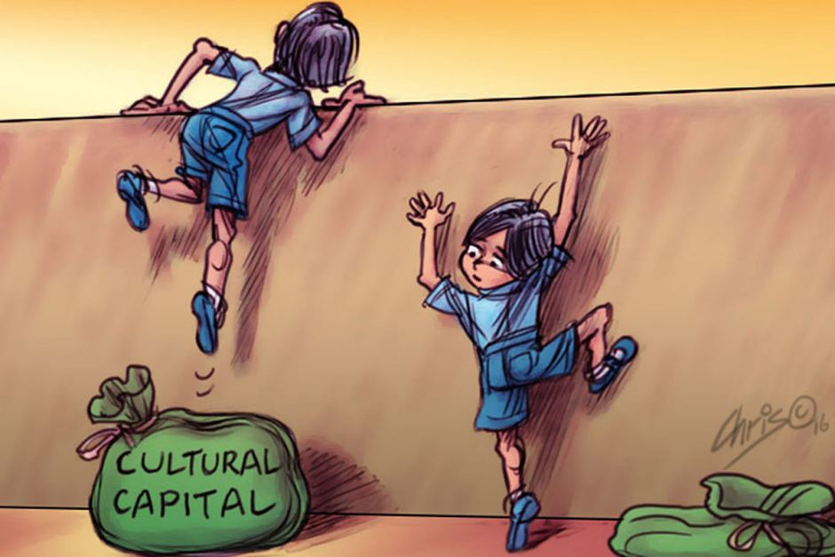
. The Westlea Vision
Dream, Believe and Achieve through L.O.V.E
Learning
Opportunities
Values
Truth
Educational Excellence
Hope
Learning for life  Reading  Writing  PSHE  RE  DT  ICT  Maths  Meta Cognition  Healthy Schools | Opportunities: the connected world  Broad and balance curriculum  Music and Sporting opportunities  Performances  Trips and Visitors  Outdoor learning  Fundraising  Extracurricular activities  Art  Geography
Rule of Law | Mutual Respect
Democracy | Individual Liberty
Vision and Dreams  Freedom to think  Global Learning  Be the best you can  Challenge  Creativity  Tolerance  Kindness  Academic excellence | Educational Excellence  Social Skills  French  Science  History  Inclusion  Purposeful Curriculum  Perseverance  am Work

Responsibility
Courage

