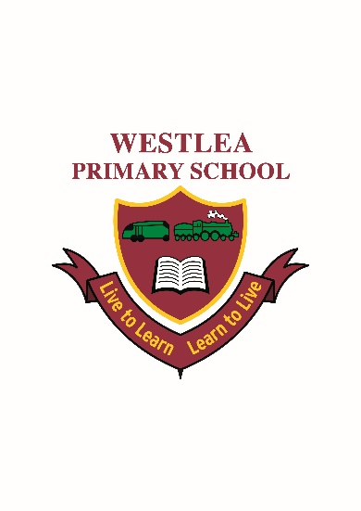
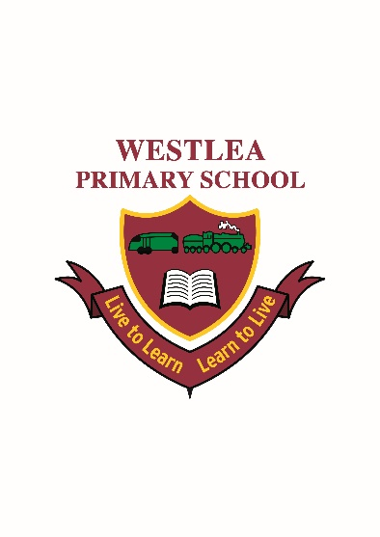

Science Policy

Science Curriculum Intent
At Westlea Primary School we believe that Science provides the foundations for understanding the world through specific disciplines of biology, chemistry and physics.
Science at Westlea builds on children’s curiosity of the natural world. We use a range of planned investigations, theory and practical activities to develop their understanding and to stimulate creative thought.
We build an extensive range of specialist scientific vocabulary.
Children are encouraged to understand how Science is used to explain what is occurring, predict how things will behave and make analysis. Providing them with a range of knowledge and skills.
Science is planned by year group and is taught consistently throughout each term and where possible Science is linked to the termly topics.
At the end of the time at Westlea we aim to have children who are inquisitive, curious and have a thirst for finding out/investigating why and how things happen.

Aims and objectives

. Through the framework of the National Curriculum, science aims to:
- Equip children to use themselves as starting points for learning about science, and to build on their enthusiasm and natural sense of wonder about the world.
- Develop through practical work the skills of observation, prediction, investigation, interpretation, communication, questioning and hypothesizing, and increased use of precise measurement skills and ICT.
- Encourage and enable pupils to offer their own suggestions, and to be creative in their approach to science, and to gain enjoyment from their scientific work.
- Enable children to develop their skills of co-operation through working with others, and to encourage where possible, ways for children to explore science in forms which are relevant and meaningful to them.
- Teach scientific enquiry through contexts taken from the National Curriculum for science.
- Encourage children to collect relevant evidence and to question outcome and to persevere.
- Encourage children to treat the living and non-living environment with respect and sensitivity.
- Stress the need for personal and group safety by the correct usage and storage of resources.
- To enable children to appreciate that we do not always know the answers and results when carrying out scientific enquiry.

Teaching and learning

- Science is planned for and taught every week, unless it has been agreed to group some lessons if appropriate,
- Science planning should be completed identifying the lesson objectives and intentions, and activities are differentiated accordingly to meet the needs of the children in class.

Sex Education (following the statutory changes from September 2020)

The DfE Guidance 2019 (p.23) recommends that all primary schools ‘have a sex education programme tailored to the age and the physical and emotional maturity of the pupils.
However, ‘Sex Education is not compulsory in primary schools’. (p. 23)

Schools are to determine the content of sex education at primary school. Sex education ‘should ensure that both boys and girls are prepared for the changes that adolescence brings and – drawing on knowledge of the human life cycle set out in the national curriculum for science - how a baby is conceived and born’.

At Westlea Primary School, we believe children should understand the facts about human reproduction before they leave primary school so we define Sex Education as understanding human reproduction. We intend to teach this within Science in which case the parent’s right to withdraw the child is not applicable.

At Westlea Primary School, puberty is taught as a statutory requirement of Health Education and covered by our Jigsaw PSHE Programme in the ‘Changing Me’ Puzzle (unit), and we conclude from the DFE Guidance that sex education refers to Human Reproduction. In order to teach this in a scientific context, and knowing that National Curriculum Science requires children to know how mammals reproduce, we have opted to teach this within our Science curriculum, not within PSHE or Relationships and Sex Education as we believe this is most appropriate for our children.

Foundation Stage

We teach science in Reception classes as an integral part of the topic work covered during the year. We relate the scientific aspects of the children’s work to the objectives set out in the Early Years Foundation stage document. Science makes a significant contribution to developing a child’s knowledge and understanding of the world, e.g. commenting on what they observe, looking at changes, similarities and differences.

Inclusion

In school we aim to meet the needs of all our children by differentiation in our science planning and in providing a variety of approaches and tasks appropriate to ability levels. This will enable children with learning and/or physical difficulties to take an active part in scientific learning and practical activities and investigations and to achieve the goals they have been set. Some children will require closer supervision and more adult support to allow them to progress whilst more able children will be extended through differentiated activities. By being given enhancing and enriching activities, more able children will be able to progress to a higher level of knowledge and understanding appropriate to their abilities.

Assessment and recording

Assessment for learning is continuous throughout the planning, teaching and learning cycle. Children are more formally assessed at the end of each unit. For both KS1 and KS2 using a variety of methods:-
- Observing children at work, individually, in pairs, in a group, and in classes.
- Questioning, talking and listening to children
- Considering work/materials / investigations produced by children together with discussion about this with them.
- End of unit assessment.

Date: July 2016
Reviewed: November 2020

Signed: Sarah Green

